Music Festival Set Times & Line-Up

Now that you’ve planned your Music Festival, it’s time to think about the “Set Times & Line-Up” of your acts, musicians, bands or DJ’s.
“Set Times” give information to your “festival-goers” about who is playing on which day, at which time, and on which stage.

Task 1: There should be at least TWO STAGES at your Music Festival and you must now organise who is playing on which stage and when.
You will need to “name” each stage and think carefully about which act will be performing when and for how long (perhaps keeping your “headliner” to ‘close’ the festival on the “Main Stage” – as is common in line-ups at many Music Festivals!)

You should present your Music Festival Set Times & Line-Up either using a Spreadsheet, PowerPoint Slides, using MS-Word or by writing this out on paper (sketching your ideas out in pencil may be a good idea first as there are often frequent ‘moves around’ when putting together a festival line-up!) One way of doing this is shown below:

Stage 1 Name: Iron First Stage (Main Stage) | Stage 2 Name: Summer Sounds
Stage 1 Style of Music: Heavy Metal Bands | Stage 2 Style of Music: Pop Bands
Stage Times: 12noon-10pm | Stage Times: 3pm-9pm
12noon-1.30pm Slippery Play  1.30pm-3pm Purely Purple  etc. | 3pm-4pm Spoons and a Toothbrush  4pm–5pm Purely Yellow  etc.

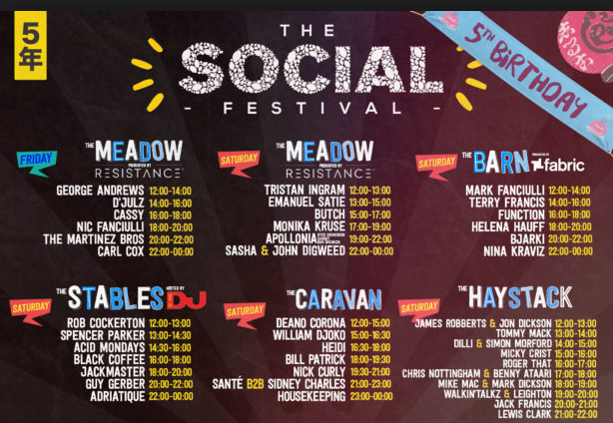
You’ll now need to present your “Set Times & Line-Up” in a professionally presented way to put out
on Social Media to your “festival-goers” so they can ‘plan their day’.

The example shown to the right is taken from “The Social Festival” which had 1 stage open on the Friday, and
5 stages or performance areas on the Saturday.

TASK 2: Create and design a professionally-presented poster of your “Set Times & Line-Up” for your own
Music Festival.

