My English Home Learning Pack 1

Task 1: “Describing a Scary Character”
In class we have been reading the play, Frankenstein. We explored how Victor Frankenstein created his monster and brought it to life. Now it’s your turn to be a mad scientist!
What to do:
- Plan a short description of a scary character, like Frankenstein’s monster.
- When you have finished your plan, write a description of your scary monster.

Task 2: “Writing a Spooky Story”
What to do:

- Use the template to plan and structure your own spooky story.
- Once you have completed the setting add the description of your character that you did in task two.

Task 3: “Grammar Time”

What to do: Adverbs of Possibility – “Finish the sentence”
- Underline the adverb of possibility in each sentence.
- Choose a suitable way to finish the sentence.

Task 4: “Groups 1, 2 and 3 Grammar Test”

What to do:
- Complete the questions on the sheet and mark them with an adult, a friend or a family member.
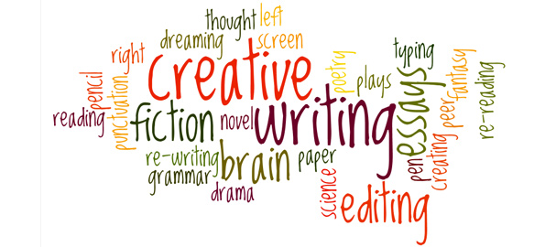
- Do they agree with your answers?

