My English Home Learning Pack 4

Reading Challenge 2

Here are some activities for enjoying reading.

*“Stories become interesting when you concentrate and picture what is happening in your mind. So don’t give up easily, show your determination and get reading and listening!”*

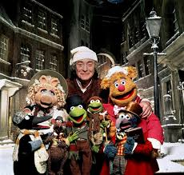

Reading Challenge 2

Ctrl and click the link 

<https://www.nypl.org/blog/2014/12/19/podcast-neil-gaiman-christmas>

If you like Neil Gaiman’s voice, try listening to him reading, ‘A Christmas Carol’ – it might not be Christmas but you could always shut the curtains, pull out the tinsel and pretend!

There is an introduction and the story starts at about 11 minutes and 50 seconds.

While you are listening:

1. Why not write a diary for Scrooge to record what happens to him and how he feels about it?
2. Or create a storyboard of key events in each chapter?

Ready for some light relief?

Watch the Muppets’ version of A Christmas Carol. Does it follow the original story?

<https://www.youtube.com/watch?v=ShoxJLlh_FY&list=PLnfTpIrAsxxWNjZOjyZCMr70G2PdTAlsQ>

*See if you can find out how many different versions of ‘A Christmas Carol’ have been produced as films. What does this tell you about Charles Dickens’ amazing story?*