Visit the website www.mymaths.co.uk

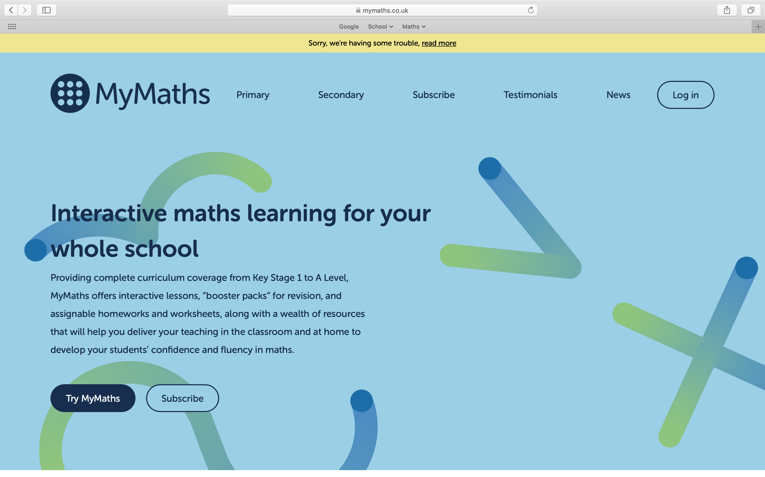

Click log in in the top right corner of the screen.

Log in using the details below

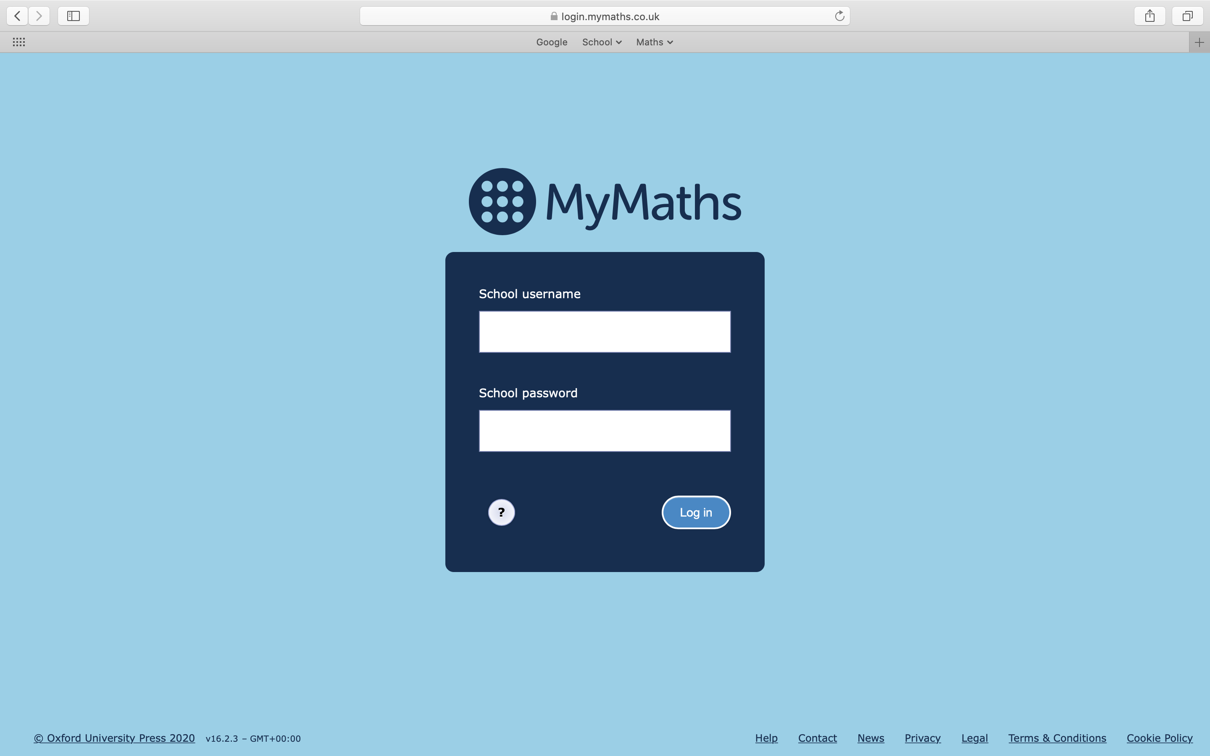
ruler
hopehi

This will take you to a second log in page. You will need your personal log in details for this section. (If you have forget your details email your teacher).

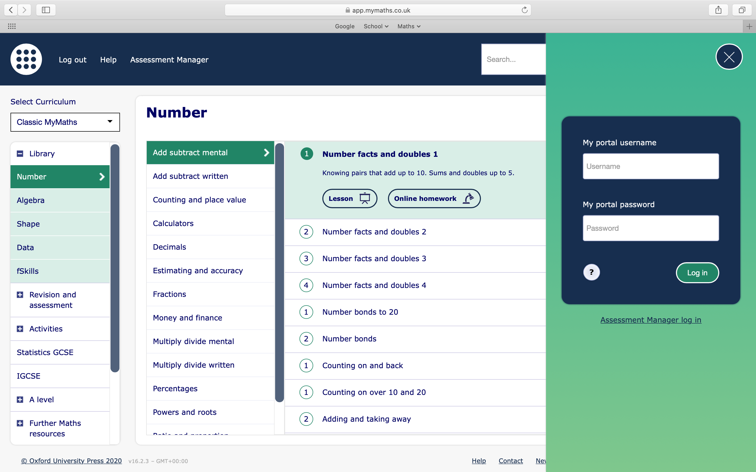

Once logged in you will be able to access the my homework and my feed sections to see set work from your teacher. You can also access any other topics you wish to have a go at.

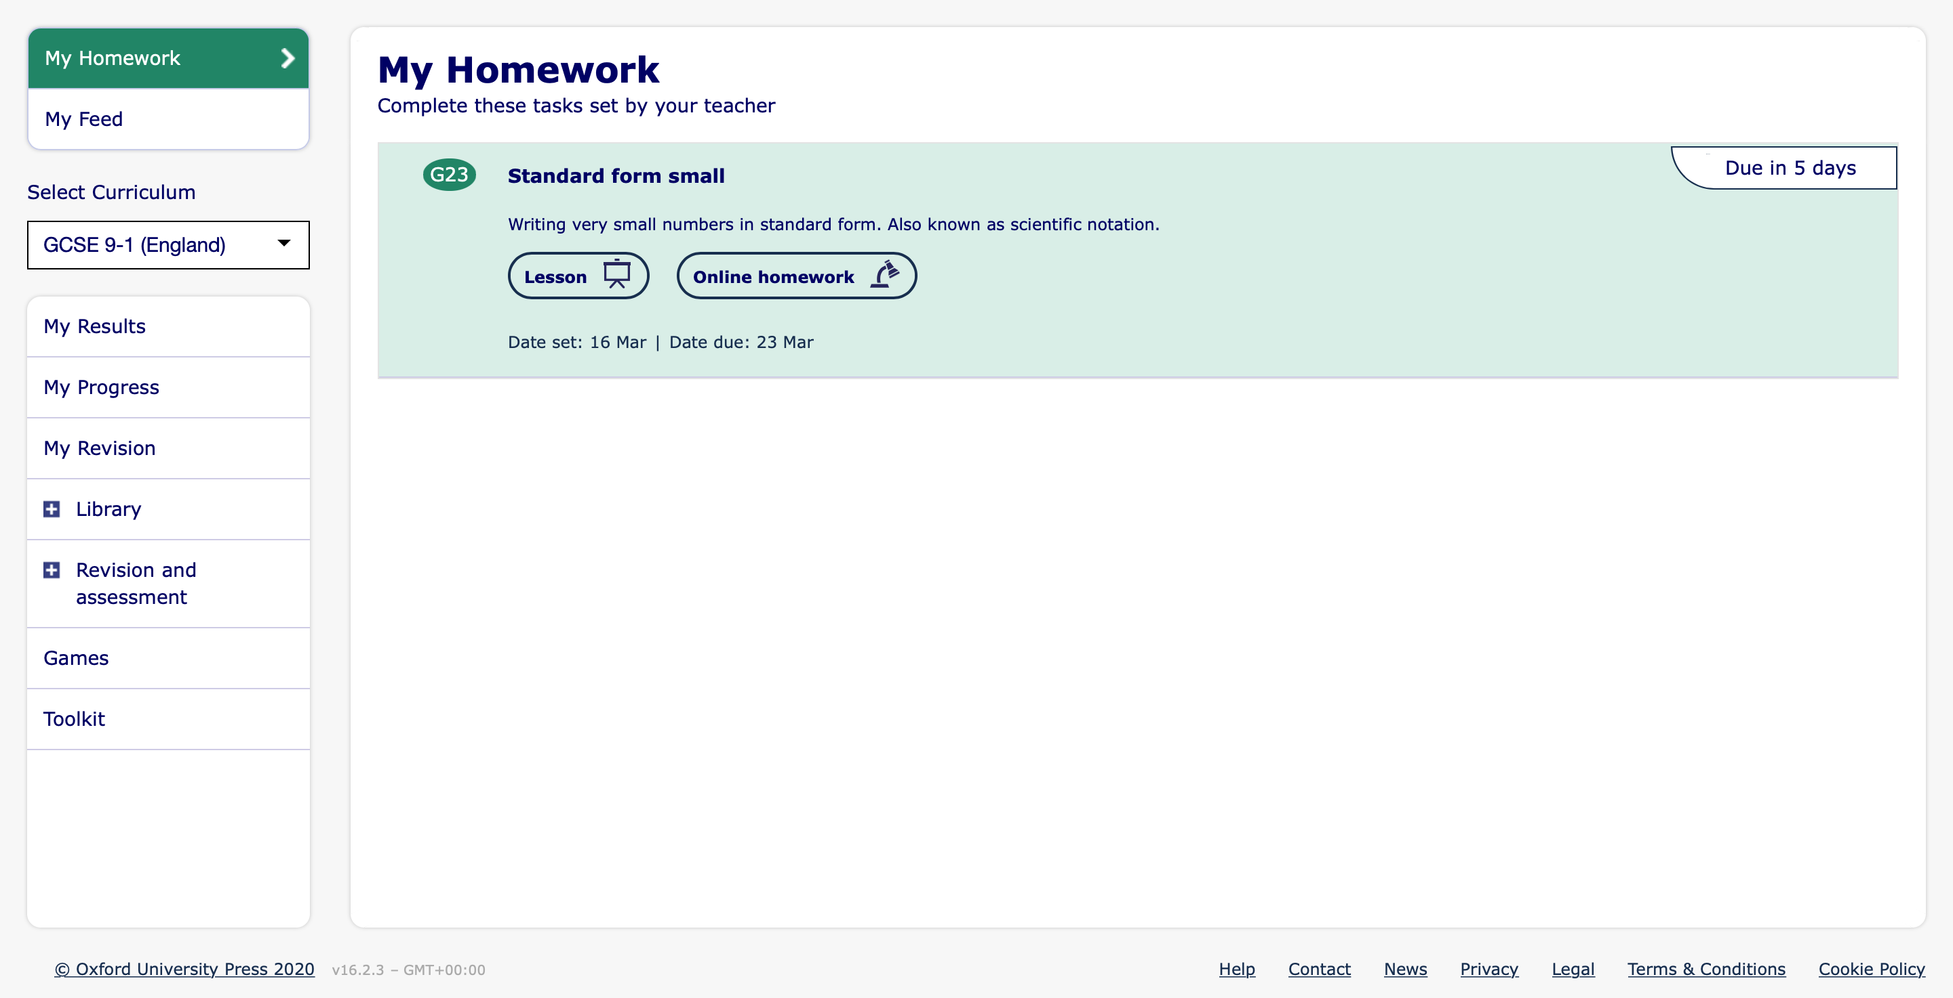

Your teacher will be able to see you score for the homework section and provide feedback and additional work if required.

