**National Careers Week at Hope High School**

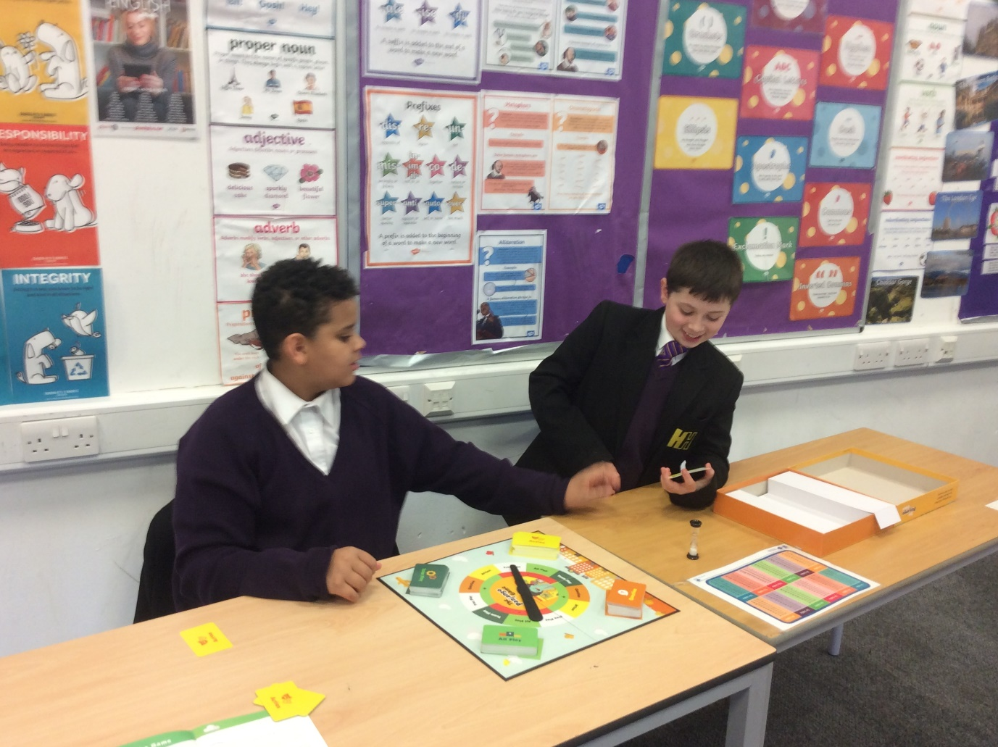

This week the students have accessed a carousel of activities during their PSHE lessons to help them develop essential skills, qualities and knowledge to succeed in the world of work.

|  |  |  |
| --- | --- | --- |
| **Skills** | **Knowledge** | **Qualities** |
| Employability | Labour Market Information | Resilience |
| Problem solving | Key Vocabulary | Building peer relationships |
| Teamwork | Vocational routes | Leadership |
| Communication | Workplace environments | Empathy |
| Problem solving |  | Modelling behaviours to peers |

Pupils where fully engaged during all sessions and demonstrated outstanding communication and teamwork skills throughout the sessions. Below are examples of our pupils engaging in their lessons.



