F





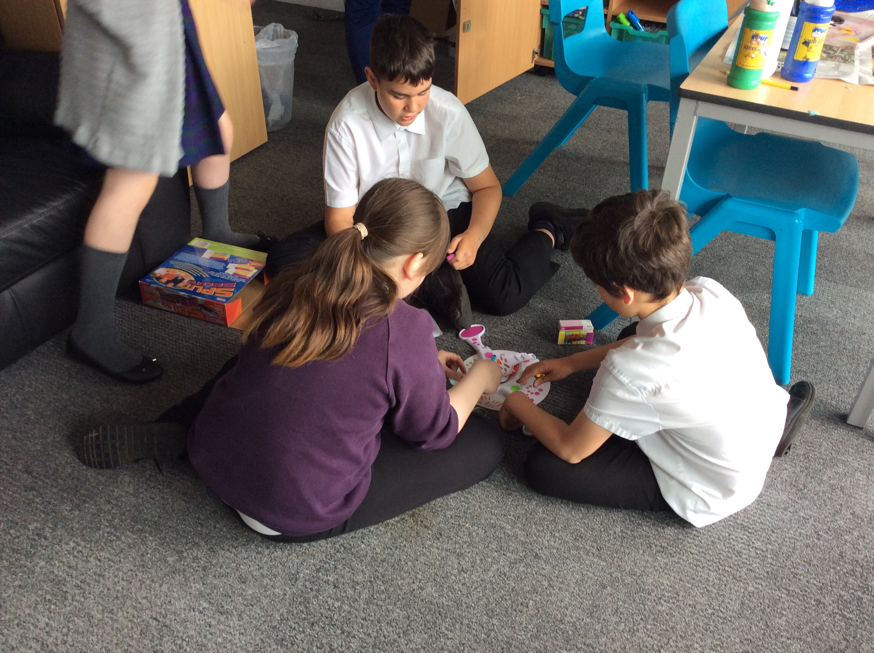

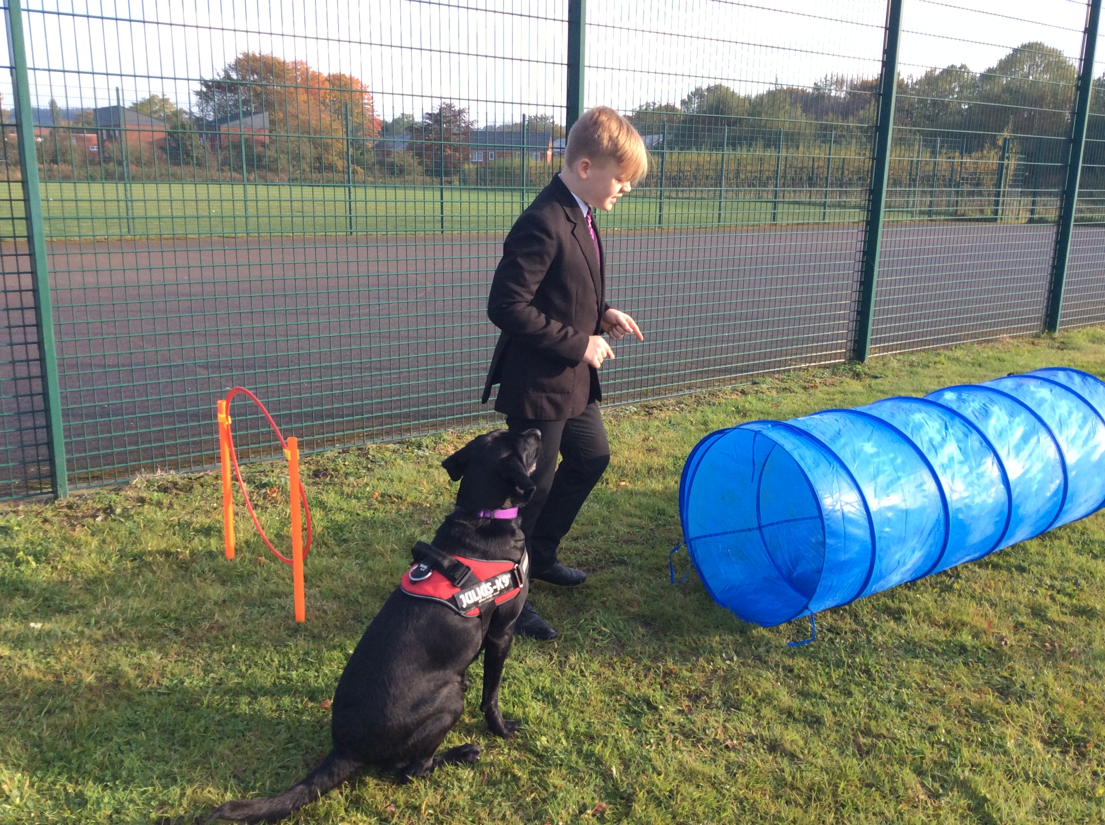

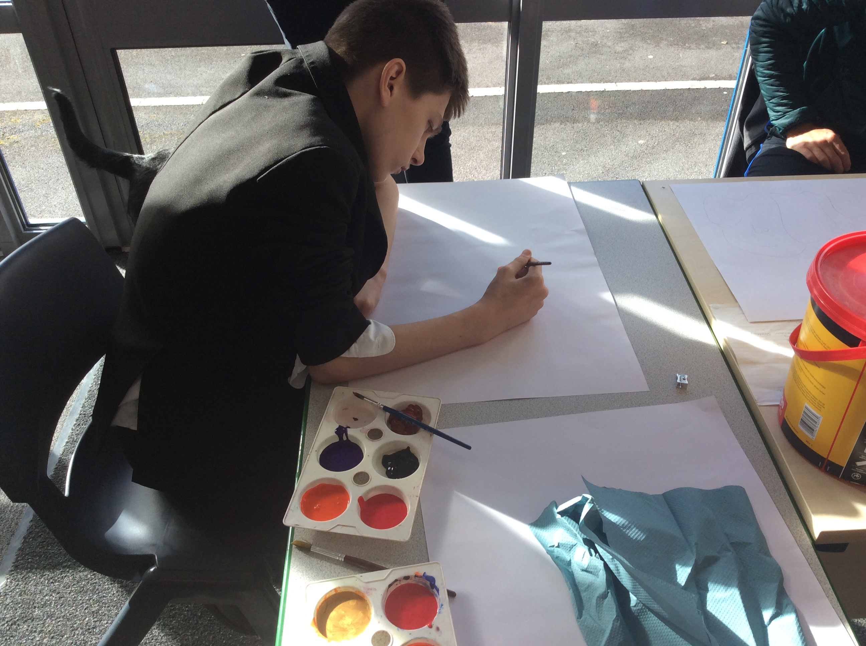



***“Learning for Life"***

Start Date 1st September 2021

Salary Grade £29,577 - £33,782 Negotiable ( pro rata)

25 hours per week - Term Time Only

Closing Date Friday 4th June 2021 – 12pm

Interview Date TBD

*During this period it is our intention to continue with essential recruitment for key positions starting in September 2021. We want to reassure applicants that effective COVID measures will be implemented to ensure their health and wellbeing.*

Occupational Therapist

Candidate Information Pack

 

**Hope High School, Carfield, Skelmersdale, Lancashire, WN8 9DP**

**Tel: 01695 721066 sbm@hopehigh.lancs.sch.uk**

**(82 on roll 11-16)**

**Mrs H Dunbavin Headteacher**

**General Information**

Do you want to work in a unique SEN school where your support will make a real difference to pupils’ lives and ambitions for their future?

We have an exciting opportunity for a creative & dynamic Occupational Therapist to help support the development of the SEN provision within our school. You will be joining a large intervention provision, led by the school’s SENCo, consisting of; SALT, Specialist teacher for inclusion, HLTAs to support SALT and inclusion specialist, HLTA for mental health and wellbeing, nurture provision and 5 member Thrive pastoral support team. The intervention team work closely and collaborate on all areas of SEN provision throughout the school.

The successful candidate will; have a recognised degree in Occupational Therapy HCPC registration and be a member of the Royal - College of Occupational Therapists, adhere to the standards for registration to the Health and Care Professions Council, have experience working with children with autism, learning disabilities and complex/SEMH, and hold a valid UK driving license and own car.

You will be joining a supportive, talented and friendly staff team where ideas are shared, staff are listened to and you will help to shape the future direction of the school. Our pupils deserve the very best staff who can inspire and ensure the best outcomes possible. Our SEN support and focus on individualised provision, ensures that each pupil gets the right help at the right time. This support and expertise provides pupils with the skills to enable them to reach their true potential.

For more information about our school, please visit www.hope.lancs.sch.uk. Booking a visit to look around the school before you apply is recommended. Please contact the Assistant Head Teacher Lucy O’Kane for an informal chat and to make an appointment.

Hope High School is an equal opportunities employer and is committed to safeguarding and promoting the welfare of children and young people. The successful applicant will be subject to an enhanced DBS check. The post you are applying for is covered by the Rehabilitation of Offenders (Exceptions) Act 1975. If successful you will be required to apply to the Disclosure and Barring Service for a 'disclosure'.

Applications must be accompanied by a supporting letter and be a maximum of 2 side of A4 and in font size 12. Completed applications must be submitted electronically to: trencherk@hope.lancs.sch.uk. Rehabilitation of offenders Act 1974 - details of any criminal record spent or unspent should be sent to the Chair of Governors at the school address by the closing date.

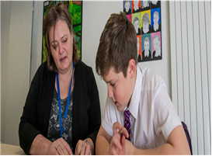

**About the School**

Hope High School in Skelmersdale is a relatively small SEN school for young people aged 11 to 16 who have individual needs based on Social, Emotional and Mental Health difficulties.

The school has created a culture for learning and behaviour, which enables pupils with additional needs to succeed. The approach that all staff share is both nurturing and innovative. The modern setting and high levels of quality provision ensures pupils learn in a calm and constructive environment. In January 2020, the school was judged by Ofsted as being good in all areas and the school intends to build on this success.

We are a purpose-built school with facilities designed to support our learners towards success. Our facilities include a modern computer suite, a fully equipped cookery room, design technology workshop, an art studio, a brand-new forest school area, a sports hall with gymnasium and climbing wall and of course classrooms each having the latest learning technology.

Our school boasts a fantastic staff team committed to improving the life chances of our young people. Our expectations are high. We aspire for pupils to flourish and succeed – socially, emotionally and academically. We personalise the curriculum and strive for every learner to make accelerated levels of academic progress. We build upon their interests, their strengths and learning styles whilst acknowledging what motivates them to learn.

Our experienced and skilled staff use their expertise to tailor individual strategies to improve pupils’ self-esteem and confidence, which we understand is a foundation for success. Young people develop their ability to build relationships, develop positive behaviour and become motivated and enthusiastic learners.

At Hope High we understand the importance of home-school partnerships and we keenly encourage active participation from all parents and carers. This includes regular communication via each pupil’s key worker, regular coffee mornings and barbeques. All parents and carers are also encouraged to play an active part in the target setting and review process which is in place for all pupils.

Hope High is a place where no two days are ever the same and is filled with vibrant, talented and driven learners who never fail to amaze and inspire us.



**Person Specification**

***“Learning for Life"***

|  |  |  |
| --- | --- | --- |
| **Personal Attributes required (on the basis of the job description)** | **Essential (E) or**  **Desirable (D)** | **To be identified by:**  **(application form (AF),**  **interview (I),**  **test (L), or**  **other (give details)** |
| **Qualifications**    Recognised qualification in Occupational Therapy  Sensory integration Training | E  D | AF    AF |
| **Experience**  Working with children/adolescents with additional needs (educational, social, emotional or mental health)  Working with parents / families who need support  Working with a range of professionals and agencies | E  E  E | I,L    I,L    I,L |
| **Knowledge/skills/abilities**    To operate as a practitioner with knowledge of learning disability, autism and associated mental health difficulties to ensure that individual occupational needs are identified.  To have a broad understanding of Occupational Therapy models and approaches across the spectrum of health conditions, to include physical and mental health.  To have a baseline knowledge of the Occupational therapy clinical evidence base, assessment and intervention approaches specific to the people we support, which can be developed through time in post.  Evidence of ability to problem solve and make effective use of clinical supervision and informal support from more senior practitioners to bring about learning and effective outcomes for clinical intervention.  To develop the skills and knowledge of approaches to support people through situations where there may be high levels of distress, where they may require complex reasoning to solve crisis situations or fluctuations in health needs.  To have experience of making best use of clinical supervision and take a lead role within your own access to and positive use of the supervision process to bring about professional development and learning.  Ability to communicate information to a broad range of individuals in a sensitive, appropriate manner.  Demonstrate the values and beliefs through daily practice that reflect the core Occupational Therapy philosophy.  Ability to develop and maintain strong and positive relationships whilst maintaining clear role, ethical and professional boundaries.  Have attention to detail in order to ensure safeguarding and medical records are accurate.  Ability to communicate effectively with colleagues, families and agencies. | E  E  E  E  E  E  E  E  E  E  E | AF,I,L  I,L  I,L    I,L    I,L  I,L  I,L  I,L  I,L  I,L    I,L |
| **Personal Qualities**  Ability to demonstrate a calm, patient disposition  Highly developed interpersonal skills  Be goal orientated in your work approach  Have a flexible approach and be able to adapt to change  Be emotionally resilient and able to work in challenging situations.  Ability to relate to young people in a positive manner  Willingness to constructively challenge the work of self and others to continually improve own and team performance  To show loyalty and commitment to the school | E  E  E  E  E  E  E | I,L    I,L  I,L  I,L  I,L  I,L  I,L |
| **Other**  Commitment to undertake in –service development  Commitment to safeguarding and protecting the welfare of children and young people | E  E | I  I |



**Job Description**

***“Learning for Life"***





|  |  |
| --- | --- |
|  | |
| **POST** **TITLE:** | Occupational Therapist |
| **SALARY:** | £29,577 - £33,782 Negotiable ( pro rata)  25 hrs - Term Time Only |
| **LOCATION:** | Hope High School |
| **REPORTING TO:** | SLT & Partaking in Clinical Supervision |
| **STAFF RESPONSIBLE FOR:** | Delivering occupational therapy support and strategies |
| **JOB PURPOSE: The main objectives to be achieved by the Postholder** | |
| Hope High school is looking to recruit an Occupational Therapist to be employed on a full time, permanent basis. This is a newly created role where you would working in a specialist SEMH school to provide specialist education, therapy and support for children, aged 11-16, with challenging behaviours, autism, learning disabilities, attachment difficulties, developmental trauma, sensory difficulties, neurodiversity and SEMH needs. Your role will involve carrying out assessments, formulating therapy plans and delivering both 1:1 and group interventions and activities.  You will be joining a large intervention provision, led by the school’s SENCo, consisting of; SALT, Specialist teacher for inclusion, HLTAs to support SALT and inclusion specialist, HLTA for mental health and wellbeing, nurture provision and 5 member Thrive pastoral support team. The intervention team work closely and collaborate on all areas of SEN provision throughout the school.  The successful candidate must:  - Have a recognised degree in Occupational Therapy HCPC registration and be a member of the Royal -College of Occupational Therapists.  - Adhere to the standards for registration to the Health and Care Professions Council.  - Have experience working with children with autism, learning disabilities and complex/SEMH  - Hold a valid UK driving license and own car  Sensory integration training is desirable but not essential. | |
| **MAIN**  **ACTIVITIES** | |
| **Job Purpose** | |
| * To provide therapy with children with communication, motor, and sensory needs within a school setting. * To complete assessments and produce reports to contribute to annual review and Educational Health and Care Plan meetings. * To ensure the service is provided in close collaboration with education staff and other professionals to meet the needs of the child or young person. | |
| **Clinical Work** | |
| * Assessing and diagnosing a wide range of motor, perceptual, sensory and functional difficulties. * Planning appropriate therapy interventions, making fine judgements about type and timing of treatment negotiated with education staff and parents. * Delivering group and individual therapy as required. * Providing advice, training and therapy programmes to education staff, parents and other health professionals. * Managing parental and/or school anxieties regarding intervention and prognosis. * Evaluating treatment outcomes. * Transferring and discharging. | |
| **Professional Responsibility** | |
| * To demonstrate clinical effectiveness by use of evidence based practice and outcome measures. * To be responsible for managing own time appropriately and prioritise tasks accordingly in order to carry out clinically related administrative duties, relevant to the caseload and operation of the school. * To independently manage a complex caseload whilst recognising own professional boundaries and access supervision, advice and support when necessary. * To work closely with relevant parties about individual students and practically demonstrate therapeutic approaches where appropriate. * To provide relevant in-service training to school staff and parents, via presentations, talks and career evenings on topics related to the role of the occupational therapist and occupational therapy. To reflect on and evaluate training provided. * To be responsible for maintaining up to date and accurate case notes in line with professional standards and school policies * To collect clinical data and write reports for Annual Reviews and Educational Health and Care Plans. * To adhere to local and national standards and guidelines relating to Professional Practice and maintain registration with the Health Professions Council * To recognise and demonstrate commitment to personal development and acquisition of further skills and knowledge relating to clinical areas and evidenced by PDP and Professional Log as specified in the job purpose and the application of these skills to clinical practice. * To undertake other duties and responsibilities as reasonably directed by the Heads of School. | |
| **Staffing** | |
| * Take part in the school’s staff development programme by participating in arrangements for further training and professional development. * Continue own professional development in the relevant areas including subject knowledge and teaching methods. * Engage actively in the performance excellence process. * Encourage the effective/efficient deployment of classroom support. * Work as a member of a designated team and to contribute positively to effective working relations. | |
| **Management** | |
| * Maintain appropriate records and to provide relevant accurate and up-to-date information * Complete the relevant documentation to assist in the tracking of students. * Track student progress and use information to inform provision. * Co-operate with other staff to ensure a sharing and effective usage of resources to the benefit of the school, department and the students. | |
| **Communication and Liaison** | |
| * Communicate effectively with the parents of students as appropriate. * Where appropriate, communicate and co-operate with persons or bodies outside the school. * Follow agreed policies for communications in the school. | |
| **Pastoral System** | |
| * Promote the general progress and well-being of individual students * Encourage attendance and their participation in other aspects of school life. * Contribute to the preparation of action plans and progress files and other reports and references. * Alert the appropriate staff to problems experienced by students and to make recommendations as to how these may be resolved. * Communicate as appropriate, with the parents of students and with persons or bodies outside the school concerned with the welfare of individual students, after consultation with the appropriate staff. * Apply the school’s behaviour management systems so that effective learning can take place. | |
| **School Ethos** | |
| * Play a full part in the life of the school community, supporting its distinctive mission and ethos and encouraging staff and students to follow this example. * Promote actively the school’s corporate policies. * Comply with the school’s health and safety policy and undertake risk assessments as appropriate. | |
| **Note** | |
| The school will endeavour to make any necessary reasonable adjustments to the job and the working environment to enable access to employment opportunities for disabled job applicants or continued employment for any employee who develops a disabling condition. This job description is current at the date but will be reviewed on an annual basis and, following consultation with you, may be changed to reflect or anticipate changes in the job requirements which are commensurate with the job title and grade. | |