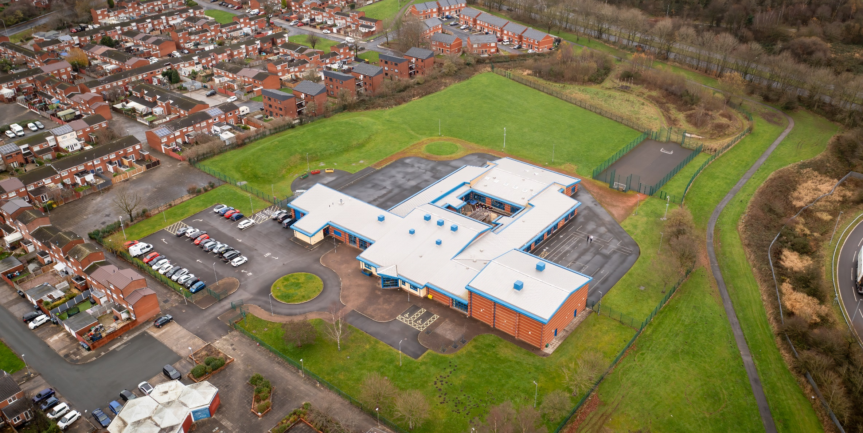

01 April 2023

Hope High School PE CURRICULUM POLICY

Hope High School
Carfield
Skelmersdale
Lancashire
WN8 9DP
Tel: 01695 721066
Physical Education Curriculum Policy

Curriculum Purpose. “Learning for Life”
Our curriculum should allow all learners to have parity of opportunity, be life ready, harness their potential, promote creativity, have rich experiences, and broaden their life choices. ​
At Hope High School the Curriculum is ambitious and tailored to meet the needs of ALL pupils. Pupils study a broad and balanced range of subjects up to Functional Skills Level 1 & 2, BTEC Level 1 & 2, and GCSE. At Key Stage 3 pupils have the opportunity to follow a knowledge rich curriculum in a wide range of subjects. At Key Stage 4 pupils will follow a Core Curriculum and follow 2 pathways in an area of interest to them. This will allow them to flourish and develop their knowledge and skills in subjects that will provide opportunities for college courses and apprenticeships in the future.

Purpose
Our policy is intended to:
- Inspire all pupils to succeed and excel in a sporting environment
- provide opportunities for pupils to become physically confident in a way which supports their health and fitness.
- Opportunities to compete in sport
- Opportunities to build character and help to embed values such as fairness and respect.

Aims:

The national curriculum for physical education aims to ensure that all pupils:

Develop competence to excel in a broad range of physical activities ▪

Are physically active for sustained periods of time.

Engage in competitive sports and activities.

Lead healthy, active lives.

Objectives:
To help meet the Aims of the PE Curriculum the department will:
- Provide opportunities for pupils to access a range of sports.
- Help pupils understand that making a mistake is a positive learning experience. It is these experiences that will develop independence.
- Ensure through quality teaching that pupils receive a knowledge rich curriculum where they acquire the technical knowledge to support future applications to colleges and apprenticeships.
- Ensure learners have access to a wide range of resources which are freely available and regularly maintained.
- Develop Schemes of Work that are tailored to the individual needs of the learners.
- Support pupils in achieving a BTEC qualification that contributes to them progressing onto a college course of their choice.

Subject Content

Key Stage 3

Pupils should build on and embed the physical development and skills learned in key stages 1 and 2, become more competent, confident and expert in their techniques, and apply them across different sports and physical activities. They should understand what makes a performance effective and how to apply these principles to their own and others’ work. They should develop the confidence and interest to get involved in exercise, sports and activities out of school and in later life and understand and apply the long-term health benefits of physical activity.
Through the PE curriculum, pupils should be taught to:
- Use a range of tactics and strategies to overcome opponents in direct competition through team and individual games [for example, badminton, basketball, cricket, football, rounders and rugby]
- Develop their technique and improve their performance in other competitive sports [for example, Health related exercise and athletics]
- Take part in outdoor and adventurous activities which present intellectual and physical challenges.
- Pupils are encouraged to work in a team, building on trust and developing skills to solve problems, either individually or as a group
- Analyse their performances compared to previous ones and demonstrate improvement to achieve their personal best.
- Take part in competitive sports and activities outside school through community links or sports clubs.

Key Stage 4 - BTEC Level 1 Introduction to sport.

Qualification Overview

The Pearson BTEC Level 1 Introductory Award is designed around practical skills and tasks that place an emphasis on learners demonstrating what they can do rather than what they know in theory. The qualifications give learners the opportunity to acquire and develop generic, transferable and sector-specific skills in order to complete tasks and demonstrate a level of achievement that enables them to progress to further learning. The Award offers a basic introduction to the construction sector and could be studied alongside other subjects. The qualification prepares learners for further learning at a higher level in construction.
For the Sport Award pupils will complete 5 Units.

Unit A1: Being Organised (Mandatory unit)
Learning aims In this unit you will:
A Explore techniques to improve own organisational skills
B Review the use of techniques to improve own organisational skills.
Learners will develop key techniques to help organise their work and priorities and manage their time effectively. in this unit will introduce you to ways that will help you to plan and use your time effectively, as well as organising yourself and your work. After learning and practising these techniques, you will have the opportunity to put them into practice over a period of time, reviewing how successful they were and whether they improved your organisational skills. The skills you learn in this unit are key for progression to the next stage in your education. They are also crucial for work and life.

Unit A2 - Developing a Personal Progression Plan. (Mandatory Unit)

Purpose
The unit will help pupils find out what opportunities are available to them in the future and how to get to the next stage. They will carry out a self-audit, identifying strengths and what they need to develop to be able to meet their progression goals. They will learn how to set goals and plan ways to achieve them. They will then produce a personal progression plan to help them reach the next step in their life. The skills they develop in this unit will be good preparation when applying for another course or training programme.

Learning aims:
In this unit pupils will:
- Explore the skills and behaviours needed to meet a personal progression goal.
- Produce a progression plan to meet intended progression goal.

Unit SP7 – Playing Sport

Purpose
This unit will give you the chance to Become more skilful in sport, improve your knowledge, focus, and you will have lots of opportunity to participate in sport and develop your performance. You will improve your skills and techniques and will reflect on your performance, thinking about your strengths and areas for improvement. This will help you to make plans to improve your performance. This unit will develop your knowledge and understanding of the skills and techniques needed to be successful in sports. The transferable and sector skills you develop in this unit can enable you to progress to further learning. They will also support you in completing units in Group A of the qualification.

Learning Aims
In this unit pupils will:
Learning aim A Show skills and techniques in sport.
Learning aim B Review own performance when playing sport to improve skills and techniques.

Unit SP5: How Exercise Affects the Body
Purpose
Learners will find out how exercise affects the body by carrying out tests and collecting and interpreting results. In this unit, you will carry out tests to measure how exercise affects your body. You will explore how your heart, lungs, muscles and bones work together to help you perform. You will show your skills and your understanding of this subject through practical activities and by carrying out tests. Learning how the body works and how its different systems are affected when you exercise is important if you want to work in sport and fitness.
Learning Aims
In this unit you will:
A Carry out tests to measure the effects of exercise on the body
B Manage information and communicate test results.
Unit SP6: Training for Fitness
Purpose
Learners will develop skills in planning and delivering training sessions to improve fitness. You will try lots of these training methods yourself and will learn which skills are needed to plan and deliver training sessions for others. You will learn how athletes’ training programmes are designed to meet the needs of their sport and find out how different training methods are used to keep training interesting. You will improve your skills and confidence in creating training plans for other people. Completing the tasks and activities in this unit will develop your planning and communication skills, and your organisation and time management.
Learning aims
In this unit you will:
A Plan a training session that meets specific needs
B Demonstrate communication skills in the delivery of a training session to meet specific needs.

Teaching and Learning
Good quality teaching and learning is at the heart of improved life chances for the pupils at Hope High School. Our pupils benefit from consistency in their lives. Hope High has adopted the teaching and learning model of Rosenshein's 10 principles of Instruction. These principles will be evident in classrooms daily.
In PE the principles are:
- Daily review. Lessons will begin with a review of learning from previous lessons. This is to support our pupil's cognitive load.
- Present new material using small steps. Teacher demonstration is an integral part of the delivery of the subject. New concepts and skills will be introduced in small steps.
- Ask questions. A range of interactive questioning techniques will be used to check pupil understanding. Direct questioning.
- Provide pupil, teacher demonstrations and visual aids to support pupil understanding.
- Guide Student practice. Teachers and TA’s will be used to help and support pupils in lessons with an emphasis on encouraging pupil independence.
- Check for student understanding. Formative assessment techniques such as direct questioning of individual pupils and observation of skills and techniques will be used to check knowledge and understanding.
- Obtain a high success rate. Pupils will be encouraged to practise techniques and skills until mastery is achieved in that area.
- Independent practice. Opportunities will be provided to pupils for them to apply their knowledge, skills and understanding within a competitive setting. Where needed pupils will be provided with alternative settings to demonstrate learning. Independence will be supported and encouraged in all our pupils in a safe and calm environment.
- Weekly and monthly review. Pupils will revisit skills they used previously to help consolidate and support learning.

Assessment
At Hope High we firmly believe that assessment should be used as a tool to help move pupil learning forward. The day to day, lesson by lesson, formative assessment that takes place with pupils will help them make progress. This will inform teachers of areas of mastery and support them in the development of scaffolding materials to help pupils who need that extra support to achieve mastery.
This formative assessment coupled with end of topic summative assessments will provide the teacher with a holistic overview of a pupil progress and inform the grade for termly reports that are sent to parents/carers.
In PE pupils are assessed on the knowledge and understanding they have gained within the PE curriculum. They are assessed on their ability to apply the skills and knowledge they have gained throughout each area of the PE curriculum. Assessments are made clear to learners to develop their independence and evaluation of their work. This will inform future target setting. Self-evaluation is key in getting learners to understand what they can do well and what they need to improve on further.

Monitoring

The Head of School and leadership team will:
Monitor the subject through the Hope High self-evaluation schedule and monitoring schedule which are reviewed annually

Departmental leader will:
- Monitor learners work and quality of teaching and learning
- Review Curriculum Maps and Schemes of Work based on suitability of use
- Review and monitor risk assessments for practical lessons
- Analyse pupil performance data
- Attend link meetings

Links to other policies:
• Teaching and Learning
• Behaviour for Learning
• Monitoring
• Assessment for Learning
• Health and Safety
• Marking and Feedback
Date Approved:
Review date:
Signed subject Lead:
Signed Headteacher:

