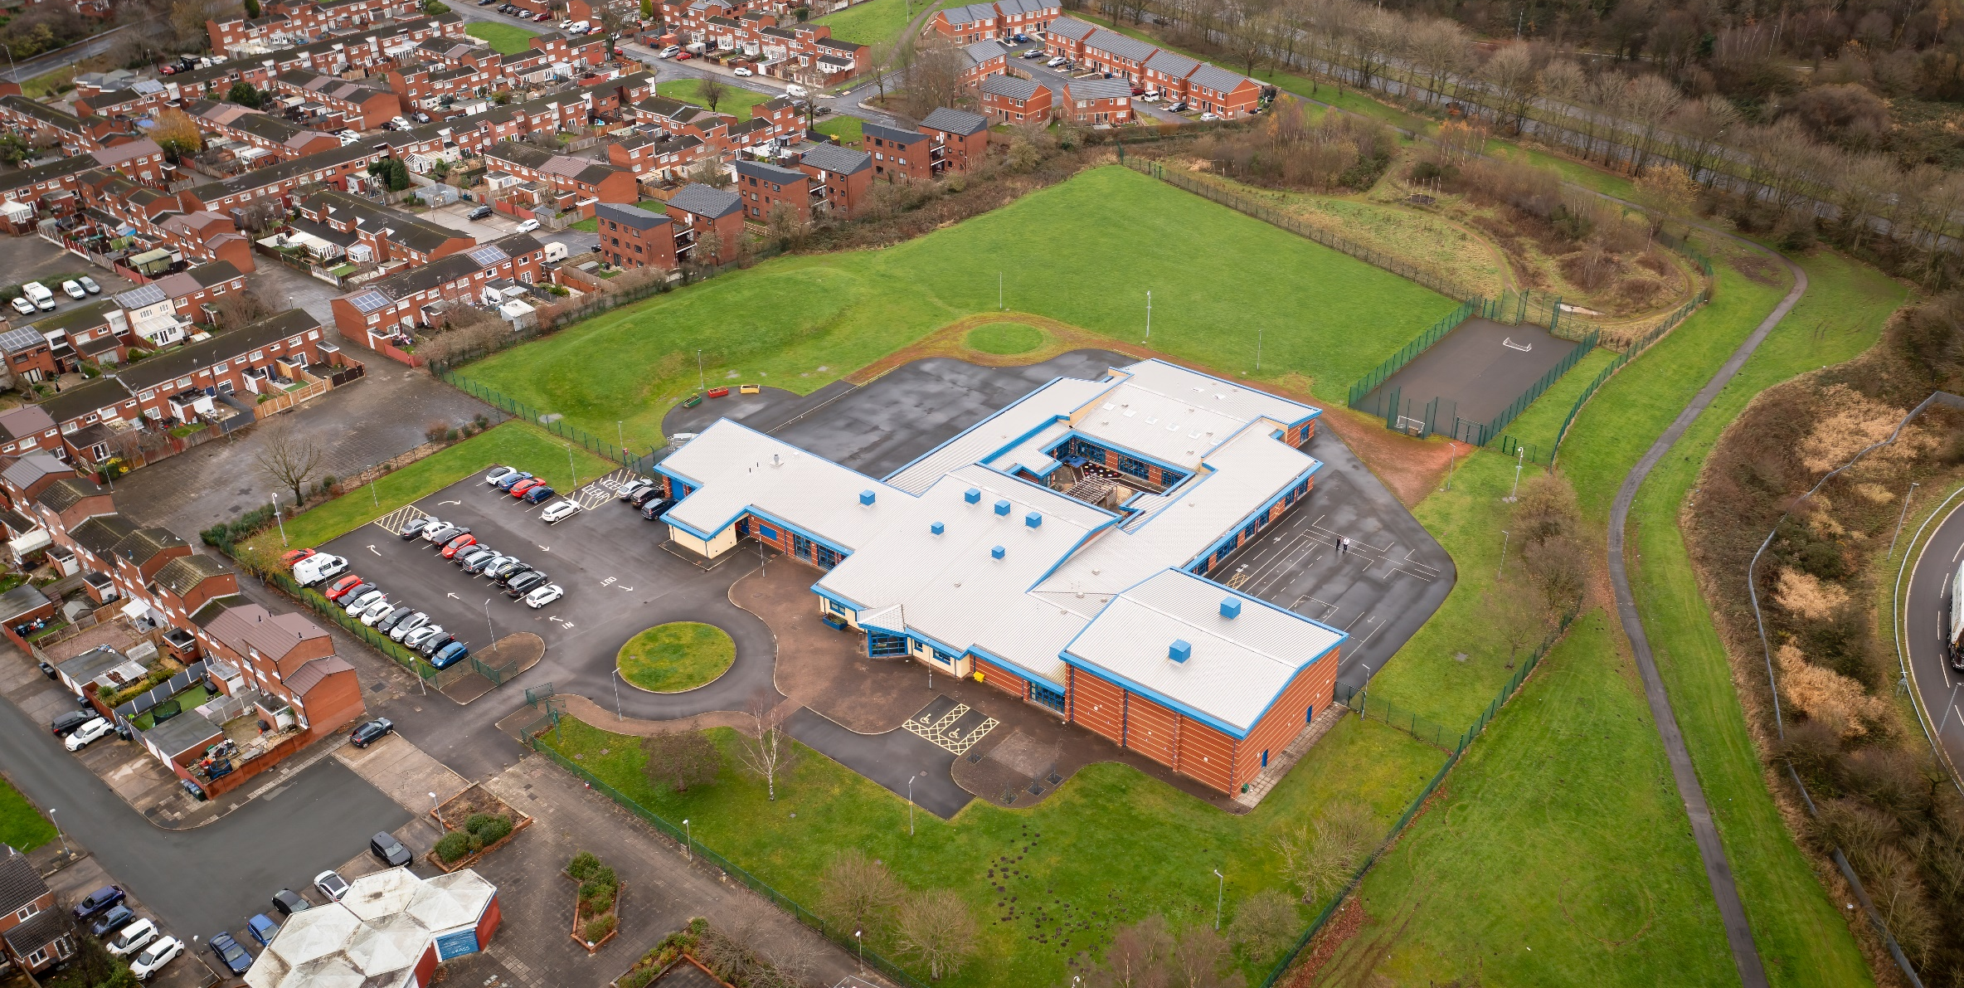

01 April 2023

Hope High School PSHE CURRICULUM POLICY

Hope High School
Carfield
Skelmersdale
Lancashire
WN8 9DP
Tel: 01695 721066
PSHE

Curriculum Purpose. “Learning for Life”
Our curriculum should allow all learners to have parity of opportunity, be life ready, harness their potential, promote creativity, have rich experiences, and broaden their life choices. ​
At Hope High School the Curriculum is ambitious and tailored to meet the needs of ALL pupils. Pupils study a broad and balanced range of subjects up to Functional Skills Level 1 & 2, BTEC Level 1 & 2, and GCSE. At Key Stage 3 pupils have the opportunity to follow a knowledge rich curriculum in a wide range of subjects. At Key Stage 4 pupils will follow a Core Curriculum and follow 2 pathways in an area of interest to them. This will allow them to flourish and develop their knowledge and skills in subjects that will provide opportunities for college courses and apprenticeships in the future.

Purpose
Our policy is intended to:
- Introduce the aims and objectives of the PSHE Curriculum.
- Outline the knowledge skills and understanding for all Key stages
- Explain the effective Teaching and Learning strategies utilised in PSHE
- Provide the formative and summative assessment strategies used within PSHE

Aims:
Through PSHE we want the pupils at Hope High School to:
- Overcome social and academic barriers.
- Promote tolerance and understanding of different faiths and beliefs.
- Understand that everyone is different.
- Stay safe in the community
- Become responsible members of society
- Become independent and have broad range of knowledge and strategies to stay safe physically and mentally.

Subject Content

Key Stage 3

At key stage 3, students build on the knowledge and understanding, skills, attributes and values they have acquired and developed during the primary phase. PSHE education acknowledges and addresses the changes that young people experience, beginning with transition to secondary school, the challenges of adolescence and their increasing independence. It teaches the knowledge and skills which will equip them for the opportunities and challenges of life. Students learn to manage diverse relationships, their online lives, and the increasing influence of peers and the media.
KS3 Learning opportunities in Health and Wellbeing
- Learn how we are all unique; that recognising and demonstrating personal strengths build self-confidence, self-esteem and good health and wellbeing.
- Learn to understand what can affect wellbeing and resilience (e.g. life changes, relationships, achievements and employment).
KS3 Learning opportunities in Relationships and Sex Education
- Learn about different types of relationships, including those within families, friendships, romantic or intimate relationships and the factors that can affect them.
- Learn that everyone has the choice to delay sex, or to enjoy intimacy without sex.
- Leran to recognise that sexual attraction and sexuality are diverse.
KS3 Learning opportunities in Living in the Wider World.
- Learn about different work roles and career pathways, including clarifying their own early aspirations.
- Learn the skills and attributes that employers value.

Key Stage 4 – PSHE

At key stage 4, students deepen knowledge and understanding, extend and rehearse skills, and further explore attitudes, values and attributes acquired during key stage 3. PSHE education reflects the fact that students are moving towards an independent role in adult life, taking on greater responsibility for themselves and others.
KS4 Learning opportunities in Health and Wellbeing
- how self-confidence self-esteem, and mental health are affected positively and negatively by internal and external influences and ways of managing this
- how different media portray idealised and artificial body shapes; how this influences body satisfaction and body image and how to critically appraise what they see and manage feelings about this
KS4 Learning opportunities in Relationships and Sex Education.
- the characteristics and benefits of strong, positive relationships, including mutual support, trust, respect and equality
- to respond appropriately to indicators of unhealthy relationships, including seeking help where necessary.
- to understand the potential impact of the portrayal of sex in pornography and other media, including on sexual attitudes, expectations and behaviours
KS4 Learning opportunities in Living in the Wider World
- to evaluate and further develop their study and employability skills.
- about the range of opportunities available to them for career progression, including in education, training and employment.

Teaching and Learning
Good quality teaching and learning is at the heart of improved life chances for the pupils at Hope High School. Our pupils benefit from consistency in their lives. Hope High has adopted the teaching and learning model of Rosenshine’s 10 principles of Instruction. These principles will be evident in classrooms daily.
In PSHE the principles are:
- Daily review. Lessons will begin with a review of learning from previous lessons. This is to support our pupils cognitive load.
- Present new material using small steps. Teacher demonstration is an integral part of the delivery of the subject. New concepts and skills will be introduced in small steps using live or video demonstration.
- Ask questions. A range of interactive questioning techniques will be used to check pupil understanding. Direct questioning, use of interactive whiteboards are just a few of the techniques used to check pupil understanding.
- Provide models. Example projects/visual aids will be provided to support pupil understanding.
- Guide Student practice. Teachers, and TA’s will be used to help and support pupils in lessons with an emphasis on encouraging pupil independence.
- Check for student understanding. Formative assessment techniques such as direct questioning of individual pupils and observation of skills and techniques will be used to check knowledge and understanding.
- Provide scaffolds for difficult tasks. Teachers, TA’, Differentiated work, visual aids and educational games provide scaffolds that can support our students in difficult tasks. An individual demonstration, support with a practical process or a verbal instruction can help pupils move forward with their learning.
- Weekly review, pupils will complete a plenary task every lesson that allows pupils to demonstrate learning. The following lesson will introduce a starter that reinforces learning from the previous lesson, and any misconceptions through recall activities.

Assessment

At Hope High we firmly believe that assessment should be used as a tool to help move pupil learning forward. The day to day, lesson by lesson, formative assessment that takes place with pupils will help them make progress. This will inform teachers of areas of mastery and support them in the development of scaffolding materials to help pupils who need that extra support to achieve mastery.
This formative assessment coupled with end of topic summative assessments will provide the teacher with a holistic overview of a pupil progress and inform the grade for termly reports that are sent to parents/carers.
Assessments are made clear to learners to develop their independence and evaluation of their work. This will inform future target setting. Self-evaluation is key in getting learners to understand what they can do well and what they need to improve on further.

Monitoring

The Head of School and leadership team will:
Monitor the subject through the Hope High self-evaluation schedule and monitoring schedule which are reviewed annually

Departmental leader will:
- Monitor learners work and quality of teaching and learning
- Review Curriculum Maps and Schemes of Work based on suitability of use
- Review and monitor risk assessments for practical lessons
- Analyse pupil performance data
- Attend link meetings

Links to other policies:
• Teaching and Learning
• Behaviour for Learning
• Monitoring
• Assessment for Learning
• Health and Safety
• Marking and Feedback
Date Approved:
Review date:
Signed subject Lead:
Signed Headteacher:

