**Pancakes**

|  |  |  |  |  |  |
| --- | --- | --- | --- | --- | --- |
| http://img.tesco.com/Groceries/pi/000/5000119004000/IDShot_225x225.jpg | http://photo.elsoar.com/wp-content/images/Two-eggs-Picture-A.jpg |  | http://4.bp.blogspot.com/_K01I4UHOXwg/TVK7R7XlCGI/AAAAAAAADJk/Dl1gb2DVvGo/s1600/IMG_2089.JPG | http://www.britishcornershop.co.uk/images/large/LE10126ULR.jpg | http://msw.usc.edu/wp-content/uploads/Sugar.jpg |
| **100g**  Plain flour | **2**  Eggs | **200ml**  Milk | Golden Syrup | Lemon Juice | Sugar |

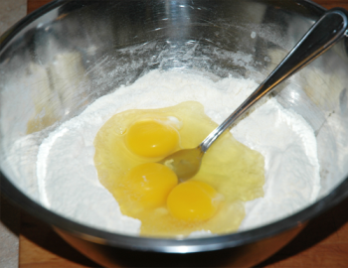

1. Whisk the flour and eggs together until smooth.

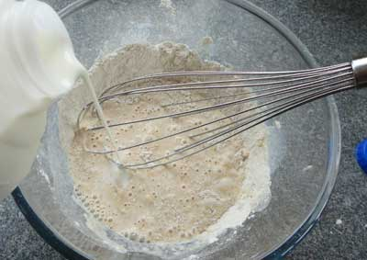

2. Gradually add the milk and carry on whisking.

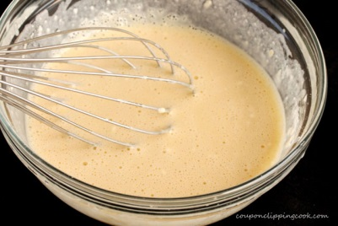

3. When the batter is lump-free, put some oil in a frying pan and put on a medium heat.

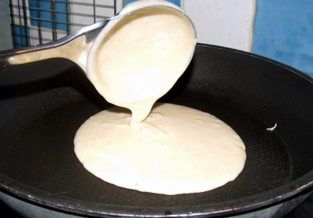

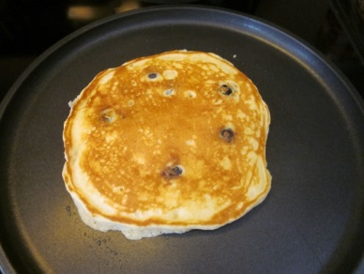4. Pour some batter into the pan and tilt to move the mix around the pan.

5. Cook for about 30 seconds until golden, then flip over and cook on the other side.

**Easiest-ever pancakes
**

6. Serve the pancakes with Golden Syrup, Sugar or Lemon juice.