Pizza Base
1 sachet of yeast | 150ml warm water | 1 level tablespoon margarine | 1 level teaspoon sugar | 225g  plain or bread flour | 1 level teaspoon salt

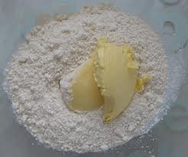
1. Add flour, sugar, salt and margarine into a mixing bowl.

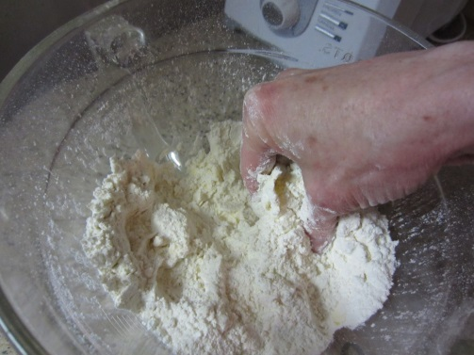

2. Mix together and add the dried yeast
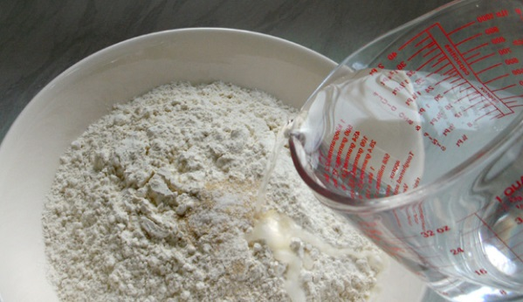

3. Add the water and stir together with a spoon.
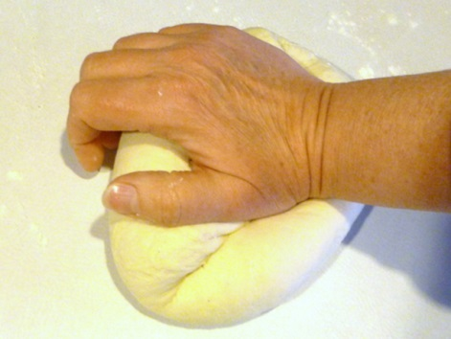
4. Put the dough onto a floured surface and knead.
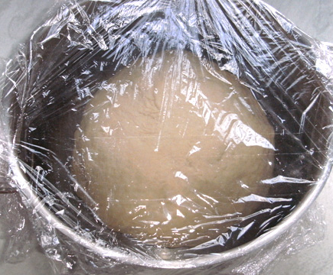

5. Cover the dough with cling film and leave for 30 minutes

