Making your Pizza

|  |  |  |  |
| --- | --- | --- | --- |
| http://www.limoncello.co.uk/acatalog/giagpureetube.jpg | http://www.feedyourkids.com/ham%20being%20chopped.jpg | http://www.freedigitalphotos.net/image/s_grated-cheese1.jpg | http://img.alibaba.com/photo/11332272/Potatoes_And_Onion_From_New_Zealand.jpg |
| Tomato puree | Ham chopped into squares | 50g grated cheese | ½ Onion chopped |

# 

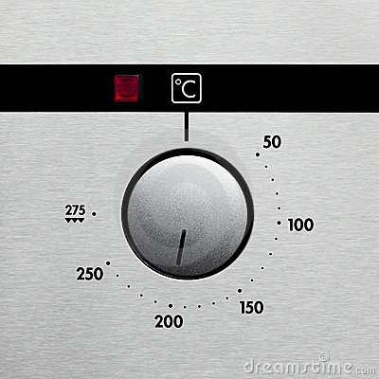1. Pre heat oven to 200ºC and grease a baking tray.

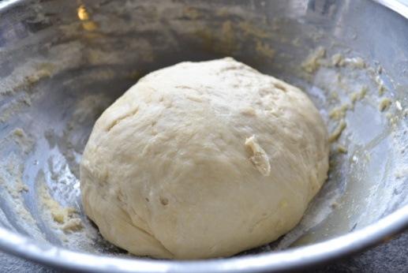

2. Take the dough out of the bowl and knead again for 3 minutes.

1. 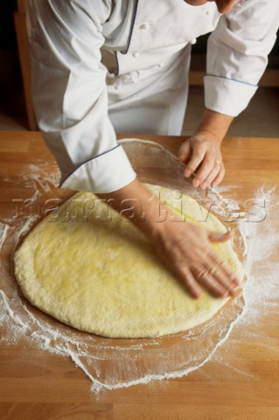
2. 3. Put the dough on a floured surface Make the dough into a pizza base and put on a floured surface.
3. 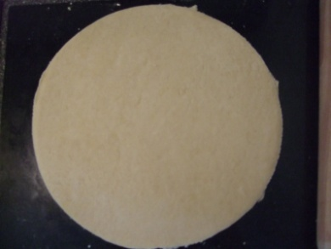
4. 4. Put the pizza base onto the baking tray.
5. 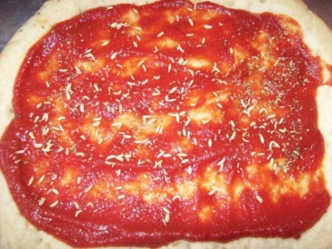
6. 5. Spread the tomato puree over the base of the pizza.

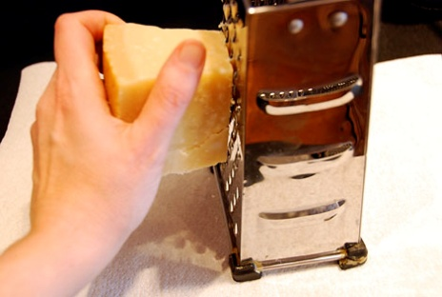

1. 6. Grate the cheese and sprinkle it on top of the pizza.

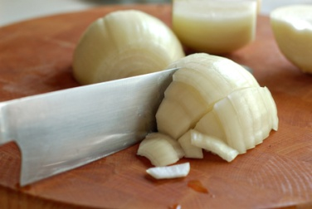

1. 7. Chop the onion, tomatoes and ham into squares.

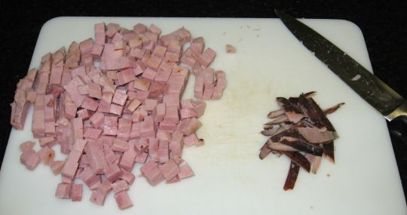

1. 8. Put the ham, tomatoes and onions on the pizza.

1. 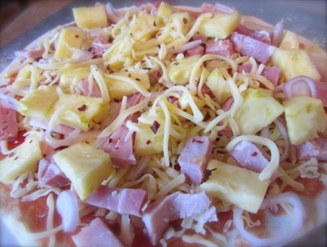9. Place in the oven and bake for 10-15 minutes, until golden brown.