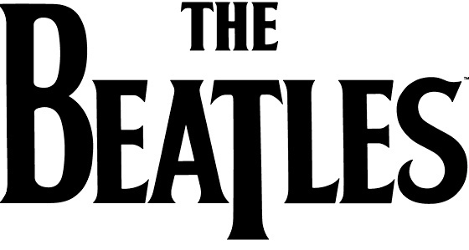
Pop Band Logos
A good logo is essential to selling records! Effective popular music bands and artists use a combination of memorable fonts, colours and images to help their logo become easily recognisable. Under each of the 12 “popular music logos” below, give one thing that you like or find effective and one thing you don’t like or could be improved.
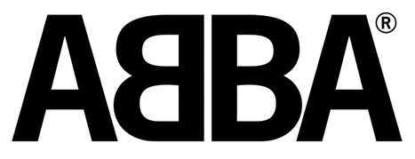 | 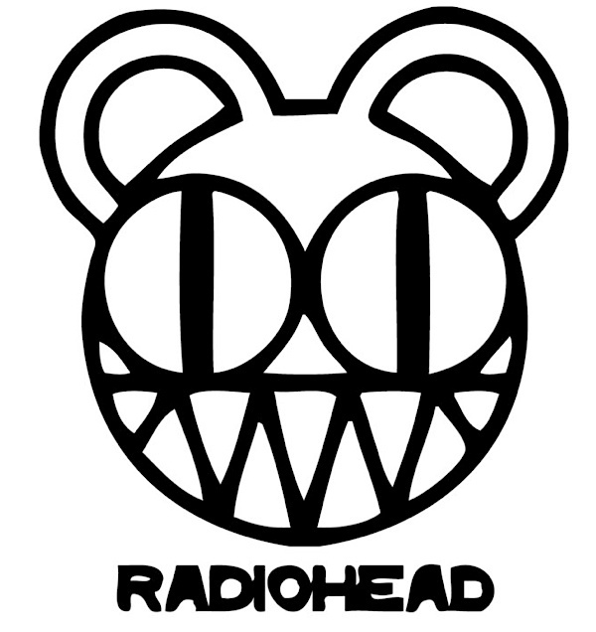
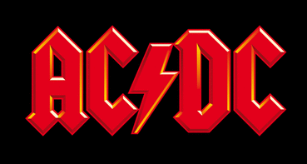 | 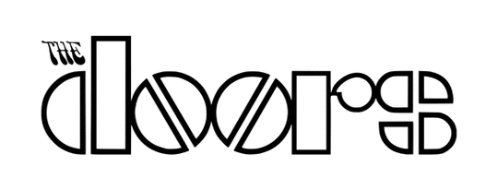 | 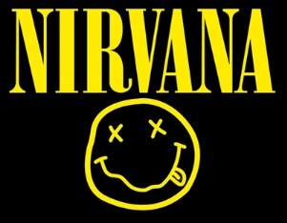
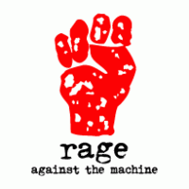 |  | 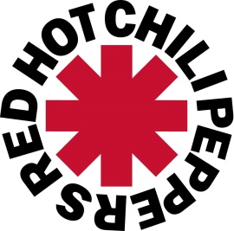

Design your own “pop band” logo in the box to the right –
using colour and any effective font or images that you
think would make your logo easily remembered by your
fans! Make up your own “pop band” name or use one of
the following to design a logo for: Campfire Conspiracy,
Lava Champ, Ouch Potato, Noah’s Ostrich, Under-Flare,
DJ Beatz, Death Disease, Mice Krispies, Fudgey.

