Sausage Rolls
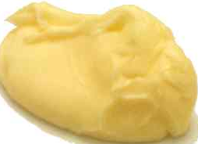 | 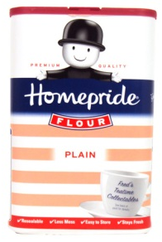 | 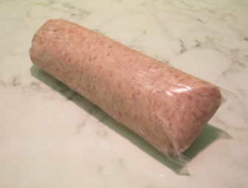 | 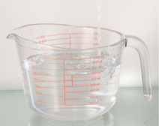
100g  Margarine | 200g  Plain flour | 100g  Sausage meat | 3 tbls  water

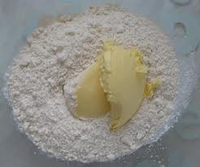
1. Add the margarine to a large bowl and sieve in the flour

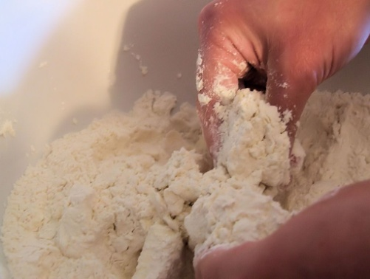

2. Gently rub the flour and margarine together with your hands.
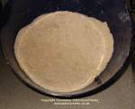
3. The mixture should end up as small crumbs.

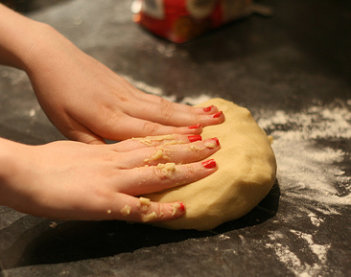

4. Add 3 tablespoons of water and mix with a spoon. Then use your hands to make it a ball.
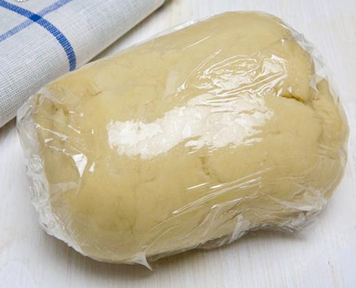
5. Wrap the mix in cling film and place in the fridge for 30 minutes to 'rest'.

6. Turn the oven on to 200C. Split the pastry into 3 parts. Put some flour on to the work surface.

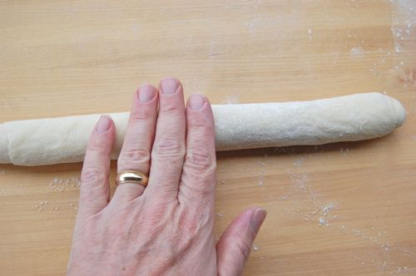
7. Roll each part of the pastry into tube shapes about 30cm long.

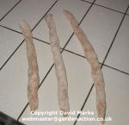

8. Split the sausage meat into 3 parts. Roll each part into a tube shape about 25cm long.

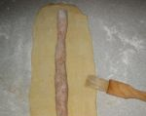
9. Place each strip of sausage on a strip of pastry. Brush milk around the edges of the pastry to help them stick.

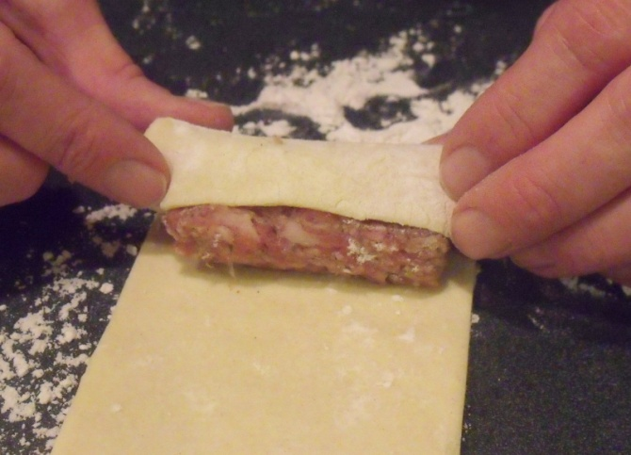
10. Roll the pastry round the sausage once. Roll the tube onto the seam.

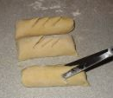

11. Cut the strips into 3 and cut small ridges in the top of each sausage roll.

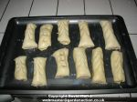

12. Grease a baking tray, place the sausage rolls on it and put it into the oven for 25 minutes.

