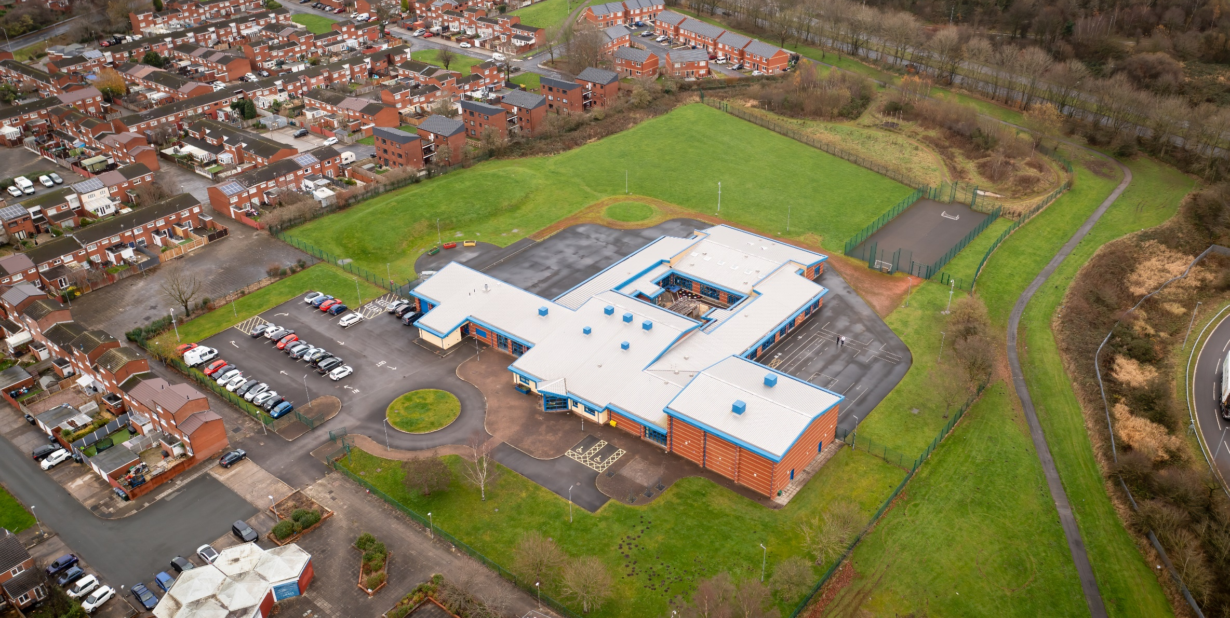

01 April 2023

Hope High School science CURRICULUM POLICY

Science Curriculum Policy
Hope High School
Carfield
Skelmersdale
Lancashire
WN8 9DP
Tel: 01695 721066

Curriculum Purpose. “Learning for Life”
Our curriculum should allow all learners to have parity of opportunity, be life ready, harness their potential, promote creativity, have rich experiences, and broaden their life choices. ​
At Hope High School the Curriculum is ambitious and tailored to meet the needs of ALL pupils. Pupils study a broad and balanced range of subjects up to Functional Skills Level 1 & 2, BTEC Level 1 & 2, and GCSE. At Key Stage 3 pupils have the opportunity to follow a knowledge rich curriculum in a wide range of subjects. At Key Stage 4 pupils will follow a Core Curriculum and follow 2 pathways in an area of interest to them. This will allow them to flourish and develop their knowledge and skills in subjects that will provide opportunities for college courses and apprenticeships in the future.

Purpose
Our policy is intended to:
- Introduce the aims and objectives of the Science Department.
- Outline the key components within science.
- Outline the knowledge skills and understanding for all Key stages.
- Explain the effective Teaching and Learning strategies utilised in science.
- Provide the formative and summative assessment strategies used within science.

Aims:
Through Science we want the pupils at Hope High School to be:
- Able to acquire a broad range of subject knowledge and link Science with disciplines such as technology, engineering, mathematics, computing and art.
- Resourceful, innovative, enterprising, and capable citizens, who utilise the skills they have learnt in school to life beyond school.
- Able to understand the impact of science in society on daily life and that of the wider world.
- Ready to access a career/college course in a science related area when they leave school.

Objectives:
To help meet the Aims of the Science Curriculum the department will:
- Provide opportunities for pupils to work with a range of scientific equipment, refine their skills and use them to solve scientific investigation.
- Help pupils understand that making a mistake is a positive learning experience. It is these experiences that will develop independence.
- Ensure through quality teaching that pupils receive a knowledge rich curriculum where they acquire the knowledge to support future applications to colleges and apprenticeships.
- Expose pupils to the latest developments in science that are used in industry and new technology which is in the process in making our planet a more habitable place.
- Ensure learners have access to a wide range of resources which are freely available and regularly maintained.
- Will work alongside other Targeted areas of the curriculum.
- Develop Schemes of Work that are tailored to the individual needs of the learners.
- Support pupils in achieving a ELC and GCSE qualifications that contributes to them progressing onto a college course of their choice.

Subject Content

Key Stage 3
A high-quality science education provides the foundations for understanding the world through the specific disciplines of biology, chemistry and physics. Science has changed our lives and is vital to the world’s future prosperity, and all pupils should be taught essential aspects of the knowledge, methods, processes and uses of science. Through building up a body of key foundational knowledge and concepts, pupils should be encouraged to recognise the power of rational explanation and develop a sense of excitement and curiosity about natural phenomena. They should be encouraged to understand how science can be used to explain what is occurring, predict how things will behave, and analyse causes.

Aims
The national curriculum for science aims to ensure that all pupils:
- develop scientific knowledge and conceptual understanding through the specific disciplines of biology, chemistry and physics.
- develop understanding of the nature, processes and methods of science through different types of science enquiries that help them to answer scientific questions about the world around them.
- are equipped with the scientific knowledge required to understand the uses and implications of science, today and for the future.
Scientific knowledge and conceptual understanding.
The programmes of study describe a sequence of knowledge and concepts. While it is important that pupils make progress, it is also vitally important that they develop secure understanding of each key block of knowledge and concepts to progress to the next stage. Insecure, superficial understanding will not allow genuine progression: pupils may struggle at key points of transition (such as between primary and secondary school), build up serious misconceptions, and/or have significant difficulties in understanding higher-order content.
Pupils should be able to describe associated processes and key characteristics in common language, but they should also be familiar with, and use, technical terminology accurately and precisely. They should build up an extended specialist vocabulary. They should also apply their mathematical knowledge to their understanding of science, including collecting, presenting and analysing data.
The social and economic implications of science are important but, generally, they are taught most appropriately within the wider school curriculum: teachers will wish to use different contexts to maximise their pupils’ engagement with and motivation to study science. The principal focus of science teaching in key stage 3 is to develop a deeper understanding of a range of scientific ideas in the subject disciplines of biology, chemistry and physics. Pupils should begin to see the connections between these subject areas and Science – key stage 3 3 become aware of some of the big ideas underpinning scientific knowledge and understanding. Examples of these big ideas are the links between structure and function in living organisms, the particulate model as the key to understanding the properties and interactions of matter in all its forms, and the resources and means of transfer of energy as key determinants of all of these interactions. They should be encouraged to relate scientific explanations to phenomena in the world around them and start to use modelling and abstract ideas to develop and evaluate explanations.
Pupils should understand that science is about working objectively, modifying explanations to take account of new evidence and ideas and subjecting results to peer review. Pupils should decide on the appropriate type of scientific enquiry to undertake to answer their own questions and develop a deeper understanding of factors to be taken into account when collecting, recording and processing data. They should evaluate their results and identify further questions arising from them. ‘Working scientifically’ is described separately at the beginning of the programme of study, but must always be taught through and clearly related to substantive science content in the programme of study. Teachers should feel free to choose examples that serve a variety of purposes, from showing how scientific ideas have developed historically to reflecting modern developments in science.
Pupils should develop their use of scientific vocabulary, including the use of scientific nomenclature and units and mathematical representations.
Spoken language.
The national curriculum for science reflects the importance of spoken language in pupils’ development across the whole curriculum – cognitively, socially and linguistically. The quality and variety of language that pupils hear and speak are key factors in developing their scientific vocabulary and articulating scientific concepts clearly and precisely. They must be assisted in making their thinking clear, both to themselves and others, and teachers should ensure that pupils build secure foundations by using discussion to probe and remedy their misconceptions.

AQA Entry Level Certificate (ELC) science
In this unit pupils will:
- Explore the skills and behaviours needed to meet a personal progression goal.
- Produce a progression plan to meet intended progression goal.

We recognise that GCSE Science is too demanding for some students. ELC Science gives students who are unlikely to achieve a grade in GCSE Science the opportunity to achieve a certificated award. It also prepares students for GCSE and can be used to monitor their progress.
The specification has been developed to meet the requirements of the Programme of Study for Key Stage 4 Science. It is used in conjunction with GCSE Combined Science specifications the scheme of work to facilitates co-teaching of the two different levels.
The component-based structure of the ELC provides students with the opportunity to work in short programmes. This gives the student a sense of achievement throughout the course and enables their progress to be monitored. It also enables teachers to gauge whether entry for both ELC Science and GCSE Combined Science is a reasonable expectation.
3.1 Component 1 – Biology: The human body
3.2 Component 2 – Biology: Environment, evolution and inheritance
3.3 Component 3 – Chemistry: Elements, mixtures and compounds
3.4 Component 4 – Chemistry: Chemistry in our world
3.5 Component 5 – Physics: Energy, forces and the structure of matter
3.6 Component 6 – Physics: Electricity, magnetism and waves

Key Stage 4

Teaching in the sciences in key stage 4 continues with the process of building upon and deepening scientific knowledge and the understanding of ideas developed in earlier key stages in the subject disciplines of biology, chemistry and physics. For some students, studying the sciences in key stage 4 provides the platform for more advanced studies, establishing the basis for a wide range of careers. For others, it will be their last formal study of subjects that provide the foundations for understanding the natural world and will enhance their lives in an increasingly technological society. Science is changing our lives and is vital to the world’s future prosperity, and all students should be taught essential aspects of the knowledge, methods, processes and uses of science. They should be helped to appreciate the achievements of science in showing how the complex and diverse phenomena of the natural world can be described in terms of a number of key ideas relating to the sciences which are inter-linked, and which are of universal application. These key ideas include:
• the use of conceptual models and theories to make sense of the observed diversity of natural phenomena
• the assumption that every effect has one or more cause
• that change is driven by interactions between different objects and systems • that many such interactions occur over a distance and over time
• that science progresses through a cycle of hypothesis, practical experimentation, observation, theory development and review
• that quantitative analysis is a central element both of many theories and of scientific methods of inquiry. The sciences should be taught in ways that ensure students have the knowledge to enable them to develop curiosity about the natural world, insight into working scientifically, and appreciation of the relevance of science to their everyday lives, so that students:
• develop scientific knowledge and conceptual understanding through the specific disciplines of biology, chemistry and physics;
• develop understanding of the nature, processes and methods of science, through different types of scientific enquiry that help them to answer scientific questions about the world around them;
• develop and learn to apply observational, practical, modelling, enquiry, problem-solving skills and mathematical skills, both in the laboratory, in the field and in other environments; Science – key stage 4 • develop their ability to evaluate claims based on science through critical analysis of the methodology, evidence and conclusions, both qualitatively and quantitatively.
Curricula at key stage 4 should comprise approximately equal proportions of biology, chemistry and physics. The relevant mathematical skills required are covered in the programme of study for mathematics and should be embedded in the science context. ‘Working scientifically’ is described separately at the beginning of the programme of study, but must always be taught through and clearly related to substantive science content in the programme of study. Teachers should feel free to choose examples that serve a variety of purposes, from showing how scientific ideas have developed historically to reflecting modern developments in science and informing students of the role of science in understanding the causes of and solutions to some of the challenges facing society. The scope and nature of their study should be broad, coherent, practical and rigorous, so that students are inspired and challenged by the subject and its achievements.

AQA GCSE Combined Science (Trilogy)
GCSE Combined Science (Trilogy) is a double GCSE. It builds on the Key Stage 3 and ELC curriculums and covers the National Curriculum Programme of Study for Science at Key Stage 4. It encourages students to explore, explain, theorise and model in science and develops a critical approach to scientific evidence. The exam board is AQA. More details including the full draft specification for GCSE Combined Science (Trilogy) is available at: http://www.aqa.org.uk/subjects/science/gcse
The GCSE Combined Science (Trilogy) is taught as 3 subjects:
Biology (Cell biology: Organisation: Infection and response: Bioenergetics: Homeostasis and response: Inheritance: variation and evolution: Ecology).
Chemistry (Atomic structure and the periodic table: Bonding, structure, and the properties of matter: Quantitative chemistry: Chemical changes: Energy changes: The rate and extent of chemical change: Organic chemistry; Chemical analysis: Chemistry of the atmosphere: Using resources)
Physics (Energy: Electricity: Particle model of matter: Atomic structure: Forces: Waves: Magnetism and electromagnetism)
The Combined Science GCSE is examined by six 1 hour 15 min written exams, each of which is worth 16.7%. There are two exams on each subject Biology, Chemistry and Physics. There are 21 required practicals that are delivered throughout the course. There will be questions relating to these practicals on the written exam papers.
GCSE Core Science gives pupils a good grounding in science. Success in Combined Science can lead to an almost limitless number of job opportunities. Highly qualified scientists are very much in demand and their skills are required in many jobs.

Teaching and Learning
Good quality teaching and learning is at the heart of improved life chances for the pupils at Hope High School. Our pupils benefit from consistency in their lives. Hope High has adopted the teaching and learning model of Rosenshein's 10 principles of Instruction. These principles will be evident in classrooms daily.
In Science the principles are:
- Daily review. Lessons will begin with a review of learning from previous lessons. This is to support our pupil's cognitive load. This could be a review of summative or disciplinary knowledge.
- Present new material using small steps. Teacher demonstration is an integral part of the delivery of the subject. New concepts and skills will be introduced in small steps using live or video demonstration.
- Ask questions. A range of interactive questioning techniques will be used to check pupil understanding. Direct questioning, use of interactive whiteboards and Near Pod are just a few of the techniques used to check pupil understanding.
- Provide models. Example projects/visual aids will be provided to support pupil understanding.
- Guide Student practice. Teachers, and TA’s will be used to help and support pupils in lessons with an emphasis on encouraging pupil independence.
- Check for student understanding. Formative assessment techniques such as direct questioning of individual pupils and observation of skills and techniques will be used to check knowledge and understanding.
- Obtain a high success rate. Pupils will be encouraged to practise techniques and skills until mastery is achieved in that area.
- Provide scaffolds for difficult tasks. In Science the support of the teacher, TA or Technician is one of the main scaffolds that can support our students in difficult tasks. An individual demonstration, support with a practical process or a verbal instruction can help pupils move forward with their learning in science.
- Independent practice. Opportunities will be provided to pupils for them to apply their knowledge, skills and understanding to different scientific investigations. Independence will be supported and encouraged in all our pupils in a safe and calm environment.
- Weekly and termly review. Summative and formative assessments will show progression in science. Pupils will revisit skills they used previously to help consolidate and support learning.

Assessment
At Hope High we firmly believe that assessment should be used as a tool to help move pupil learning forward. The day to day, lesson by lesson, formative assessment that takes place with pupils will help them make progress. This will inform teachers of areas of mastery and support them in the development of scaffolding materials to help pupils who need that extra support to achieve mastery.
This formative assessment coupled with end of topic summative assessments will provide the teacher with a holistic overview of a pupil progress and inform the grade for termly reports that are sent to parents/carers.
In science pupils are assessed on the knowledge and understanding they have on equipment and processes that they use in lessons. They are assessed on their ability to use this knowledge and practical ability in scientific investigations.
Assessments are made clear to learners to develop their independence and evaluation of their work. This will inform future target setting. Self-evaluation is key in getting learners to understand what they can do well and what they need to improve on further.

Monitoring

The Head of School and leadership team will:
Monitor the subject through the Hope High self-evaluation schedule and monitoring schedule which are reviewed annually

Departmental leader will:
- Monitor learners work and quality of teaching and learning
- Review Curriculum Maps and Schemes of Work based on suitability of use
- Review and monitor risk assessments for practical lessons
- Analyse pupil performance data
- Attend link meetings

Links to other policies:
• Teaching and Learning
• Behaviour for Learning
• Monitoring
• Assessment for Learning
• Health and Safety
• Marking and Feedback
Date Approved:
Review date:
Signed subject Lead:
Signed Headteacher:

