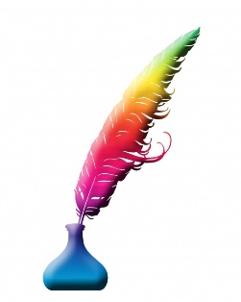
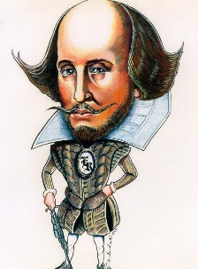
Cussing Shakespeare Style!
Shakespeare’s plays are full of wonderful insults. They don’t always make sense to us, and they didn’t always make sense to Shakespeare’s audiences either, but people always enjoyed characters cussing one another!

Have a go at inventing some insults with Shakespeare’s words.
Here’s what to do…
- Take a word from list A, and one from list B.
- Put them together to make an insult! For example…. “You red-tailed crookback!” or, “Thou art a scurvy ape!” And that’s it!
- On the next page, make ten insults and write out your best five in the speech bubbles.
A | B
Taffeta | Lump
Scurvy | Ape
Red-Tailed | Chuff
Threadbare | Bumble-bee
Mad-Headed | Punk
Fat | Juggler
False | Crookback
Deformed | Lord
Bloodsucker of | Caterpillars
Scolding | Sleeping Men

My Shakespearean Insults
1

2

3

4

5

6

7

8

9

10.

My top 5 Shakespearean Insults

