Simple shortbread
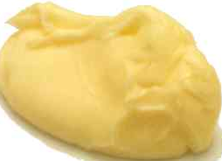 | 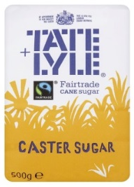 | 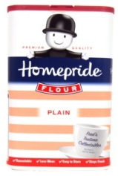
200g  margarine | 100g  caster sugar | 300g  plain flour
1. Heat oven to 190C
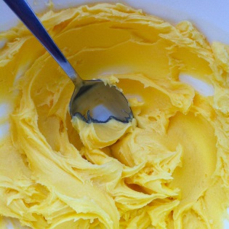

2. Beat the sugar and margarine together until smooth with a spoon
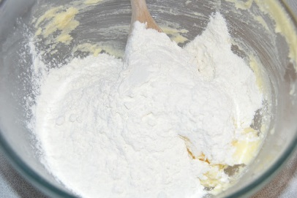

3. Stir in the flour with a spoon so the mixture looks like breadcrumbs.
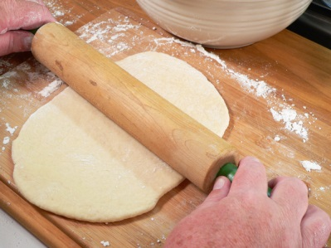
4. Put on the work surface and roll flat with a rolling pin.

5. Cut into circles with a cutter and put on a baking tray.

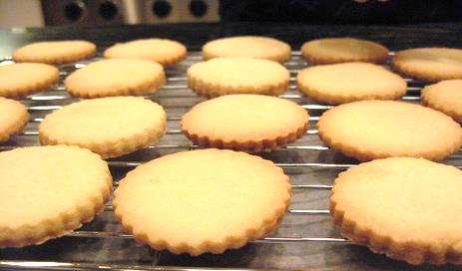
6. Bake in oven for 20 minutes and put on a rack to cool

