Home Learning Activities

This is a series of activities to help you to continue your career learning at home. They’ll help you to focus on what’s important when thinking about your future and include online and offline activities covering topics such as:

- Selling yourself - the importance of a personal brand
- Learning from the jobs people in your family have done
- Understanding the importance of technology and how it’s changing the workplace

Create yourself a plan to work through all of the activities. New activities will keep being added, so check back on the site regularly.

You’ll need to login with your Start account to do the activities. If you don’t have one, just register yourself when prompted. If you have any trouble registering or remembering your username or password, please contact:

Name: | School/ college contact name
Email: | School/ college contact email
Telephone: | School/ college contact telephone

Let’s Get Started!

Step 1: Go to www.startprofile.com/homelearning

Click the link above and you’ll be taken to the Home Learning Activities landing page.

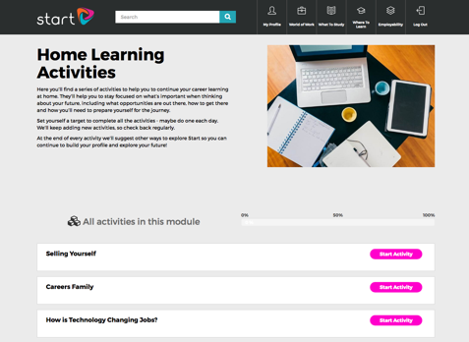
Step 2: Choose an Activity

We suggest working through the activities in order. When you’re ready, simply click ‘Start Activity’. You’ll need to login or register. If you don’t complete the activity there and then, that’s fine. Just come back later and click ‘Resume Activity’.

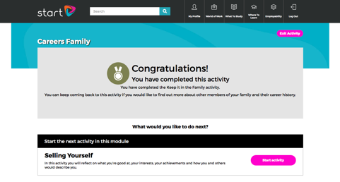
Step 3: Complete an Activity

When you complete an activity, you have two options. Either follow the on-screen instructions to go and explore other areas of Start, or begin the next activity.

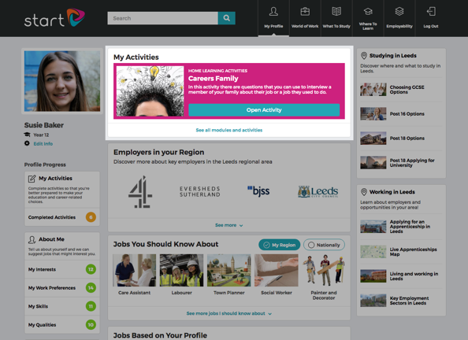
And finally, you can always find your next activity in the ‘My Activities’ box at the top of
your Profile page.

Good luck!

