Home Learning Activities
Website Information

To help you promote the Home Learning Activities on Start, you can use the information below on your school website.

Careers – Home Learning Activities for Students

Go to: www.startprofile.com/homelearning

During the school closure, we’d like all students to work through a set of activities to help you to continue your career learning at home.

These activities will help you to focus on what’s important when thinking about your future and they include online and offline activities covering topics such as:

- Selling yourself - the importance of a personal brand
- Learning from the jobs people in your family have done
- Understanding the importance of technology and how it’s changing the workplace

Create yourself a plan to work through all of the activities. New activities will keep being added, so check back on the site regularly.

You’ll need to login with your Start account to do the activities. If you don’t have one, just register yourself when prompted. If you have any trouble registering or remembering your username or password, please contact:

School contact name
School contact email address

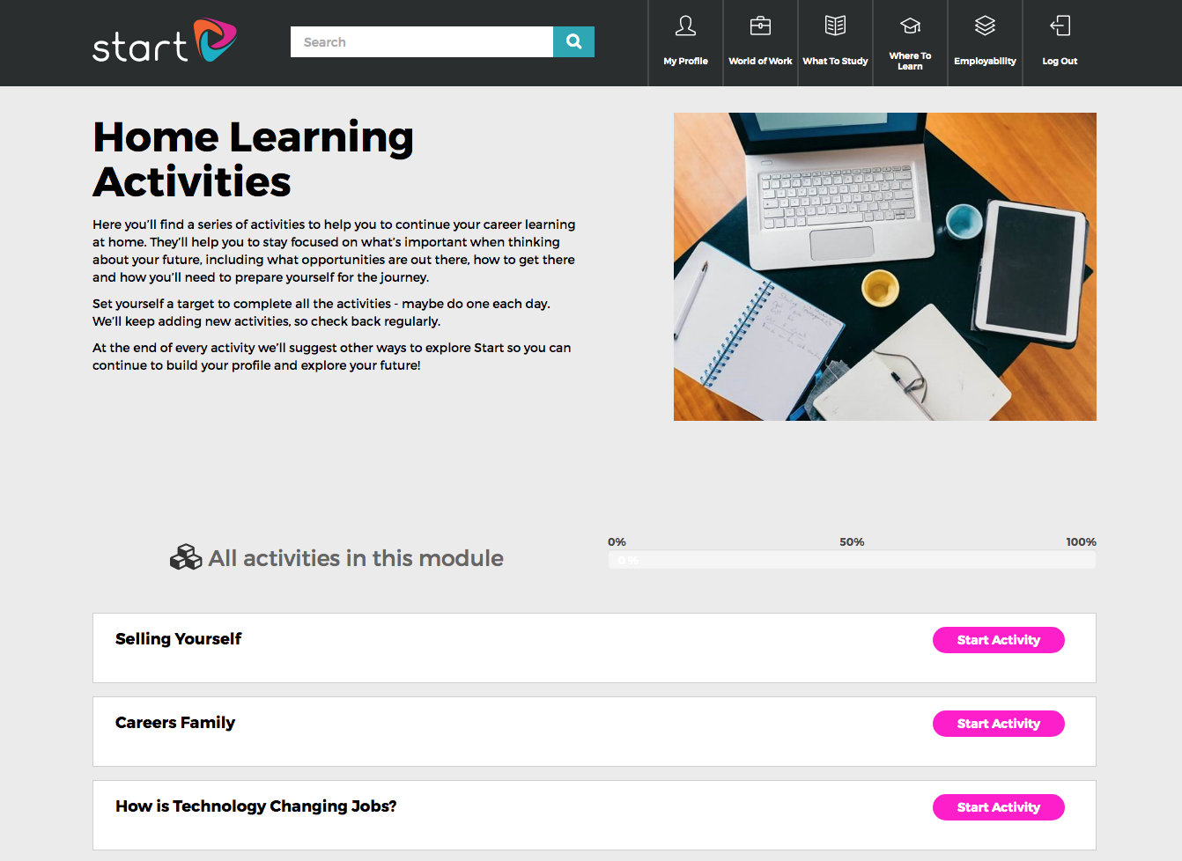
NB: This image has been included in the Zip file along with information to help you to communicate with Parents and a Worksheet to email to students or upload to your school VLE/ website.

