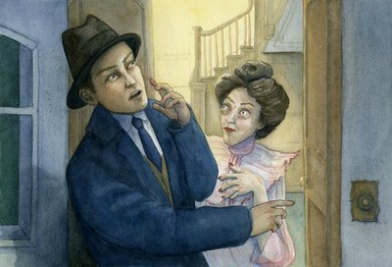
Task 5: Comparing the text to the short film.
DETECTIVE TIME: Similarities and Differences

Whilst watching the short film, make some notes about the similarities and differences between the text and the film. See how many you can find.
For example:
- Does Roald Dahl mention a conversation between Billy and the Vicar on the train?
- Are Billy’s clothes the same colour in the film as stated in the text?

Text | Film
Text | Film

