**Lasagne**: Making the cheese sauce

|  |  |  |  |  |
| --- | --- | --- | --- | --- |
| http://www.britishcornershop.co.uk/images/large/QWOP2151.jpg | **http://www.healingdaily.com/detoxification-diet/essential-fatty-acids-not-margarine.jpg** | http://www.freedigitalphotos.net/image/s_grated-cheese1.jpg | http://cache1.asset-cache.net/xt/56399750.jpg?v=1&g=fs1%7C0%7CPDI%7C99%7C750&s=1 | http://affordableorganics.com.au/wp-content/uploads/lasagne-sheets.jpg |
| **50g**  Plain Flour | **50g** Margarine | **150g** Cheese | **500ml** Milk | Lasagne sheets |

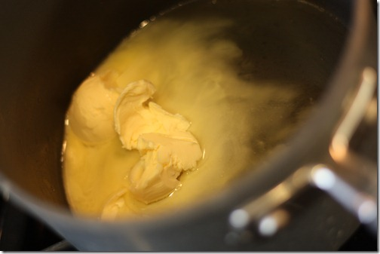

1. Melt the **margarine** in a

saucepan on a low heat

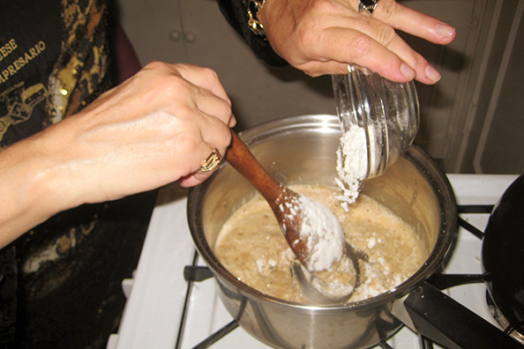

2. Stir in the **flour** and

cook for 1 min

[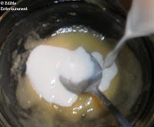](http://3.bp.blogspot.com/-BFkbMnUFGd4/Tt2Dj9TK3nI/AAAAAAAACPM/LjTwOyLmohU/s1600/Cheese+Sauce+(in+microwave)06.JPG)

3. Gradually stir in the **milk** to

make a thick white sauce.

[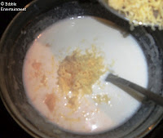](http://2.bp.blogspot.com/--6_QjjCpUT4/Tt2DkvToQbI/AAAAAAAACPQ/Xd-pwV9EHd0/s1600/Cheese+Sauce+(in+microwave)07.JPG)

4. Take from the heat and stir

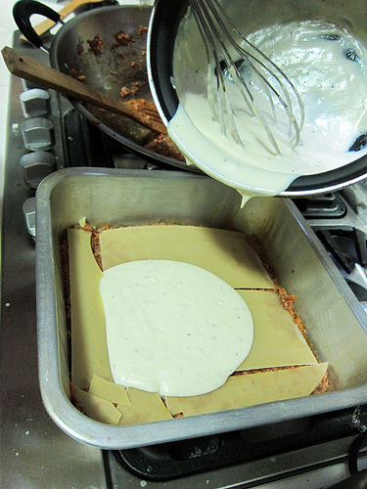in half of the **cheese**.

5. Pour the sauce on top of each lasagne sheet before adding another layer of the vegetables.Sprinkle top with cheese and put in the oven for 30 mins.

**Lasagne**: Preparing the ingredients

|  |  |  |  |  |
| --- | --- | --- | --- | --- |
| http://img.tesco.com/Groceries/pi/431/5000436541431/IDShot_225x225.jpg | http://www.camerican.com/files/8812/8556/9526/iStock_000012105607XSmall.jpg | http://cdn3.volusion.com/gyauc.spxen/v/vspfiles/photos/REDONION200-2.jpg?1342260329 | http://www.scobiesdirect.com/scobiesdirectimages/MainPictures/AS22058301.jpg | Image result for minced beef |
| **Tin of Tomatoes** | **Mushrooms** | **Onion** | **Foil Tray** | **Frozen mince** |



1. Heat oven to **180C**.

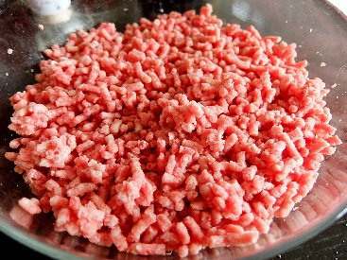

2. Fry the **mince** until all pinkness has gone, add **mushrooms** to the mince, chop **peppers** and **onions** and add to mix.

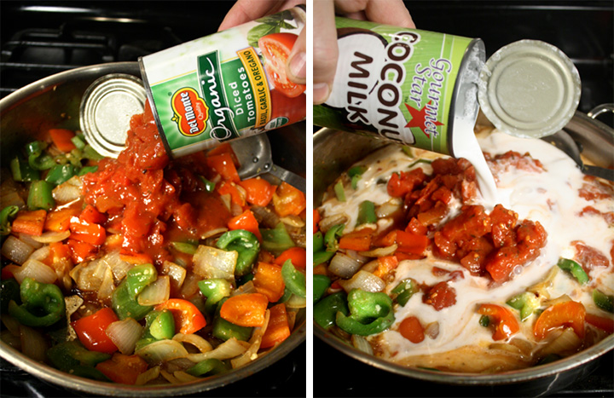

3. Add the **tin of tomatoes** to the pan and simmer for about **15 minutes**.

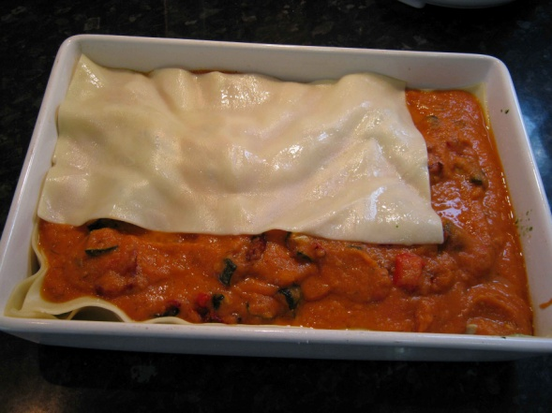4. Put a layer of cooked vegetables/mince in the bottom of the foil tray and cover with the lasagne sheets.

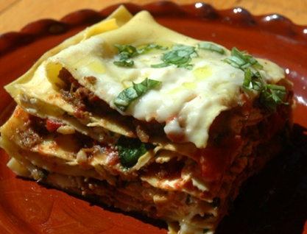

5. Pour the sauce on top of the lasagne sheet before adding another layer of the vegetables.(*Repeat until the tray is full)*