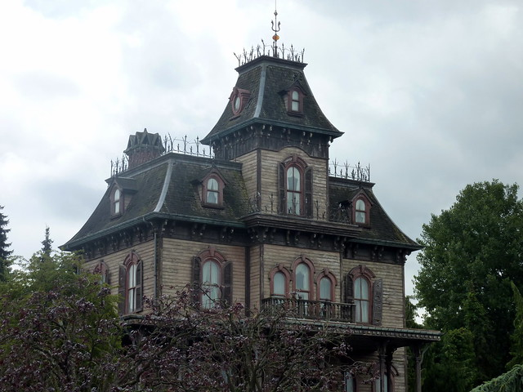

Where is the setting or place?

What can you see around this place?

What types of noises can you hear?

What does it feel like? Are the walls rough or smooth? Is the temperature hot or cold? Is it a mess or is it untouched?

How does this place make you feel? What effect does it have on your body? Does it make you sweat or does it make you shiver?

Write a sentence that includes alliteration and a simile about this place.

What are the smells surrounding this place?

What will you see here?