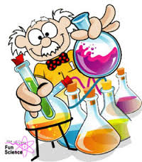
HOMEWORK BOOKLET
Chemistry
Elements, compounds, mixtures and separation techniques.

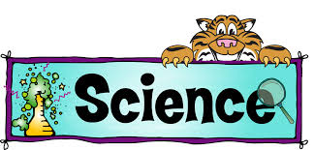

Name: _______________________________ Group: ______________
Date Given: ______________ Date to Hand in:___________

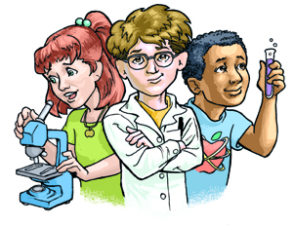

Parent / Guardian Comment:

WWW:

NS/Target for next piece of work:

Guidelines

Within this booklet there are a series of tasks.
Parents/Guardians are encouraged to support their children in the completion of this booklet. Each task should last for approximately 30 minutes.
Marks will be awarded for:
- High quality presentation of work
- Correct spelling, punctuation and grammar
- Use of key terms
Extra Help
Consider doing the following to help you find information to complete the tasks.
- Useful Website: http://www.bbc.co.uk/bitesize/science
- Use a search engine e.g. google.com or bing.com
- Use key words in your google searches e.g. ‘punnet squares’. Even better if you add ‘bitesize punnet squares’ which normally finds the exact page on bitesize which Is easily understandable with examples.
- Use ask.com to find a fact out.
- Avoid Wikipedia.

Homework tasks
The following section is levelled from task 1 to task 5. These tasks will get progressively more difficult but try them all and stretch your knowledge
Dispatches will be awarded for each section completed correctly and for excellent presentation. You may need to research the answers using books or the internet.

Task 1 Fill in the table by looking at a Periodic table. Remember the 1st letter is always a CAPITAL the 2nd letter is always small.
Symbols

Helium
Mg
Oxygen
C
Nitrogen
H
Pb
Au
Ag
Boron
Chlorine
Tin
Iodine
Fe
Zn
F
Cu
Calcium
Mercury
Uranium

Task 2 Use the Bite size website to help you.
http://www.bbc.co.uk/education/guides/zt2hpv4/revision
Compounds and elements
We can represent compounds and elements in the form of particle (atom) diagrams. Use the pictures below to answer the questions in this section.
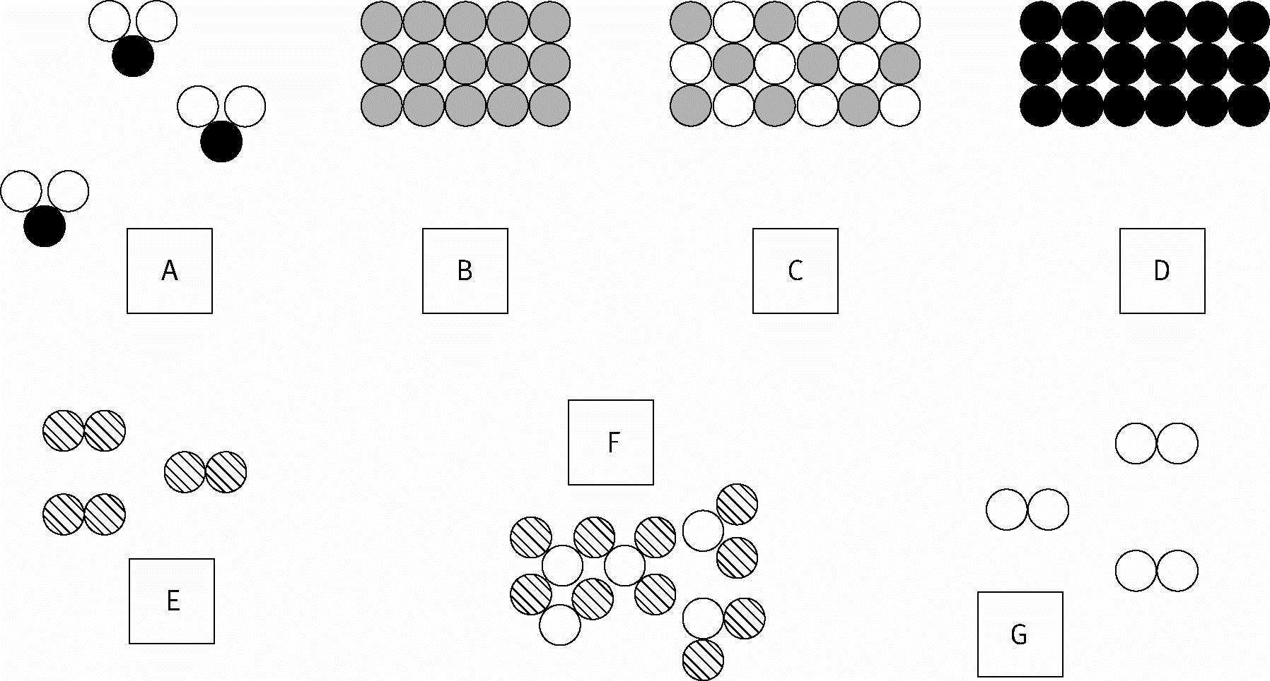
- Which diagrams show:

a elements? _________________________________________________________________
b compounds? _______________________________________________________________

This key shows which element the circles represent

- Which diagrams show:
a iron? _____________ b iron oxide? _____________
c oxygen? _____________ d carbon? _____________
e carbon dioxide? _____________ f hydrogen? _____________
g water (hydrogen oxide)? _____________

1 Which diagrams show:

a elements? _________________________________________________________________
b compounds? _______________________________________________________________

2 This key shows which element the circles represent.

Which diagrams show:

a iron? _____________ b iron oxide? _____________
c oxygen? _____________ d carbon? _____________
e carbon dioxide? _____________ f hydrogen? _____________
g water (hydrogen oxide)? _____________

Task 3 - Use the Bite size website to help you.
http://www.bbc.co.uk/education/guides/zypv34j/revision/5

Matching elements to make compounds

- Each of the following compounds is made from two or three elements. Next to each one write the names of the elements that make it up.
Select the elements from the list below (you will use some of them more than once).

Sodium chloride______________________________________________________________

Carbon monoxide_____________________________________________________________

Iron oxide_________________________________________________________________

Copper nitrate________________________________________________________________

Iron sulphate______________________________________________________________

Water __________________________________________________________________

Hydrochloric
acid_____________________________________________________________

Sulphuric
acid_____________________________________________________________

Sugar__________________________________________________________________

sodium, oxygen, carbon, iron, sulphur, hydrogen, chlorine, nitrogen

Task 4 - Use the Bite size website to help you.
http://www.bbc.co.uk/education/guides/zgvc4wx/revision
Separating mixtures
There is a crisis in Blackpool !!!!! The local chip shops have run out of salt.
Somebody said you can get salt from the sea.
The sea at Blackpool is very dirty, how can you separate clean salt from it and help the chip shops?
Here are some apparatus you MAY use.

Help: Here are some helpful tips.
You do not have to use every piece of equipment.
Think of things that will, and will not go, through filter paper.
What will this be able to separate in the mixture?
Think of what happens to water when you heat it. How might this be useful? What pieces of equipment could you use to do this?

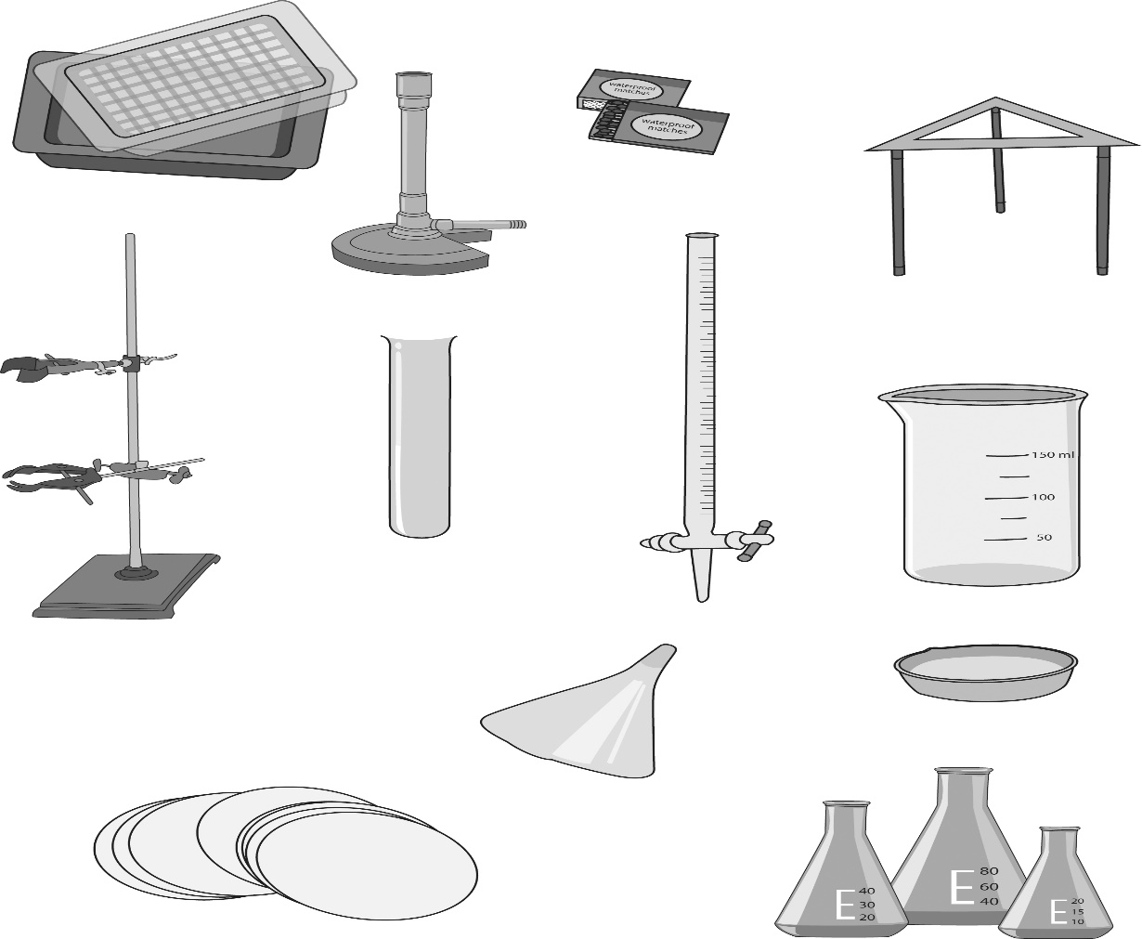

Task 4 continued
Diagram

Method _________________________________________________________________________________________________________________________________________________________________________________________________________________________________________________________________________________________________________________________________________________________________________________________________________________________________________________________________________________________________________________________________________________________________________________________________________________________________________________________________________________________________________________________________________________________________________________________________________________________________________________________________________________________________________________________________________________________________________________________________________________________________________________________________________________________________________________________________________________________________________________________________________________________________________________________________________________________________________________________________________________________________________________________________________________________________________________________________________________________________

Task 5 : Use the Bite size website to help you.
http://www.bbc.co.uk/education/guides/zqd2mp3/revision/2
Word Equations REACTANTS PRODUCTS
Below are five examples of chemical reactions. Write a word equation for each of them.
- Methane gas burns in oxygen to produce carbon dioxide and water.

_________________________________________

2) Lead nitrate reacts with potassium iodide. This produces a yellow solid called lead iodide and a clear liquid called potassium nitrate.

_________________________________________
3) In a car, when the engine is started enough energy is produced to combine nitrogen from the air with oxygen to form nitrogen dioxide.

_________________________________________
4) To make sodium chloride one possible method is to react hydrochloric acid and sodium hydroxide together. This reaction also produces water.

_________________________________________
5) Often during an experiment we find that a gas is produced. An example of this is the production of hydrogen when a metal, such as magnesium, reacts with an acid, such as hydrochloric acid. In this reaction magnesium chloride and hydrogen will be produced.

________________________________________

FUN Task Use your Periodic table in your PLANNER to find the symbols for the groups of elements below. Each group should spell a different cartoon character.
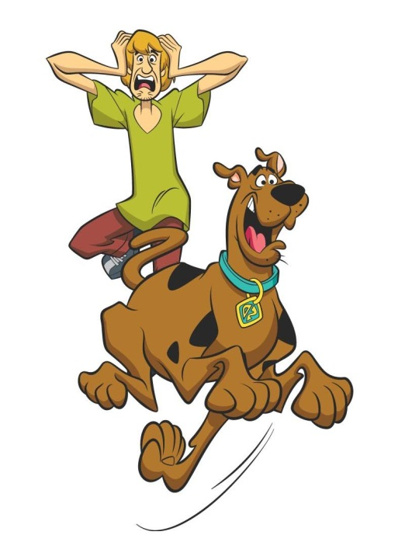
Example : Tungsten, oxygen, oxygen, dysprosium W O O Dy
W O O Dy
Phosphorus, iodine, nitrogen, nobelium, carbon, hydrogen, iodine, oxygen ______________

Rhenium, platinum, argon ___________

Sulphur, hydrogen, rhenium, potassium ______________

Argon, iodine, aluminium _____________

Tin, oxygen, oxygen, phosphorus, yetrium ________________

Carbon, hydrogen, iodine, phosphorus __________________

Flourine, lithium, potassium _________________

Samarium, iodine, thorium, erbium, sulphur ____________

Sulphur, cobalt, oxygen, boron, yetrium _______________

Boron, aluminium, oxygen, oxygen _______________

Sulphur, lithium, nitrogen, potassium, yetrium ______________

Aluminium, iodine, cerium ________________

Oxygen, scandium, argon ___________

Polonium, calcium, hydrogen, oxygen, nitrogen, tantalum, sulphur ______________

Phosphorus, iodine, potassium, actinium, hydrogen, uranium _____________

Scandium, radium, technetium, hydrogen, yetrium _____________

