‘Learning for Life’

Teaching and Learning Policy 2023-2024
Contents
1 Policy Overview 2
1.1 Policy Details 2
1.2 Record of Policy Amendments 2
1.3 Monitoring and Evaluation of the Policy 2
1.4 Related School Policies and Documents 3
1.5 Equality And Diversity Statement 3
1.6 Policy References 3
1.7 Policy Aims (Outline) 3
1.8 Policy Link to School Vision, Mission and Aims 3
1.9 Abbreviations Used in Policy 4
2 Introduction 5
3 School values and aims 5
3.1 The school will: 5
3.2 The school aims to enable pupils to: 5
3.3 This Policy reflects our high expectations of all staff and children who work in our school: 5
4 Equal opportunities 6
5 Teaching 6
6 The Learning Environment 6
7 Classrooms: 7
7.1 Working Walls 7
8 Celebration displays 7
9 The Curriculum 7
10 Differentiation 8
11 Assessment 8
12 Types of assessment 8
12.1 Formative Assessment (Assessment for Learning) 8
12.2 Summative Assessments 8
12.3 Assessment for Learning 9
12.3.1 Planning 9
12.3.2 During Lesson 9
13 Intervention 11
14 Teaching Assistants 11

Policy Overview

Policy Details
Policy Title: | Teaching and Learning Policy 2023-2024
Target Audience: | Pupils, Parents Teachers
Policy Review Lead: | Leanne Fletcher
Personnel Involved in the  Review of this Policy: | Executive Headteacher, Head of School and Senior Leadership Team
This policy was presented to  the Board of Governors on: | 14 October 2023
This policy was ratified by the Board of Governors on: | 14 October 2023
This policy is effective from: | 01 September 2023
Frequency of Policy Review: | This policy should be reviewed annually
This policy will be reviewed: | On or before September 2024
Executive Headteacher: | Helen Dunbavin
Head of School: | Leanne Fletcher
Chair of Board of Governors | Matthew Walker

Record of Policy Amendments
The following table outlines any significant changes/amendments made to this policy since it was last ratified by the Board of Governors.
DATE OF REVIEW OR  AMENDMENT | SUMMARY OF CHANGES / AMENDMENTS TO POLICY | AMENDED BY
02/2024 | Rebranded formating and Executive Headteacher amends | AnAr

Monitoring and Evaluation of the Policy
It is the responsibility of the Board of Governors, in liaison with the Headteacher, to monitor the effectiveness of this policy. This policy will be reviewed annually but may be updated sooner in response to:
- relevant circulars and publications provided by the Department of Education (DFE) / Education Authority (LEA);
- a recommendation by Ofsted
- learning which emerges from issues/situations which arise; or
- a review of other related school policies that impact this policy.
To ensure that this policy is relevant and up to date, comments and suggestions for additions or amendments are sought from users of this document. To contribute towards the process of review, please contact the Policy Review Lead listed with this document or an SLT member.

Related School Policies and Documents
This policy is related to the following school policies and documents:
Document/Policy name
Behaviour Policy
Special Educational Needs Policy
Marking and Assessment Guidance
Assertive Mentoring Policy

Equality And Diversity Statement
Hope High School is committed to the fair treatment of all in line with the Equality Act 2010. An equality impact assessment has been completed on this policy to ensure that it can be implemented consistently regardless of any protected characteristics, and all will be treated with dignity and respect.

Policy References
This policy has been developed with reference to the following relevant sources and publications:
Document/Policy name
Equality Act 2010
Equality Act 2010 (Disability) Regulations 2010
Non-Maintained Special Schools Regulations 2015
DfE (2015) ‘Special educational needs and disability code of practice: 0 to 25 years’

Policy Aims (Outline)
This policy and its associated procedures aim to:
We believe that everyone at Hope High School is valued equally and must be treated with dignity and respect. We have high aspirations and expectations for all involved within the learning community, striving for an outstanding learning experience for its pupils. The school celebrates and supports individual talents and provides exceptional care, guidance and support. The school is founded on strong relationships, nurture and seeing everyday as a new day. The school is always innovating and finding new ways to engage and inspire our learners. See section 3 for full values and aims.

Policy Link to School Vision, Mission and Aims
This policy reflects the Hope High Schools vision for Inspiring Excellence, Fulfilling Potential and the school’s mission to provide a stimulating, challenging and caring environment that allows each individual to develop to his/her full potential.
The policy relates directly to the following school aims whereby we:
- challenge and stimulate the minds of pupils through excellent teaching, diverse learning opportunities, and a rich, balanced curriculum;
- provide pupils with every opportunity to flourish academically and to develop their skills, gifts and talents as individuals;
- tailor personalised learning and specialist support to meet the needs of pupils so that they reach their full potential;
- offer an extensive extra-curricular programme that enriches and extends the curriculum, encouraging pupils to explore and develop their personal interests;
- develop wide ranging opportunities for pupil leadership to enable pupils to develop the skills, knowledge and qualities they will need to be leaders in the future;
- support and encourage pupils to play an active and responsible role in society, to develop as global citizens and to use their talents for the service of others; and
- work in close partnership with parents/guardians and members of the wider community to provide the best possible education for all pupils.

Abbreviations Used in Policy
The following abbreviations are used throughout this policy:
DFE | Department for Education
LEA | Lancashire Education Authority
EHT/HT | Executive Headteacher/Headteacher
HOS | Head of School
DHT | Deputy Headteacher
AHT | Assistant Headteacher
SENCO | Special Education Needs Coordinator
DSL | Designated Safeguarding Lead

Introduction
Our curriculum should allow all learners to have parity of opportunity, be life ready, harness their potential, promote creativity, have rich experiences, and broaden their life choices.
Teaching is the process that all staff undertake to help the pupils develop skills, strategies and understanding which will enable them to learn new skills and problem solve. It lays the foundation for our approach to teaching the curriculum and should be read in conjunction with all:
- Special Educational Needs Policy
- Assertive Mentoring Policy
- Marking and Assessment Guidance. (Currently under review)
- School Behaviour Policy

School values and aims
We believe that everyone at Hope High School is valued equally and must be treated with dignity and respect. We have high aspirations and expectations for all involved within the learning community, striving for an outstanding learning experience for its pupils. The school celebrates and supports individual talents and provides exceptional care, guidance and support. The school is founded on strong relationships, nurture and seeing everyday as a new day. The school is always innovating and finding new ways to engage and inspire our learners.

The school will:
- Deliver a broad, balanced and differentiated curriculum which is pupil centred and responsive to individual needs.
- Provide a wide range of relevant and appropriate learning opportunities and experiences.
- Create a high-quality learning and teaching environment which is stimulating and safe.
- Promote pupils’ emotional health and well-being.
- Ensure continuity and progression within the school and prepare pupils for the next phase of life, including life-long learning.
- Work in partnership with pupils, parents, carers, and other professionals, voluntary agencies and the local community.

The school aims to enable pupils to:
- Enjoy learning.
- Make progress and become as independent as possible.
- Build self-esteem and confidence.
- Develop effective means of communication.
- Form positive healthy relationships with others.
- Become an active citizen.

This Policy reflects our high expectations of all staff and children who work in our school:
- To ensure that high quality learning takes place in every lesson
- To ensure high levels of expectation and standards of pupil achievement
- To ensure consistency within the school
- To embed very good practise across the school
- To provide a focus for monitoring learning and classroom practise
- To provide new staff with a clear understanding of the school’s expectations

Equal opportunities
- The school will ensure that all pupils have access to all aspects of educational life at the school, regardless of SEND. The school will provide reasonable adjustments wherever necessary to ensure that pupils with particular support needs can access the same opportunities as pupils without those needs.
- The school will ensure that all teaching is made accessible for all pupils, and appropriate additional learning resources will be provided to ensure this wherever this is necessary, e.g. support from TAs or sensory materials.
- Teaching staff will ensure that pupils’ needs are assessed and reviewed where necessary in response to their behaviour, progress and attainment, and that these needs are catered for wherever reasonably practicable.
- Staff will maintain high expectations of all pupils and will be expected to provide an environment where all pupils feel included, supported and challenged, and can achieve their best outcomes.
- The school will implement a whole-school approach to the promotion of the fundamental British values, and will ensure that these values are taught throughout all relevant areas of the curriculum.

Teaching
- Staff have secure subject knowledge and understanding, when support is required, staff seek advice from one-another, SLT or colleagues within the subject network meetings and from subject experts within school.
- Staff plan appropriately for all groups of children and access appropriate resources. All subject leads should have a “Curriculum Policy”, “Long Term Plan” and “Medium Term Plan” for their subject areas.
- Every lesson has clear learning objectives that is explained to the pupils.
- All lessons demonstrate good assessment for learning practise and supports pupil progression in lessons.
- Activities in lessons are differentiated/scaffolded to enable pupils to explore, develop and practise new skills
- Staff cater for a range of differing learning styles ensuring pupil understanding and participate.
- Staff are dynamic and adapt teaching to suit the needs of all learners.
- Staff cater for cultural diversity and ensure learning activities and environments reflect life in modern Britain
- Staff provide appropriate resources which supports learning outcomes and are differentiated/scaffolded to challenge the more able
- Time targets are set within lessons to ensure pace is maintained
- Staff have high expectation with regards to the presentation, quality and quantity of work
- Teachers clearly communicate and direct TA’s on how they are to support teaching and learning. TA’s are fully involved in the lesson to support learning
- Staff encourage independent enquiry and learning

The Learning Environment
The physical environment should support and enhance learning and reflect the ethos of the school. It is fundamental to the learning process and enables children to enjoy, achieve and develop self-esteem, confidence and a sense of belonging to the school community. Pupils should be encouraged to take care of, and have pride in, the school environment.
They should also be encouraged to take responsibility for creating and maintaining the school environment. Pupil work should be displayed in classrooms and outstanding work should be displayed weekly on the “Proud Friday” board.

Classrooms:
- The school rules should be clearly displayed in each room
- Procedures for fire drills and first aid staff clearly displayed
- Pupils' individual behaviour targets displayed and updated termly or when applicable.
- Pupils individual subject targets should be displayed in books and be reflective of the summative and formative assessments that have taken place throughout the year.
- Pupil's individual books and progress files to be kept in each tutor room at the end of academic year
- Teaching staff and TA’s are responsible for organising work for both the working wall displays and celebration displays and handing this over to TAs to put up.

Working Walls
Working walls are a learning resource which develops along with the subject topic, they provide both a resource to aid pupils learning and a record of progress throughout the topic.
- Each classroom should have 3 working wall displays for each of the core curriculum subject (Maths, English and Science)
- Working walls should be updated regularly
- Pupils should take ownership of working walls
- Staff should refer to working walls regularly and encourage pupils to use them as a resource
- Teaching staff and TA’s should provide work for the “Proud Friday” board so outstanding work can be displayed for the whole school to see on a weekly basis.

Celebration displays
Celebration displays should be of a high standard and all children should have the opportunity for their work to be displayed in shared areas of the school, including the headteacher’s office wall. They should be maintained and updated termly, with pupils' names, keywords and titles clearly labelled.

The Curriculum
Our curriculum should allow all learners to have parity of opportunity, be life ready, harness their potential, promote creativity, have rich experiences, and broaden their life choices.
The whole curriculum should enable learners to:
- Acquire knowledge, skills and understanding
- Develop practical abilities and the motivation to use them
- Develop a sense of self-esteem and mutual respect and understand the right to social and cultural differences amongst others
- Develop qualities of mind, body, feeling and imagination
- Extend the effective use of language
- Develop the effective use of number
- Acquire an understanding of the social, economic and political nature of society
- Develop skills to help pupils to prepare for life in modern Britain
- Enable pupils to aspire to their full potential for lives at home, work and as positive members of society

Differentiation
Differentiation takes into account all the needs of the learners and ensures that all pupils are set challenging goals to help them make expected progress. Lesson planning should take into account the variety of pupils’ abilities and will aim to maximise progress for all. Differentiation can take many forms and a combination of these will encourage sustained pupil progress:
- Providing a range of alternative tasks
- Deliberately grouping students according to tasks (jigsaw, mixed ability, peer tasks challenging activities)
- Assign roles to individual pupils (leader, scribe, spokesperson, questioner)
- Effective use of TA
- Varying degrees of challenge with open questioning
- Adapting resources to support or extend pupils
- Adapting resources or activities to match differing learning styles (visual, auditory or kinaesthetic)

Assessment
Details of assessment through the curriculum are available in the assessment guidance document.
- The consistent use of assessment for learning throughout both the Core and Enhanced Curriculum should:
- Enable children to demonstrate what they know, understand and can do
- Be used to ensure children are aware of what stage and sub-stage they are working at and what they must do to move on
- Be a vehicle for rapid and sustained progress
- Provide positive reinforcement and celebrate achievements
- Provides useful feedback and enables pupils to recognise what needs to be done to improve their work
- Provides useful information to aid teachers to plan differentiated work that addresses any gaps in learning or understanding
- Inform target setting process
- Provide information for whole school progress tracking and evaluation

Types of assessment

Formative Assessment (Assessment for Learning)
These involve both the pupil and the teacher in identifying areas for development so that next steps can be planned to meet individual learning needs and also to celebrate successes that have been achieved. When embedded in our daily classroom practises formative assessment provides information that can inform planning for teaching and learning that is matched to suit individual needs.

Summative Assessments
These involve making a judgement of pupil attainment at a point in time in order to assess their performance against particular standards. Children are assessed formally, termly in all subjects with Maths and English using the Assertive Mentoring Policy and resources.
Assessments are moderated by SLT and pupil progress is evaluated termly during full staff progress meetings. After each termly assessment period progress meetings are held to evaluate pupil progress and identify any pupils who; have excelled through intervention and can now engage in class independent, or those who require additional support. The assertive mentoring files and assessment data provide an instant visual representation that all, including children, understand. It clearly indicates where a child is doing well, where care needs to be taken and where additional support is required.
Following assessment weeks and the progress meetings each pupil will meet with their designated assertive mentor to discuss their achievements and areas for development. The primary focus of mentoring sessions is to target and support learning and drive achievement.

Assessment for Learning

Planning
- Use assessments from previous lesson, including marking and tracking. Link to success criteria, are pupils secure or require reinforcement?
- Generate open questions, differentiate to make accessible for both more able and scaffold those requiring support.

During Lesson
- Use the school’s PowerPoint template for consistency of approach
- Provide opportunity to address marking and corrections
- Share and explore the lesson objectives/the big question
- Introduce success criteria – What would make this a good piece of work? How will pupils know they have been successful?
- Model subject specific language (Vocab project including word of the week and word bank), behaviour or activity
- Ensure activities are engaging and varied
- Use extension activities to encourage independent enquiry and self-assessment
- Use visual signs, thumbs up, smiley faces
- Use talking partners
- Follow Rosenshine’s Principles of Instruction (See following page for poster)
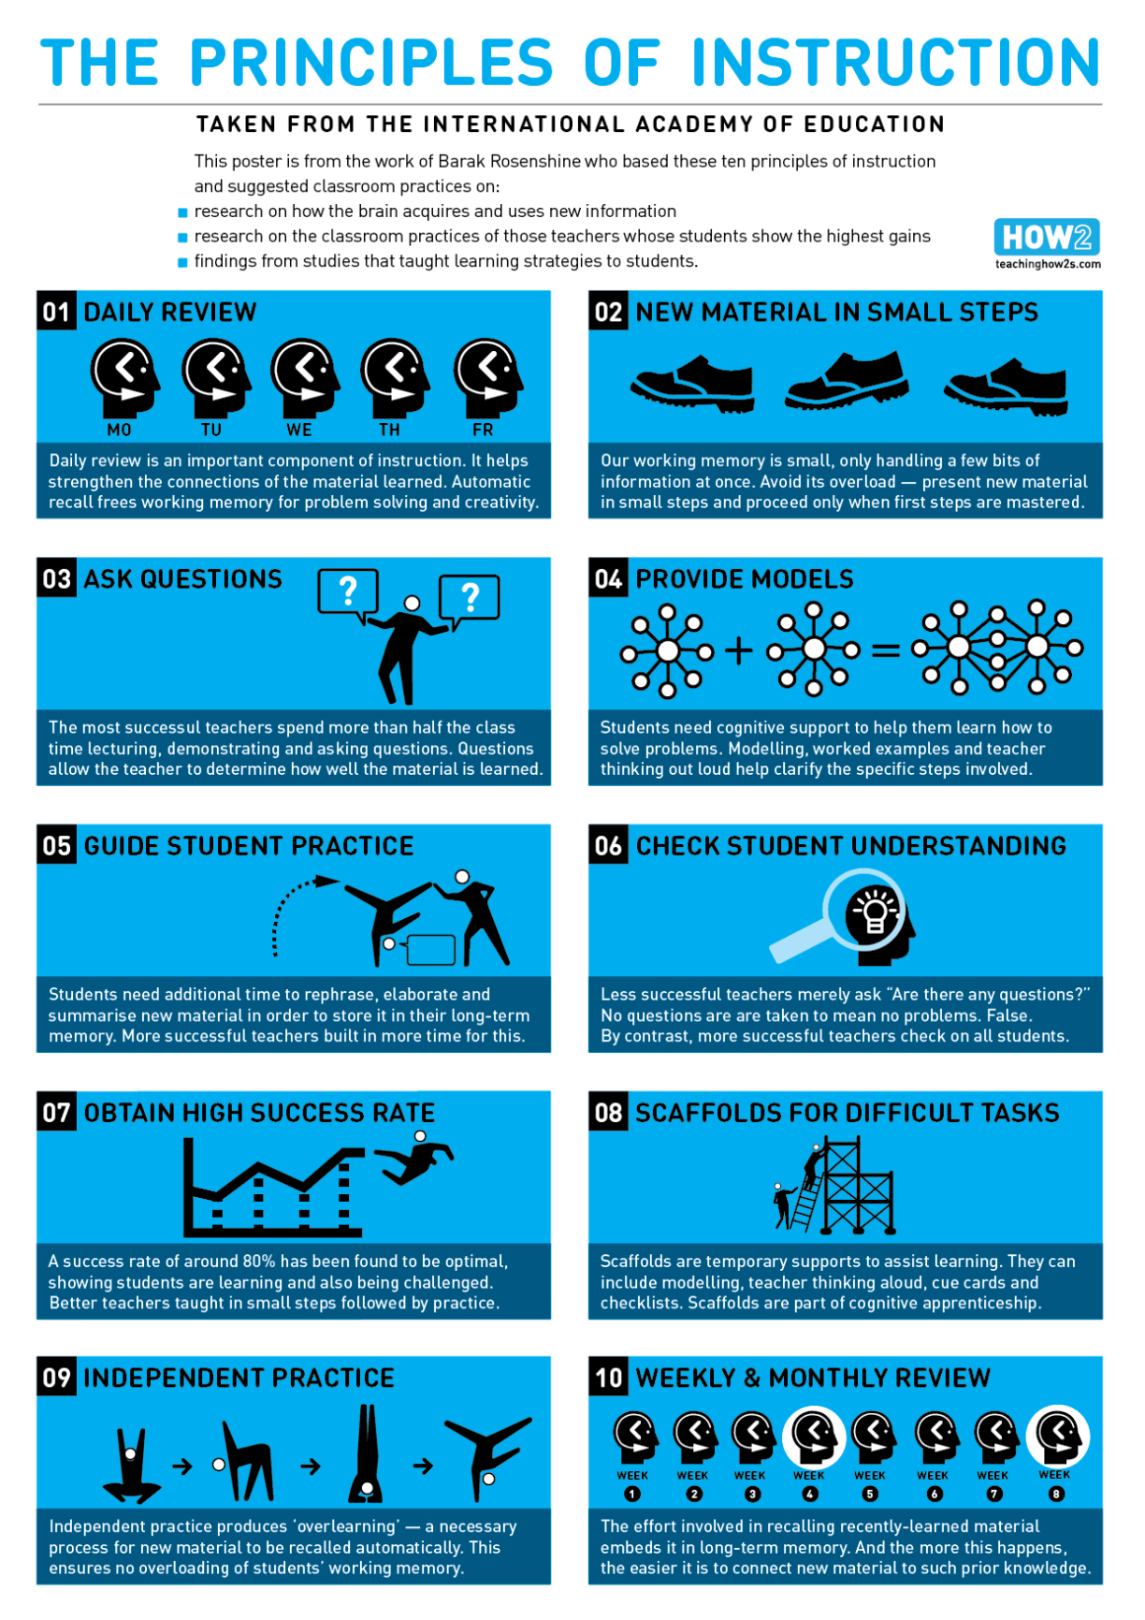

Intervention
Teachers must be aware of pupils making less than the expected progress and plan for intervention. Academic Interventions are put in place to support pupils in core curriculum subjects.
Based on accurate assessment data teachers will recommend pupils for a sequence of intervention sessions that will support pupils gaining the knowledge and skills in a topic they need support with. The academic interventions will usually take place outside of core curriculum time. This will prevent pupils missing crucial curriculum content. Occasionally some pupils will receive extensive academic intervention in core subjects, and this will involve intensive 1:1 support for literacy and numeracy over a sustained period.

Teaching Assistants
Teaching assistants are most effectively deployed in the classroom when they are informed of and involved in the learning.
- Teachers must provide TA’s with schemes of work in advance. These are all available on TEAM’s in the Curriculum folder.
- Regular discussion of student progress and wellbeing should take place between the TA’s and form tutor.
- All should contribute to staff de-brief
- Teachers must provide TAs with appropriate guidance on their role within the lesson or sequence of lessons
- TA’s should share their knowledge of students being supported, particularly if progress differs significantly in other lessons.
- TA’s should be directed to work with small groups to enhance learning activities
- TA’s must be provided with work and directed to materials by teachers to put up displays and enhance the learning environments
- TA’s should work with class teachers to complete and write up pupil behaviour and attitude records
- TA’s should contribute to annual statement review advise, IEPs and Pupil Risk Assessments

