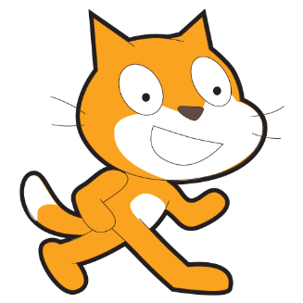
Scratch – Lesson 4
Name:

Draw a line to join the technical jargon to the correct description:
Stage |  |  | A script line that decides if another script runs
Sprite |  |  | Script that runs a set number of times
Costume |  |  | A single character that you can program to move or act in a particular way
If |  |  | Script that keeps running until it is told to stop
Forever |  |  | The background
Repeat |  |  | Pauses the program for a set amount of time
Wait |  |  | What the sprite looks like and the sprite can have more than one of these for different looks.
 |  | Questions to answer

Circle the section of the screen that allows you to rename a sprite.

Circle the group which you would use to find the “Touching colour” script?

