Spellings Autumn 1 2021 Year 3 (Scroll down for Year 4)
Week 1 | Week 2 | Week 3 | Week 4 | Week 5 | Week 6 | Week 7
Test on  10 Sep | Test on  17 Sep | Test on  24 Sep | Test on  1 Oct | Test on  8 Oct | Test on  15 Oct | Test on  22 Oct
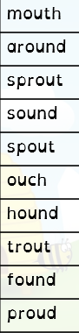 | 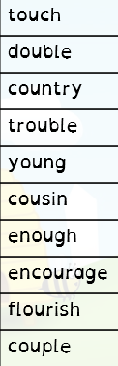 | 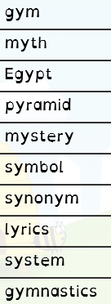 | 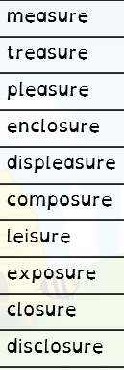 | 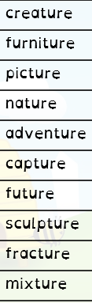 | 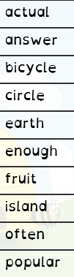 | 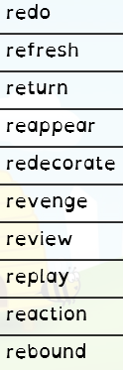

Autumn 1 2021 Year 4
Week 1 | Week 2 | Week 3 | Week 4 | Week 5 | Week 6 | Week 7
Test on  10 Sep | Test on  17 Sep | Test on  24 Sep | Test on  1 Oct | Test on  8 Oct | Test on  15 Oct | Test on  22 Oct
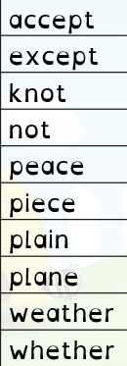 | 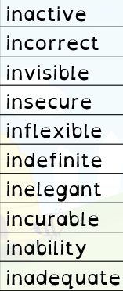 | 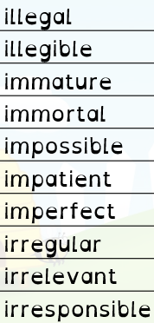 | 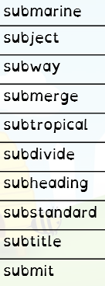 | 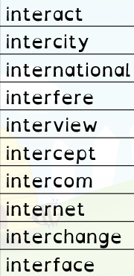 | 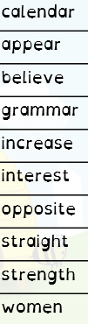 | 