21st October 2020

Dear Parents and Carers,

As we reach the end of the first half term, I would like to take this opportunity of thanking everyone for their continued support.

As you will be aware, the number of people who are infected with COVID-19 is on the rise, and we must all do our bit to try and stem this in order to protect our health, protect the NHS, and to save lives.

We have reviewed our risk assessments as a consequence of the increased infection rate. In order to keep everyone safe, from Monday 02nd November we are asking that all parents/carers wear face masks when dropping off and collecting children from any of our schools, or entering the school for any reason.

In order to protect our bubbles and again, to keep both children and staff safe, we will be continuing with the current opening and closing times, according to the class your child is in. For the second half of the Autumn term, schools will continue to close at 1.30pm on Friday. The usual Care Club arrangements will continue as per this first half term.

I wish you and your families a happy and safe half term holiday.

Yours sincerely
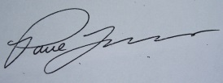

Mr P J Lovern
Chief Executive Officer

