Year 3 Spelling Autumn- Spelling will be tested on a Friday
Test 1  11/09/20 | Test 2  18/09/20 | Test 3  25/09/20 | Test 4  02/10/20 | Test 5  09/10/20 | Test 6  16/10/20 | Test 7-  23/10/20
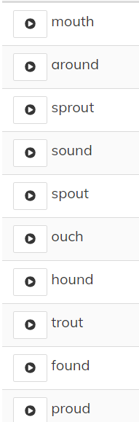 | 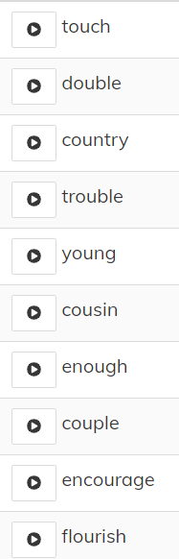 | 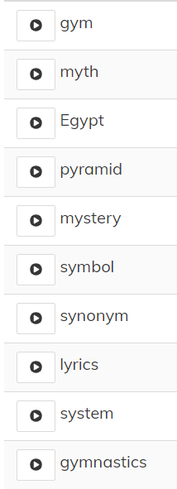 | 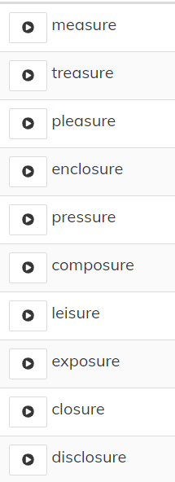 | 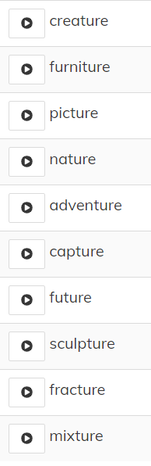 | 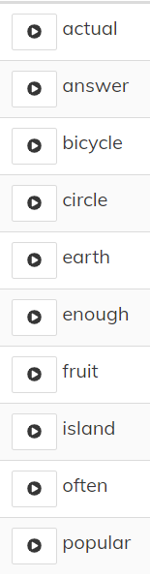 | 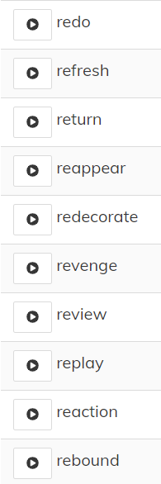

Year 4 Spelling Autumn- Spelling will be tested on a Friday

Test 1  11/09/20 | Test 2  18/09/20 | Test 3  25/09/20 | Test 4  02/10/20 | Test 5  09/10/20 | Test 6  16/10/20 | Test 7-  23/10/20
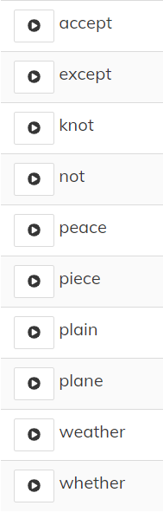 | 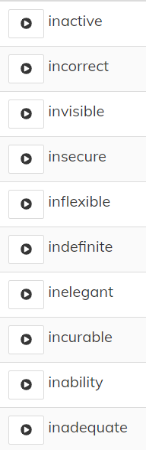 | 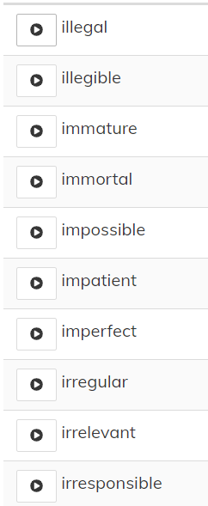 | 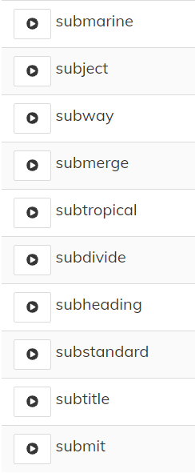 | 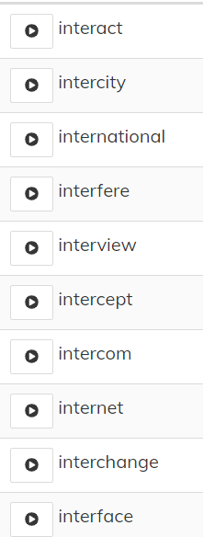 | 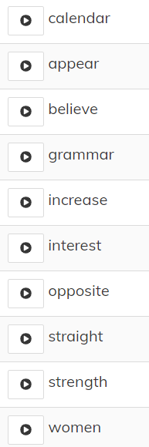 | 