Year 3 Spelling Spring 1- Spelling will be tested on a Friday
Test 1  8/01/2021 | Test 2  15/1/21 | Test 3  22/1/21 | Test 4  29/1/21 | Test 5  5/2/21 | Test 6  21/12/21
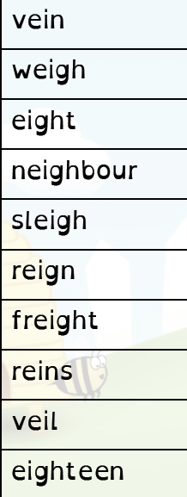 | 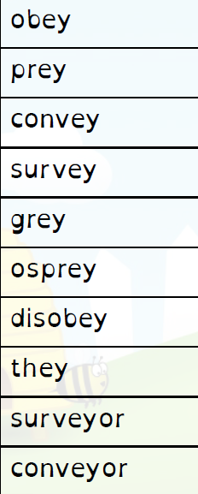 | 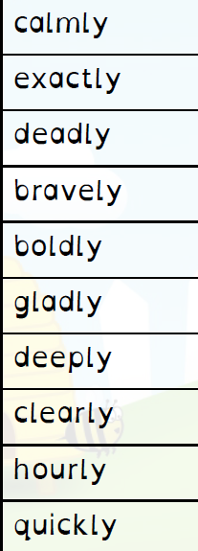 | 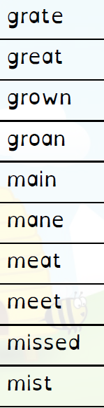 | 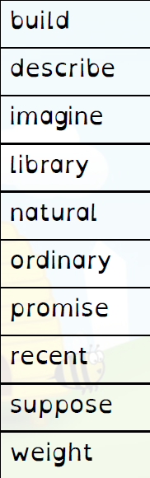 | 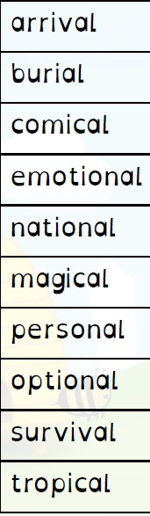

Year 4 Spelling Spring- Spelling will be tested on a Friday
Test 1  8/01/2021 | Test 2  15/1/21 | Test 3  22/1/21 | Test 4  29/1/21 | Test 5  5/2/21 | Test 6  21/12/21
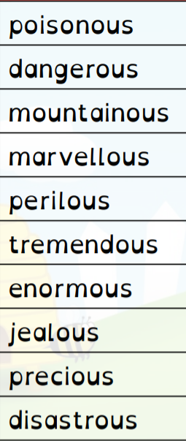 | 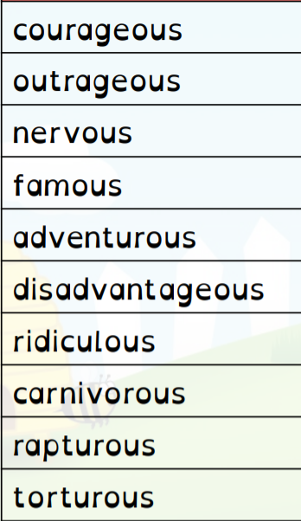 | 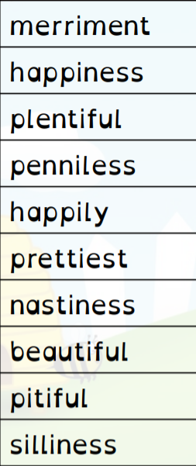 | 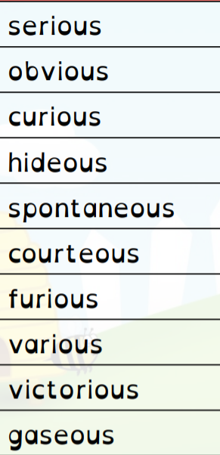 | 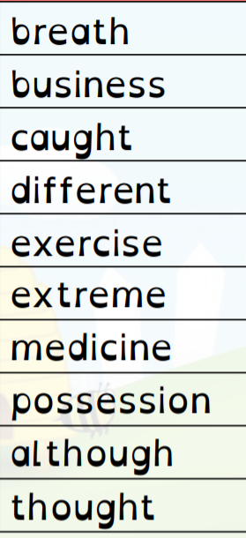 | 