Year 3 Spelling Spring 1- Spelling will be tested on a Friday
Test 1  26/02/2021 | Test 2  05/03/21 | Test 3  12/03/21 | Test 4  19/03/21 | Test 5  26/03/21 | Test 6  01/04/21
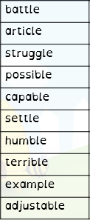 | 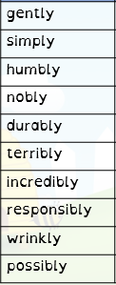 | 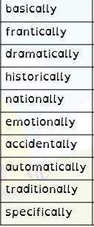 | 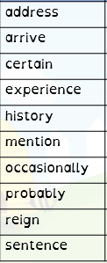 | 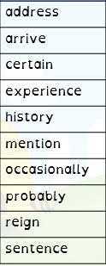 | 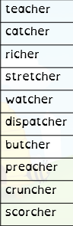

Year 4 Spelling Spring- Spelling will be tested on a Friday
Test 1  26/02/2021 | Test 2  05/03/21 | Test 3  12/03/21 | Test 4  19/03/21 | Test 5  26/03/21 | Test 6  01/04/21
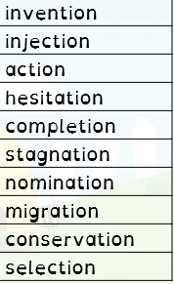 | 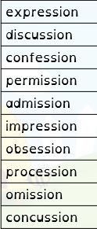 | 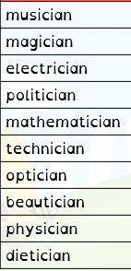 | 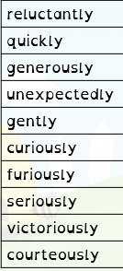 | 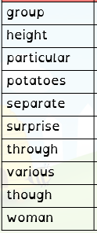 | 