Year 3 Spelling Summer 1- Spelling will be tested on a Friday
Test 1  23/04 /2021 | Test 2  30/04/21 | Test 3  7/05/21 | Test 4  14/05/21 | Test 5  21/05/21
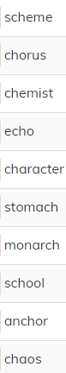 | 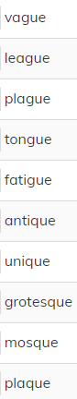 | 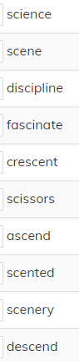 | 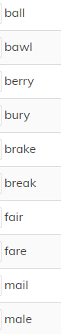 | 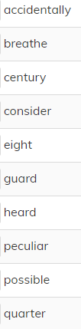

Year 4 Summer 1 Spellings will be tested on a Friday
Test 1  23/04/2021 | Test 2  30/04/21 | Test 3  7/05/21 | Test 4  14/05/21 | Test 5  21/05/21
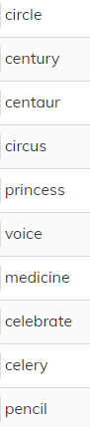 | 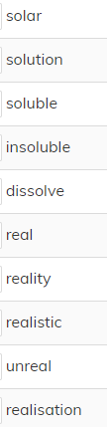 | 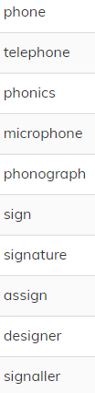 | 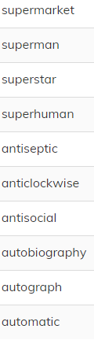 | 