Year 4 Spelling Summer 1- Spelling will be tested on a Friday
Wk 1- Test 20/04/20 | Wk 2- Test 27/04/20 | Wk 3- Test  04/05/20 | Wk 4- Test 11/05/20 | Wk 5- Test7  18/05/20 | Wk 6-  Test 25/05/20
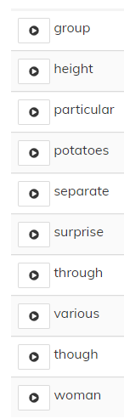 | 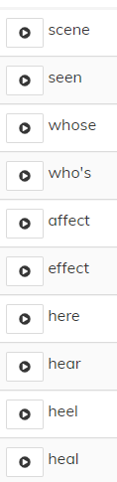 | 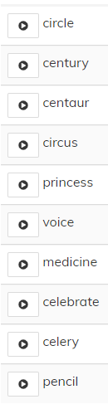 | 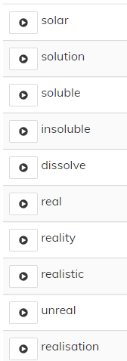 | 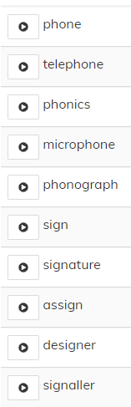 | 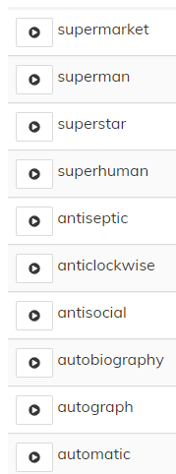

Year 3 Spelling Summer 1- Spelling will be tested on a Friday
Wk 1- Test 20/04/20 | Wk 2- Test 27/04/20 | Wk 3- Test  04/05/20 | Wk 4- Test 11/05/20 | Wk 5- Test  18/05/20 | Wk 6- Test  25/05/20
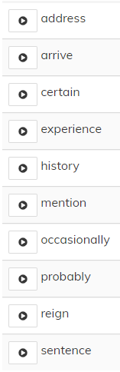 | 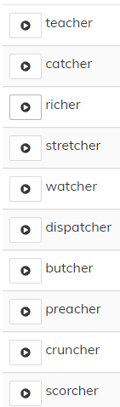 | 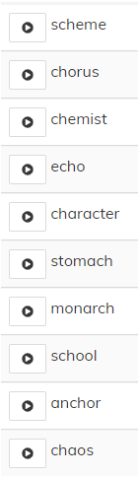 | 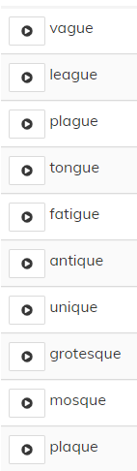 | 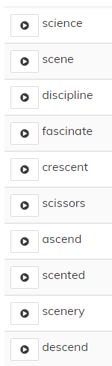 | 