Year 4 Spelling Summer 2- Spelling will be tested on a Friday
Wk. 1-  01/06/20 | Wk. 2-  08/06/20 | Wk. 3-  15/06/20 | Wk. 4-  22/06/20 | Wk. 5-  29/06/20 | Wk. 6-  06/07/20 | Wk. 7-  13/07/20
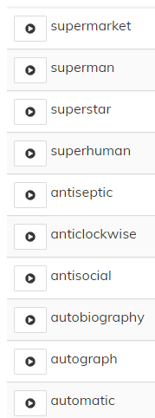 | 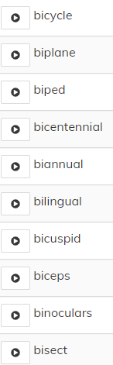 | 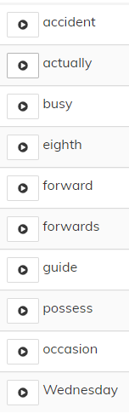 | 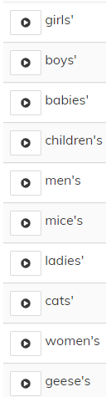 | 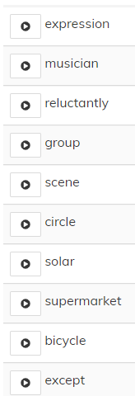 | 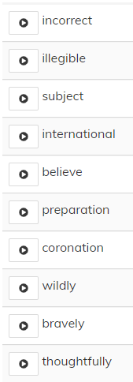 | 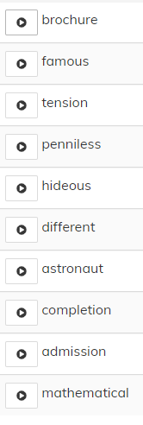

Year 3 Spelling Summer 2- Spelling will be tested on a Friday
Wk. 1-  01/06/20 | Wk. 2- 08/06/20 | Wk. 3-  15/06/20 | Wk. 4- 22/06/20 | Wk. 5-  29/06/20 | Wk. 6-  06/07/20 | Wk. 7-  13/07/20
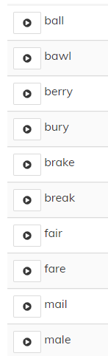 | 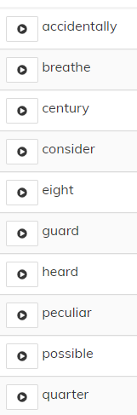 | 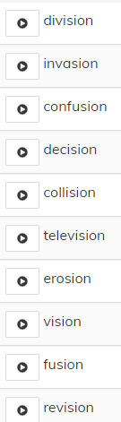 | 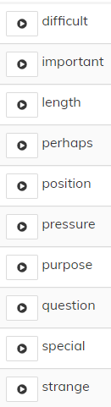 | 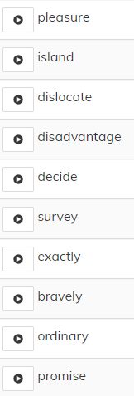 | 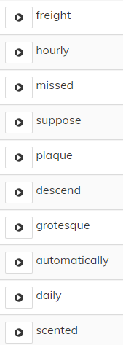 | 