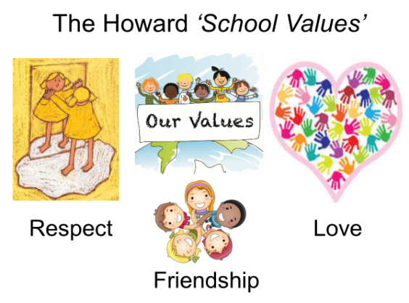

Summer 1 Curriculum – YEAR 5/6
English | Our texts for this term will be:  FICTION - THIEF BY MALORIE BLACKMAN - Fleeing onto the moors when she is unfairly accused of being a thief an extraordinary storm suddenly whirls twelve-year-old Lydia into the future – a computer-dominated future where a cruel tyrant rules her hometown.  NON FICTION - STUFF YOU SHOULD KNOW - A fascinating book of fact and figures that will have you enthralled from the start
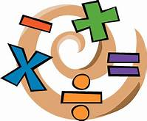  Maths | YEAR 6 - STATISTICS AND PROPERTIES OF SHAPE  YEAR 5 - DECIMALS
History  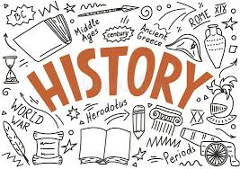 | CRIME AND PUNISHMENT  We will be learning about how crime and punishments have changed over the last 1000 years. From the times of the Vikings, through until modern day, we will be looking at time lines and asking questions that involve personal research to find the answers. It could get a little gruesome!
Art | SCULPTURE  We will be learning about famous artists and evaluating their work. In addition, we will be looking at tessellation and making our own sculptures using balsa wood.
Science | LIGHT  Our light topic explores sources of light as well as how light travels. We have the opportunity to study shadows and plan experiments to improve our predicting and measuring skills. We will have to draw conclusions from data and begin to ask scientific questions. Year 6 will be using the data collected in their maths lessons.
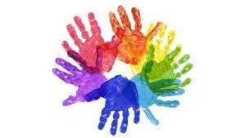  PSHE | SRE  All children will learn about the life cycles of humans and animals, including reproduction. They also learn about the changes that happen in humans from birth to old age. This includes learning what happens in puberty, including periods.
Computing | ICT  Pupils will recognise that technology can be used to alter and manipulate images and use and combine a variety of software to design and create digital and printed media. They will also explore and create 3D animation and recognise the benefits of using a spreadsheet to manipulate data.
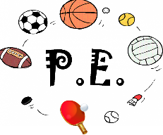  PE | CRICKET AND ATHLETICS  We hope for sunshine as we move into the summer term. We will be learning how to bat, bowl and field as well as learning the tactics involved in small-sided games. Athletics will give us the opportunity to learn how to run faster, throw further and jump higher!
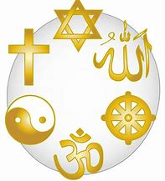  Religious Education | THE KINGDOM OF GOD  We will be looking at Jesus and God and making clear connection between the Kingdom of God and how Christians put their beliefs into practice in different ways; including worship and service to the community.

