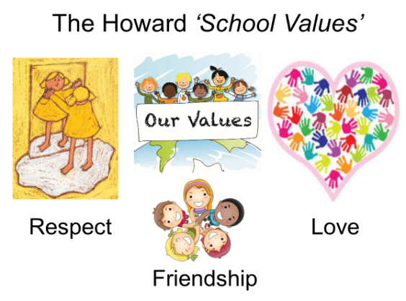

Summer 2 Curriculum – YEAR 5/6
English | Our texts for this term will be:  (Ongoing Topic) FICTION - THIEF BY MALORIE BLACKMAN - Fleeing onto the moors when she is unfairly accused of being a thief an extraordinary storm suddenly whirls twelve-year-old Lydia into the future – a computer-dominated future where a cruel tyrant rules her hometown.  (New text) NON-FICTION - STUFF YOU SHOULD KNOW - A fascinating book of fact and figures that will have you enthralled from the start  We will also be learning our lines and rehearsing for our end of term play.
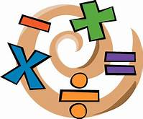  Maths | YEAR 6 - STATISTICS AND PROPERTIES OF SHAPE  YEAR 5 – PROPERTIES OF SHAPE, POSITION AND DIRECTION and CONVERTING UNITS
History  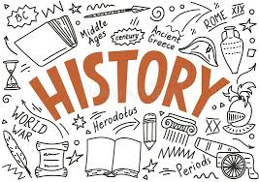 | (Ongoing Topic) CRIME AND PUNISHMENT  We will be learning about how crime and punishments have changed over the last 1000 years. From the times of the Vikings, through until modern day, we will be looking at time lines and asking questions that involve personal research to find the answers. It could get a little gruesome!
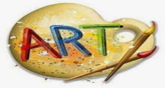  Art | (Ongoing Topic) SCULPTURE  We will be learning about famous artists and evaluating their work. In addition, we will be looking at tessellation and making our own sculptures using balsa wood.
Science | (Ongoing Topic) LIGHT  Our light topic explores sources of light as well as how light travels. We have the opportunity to study shadows and plan experiments to improve our predicting and measuring skills. We will have to draw conclusions from data and begin to ask scientific questions. Year 6 will be using the data collected in their maths lessons.
PSHE | SRE  All children will learn about the life cycles of humans and animals, including reproduction. They also learn about the changes that happen in humans from birth to old age. This includes learning what happens in puberty, including periods. Letters have been sent to parents.
Computing | ICT  Pupils will recognise that technology can be used to alter and manipulate images and use and combine a variety of software to design and create digital and printed media. They will also explore and create 3D animation and recognise the benefits of using a spreadsheet to manipulate data. We will also be building our own website.
PE | TENNIS AND ATHLETICS  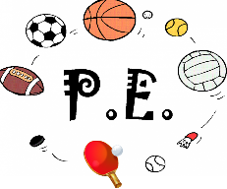  Athletics will give us the opportunity to learn how to run faster, throw further and jump higher! We will be learning the skills of tennis as well as looking forward to our annual sports day.
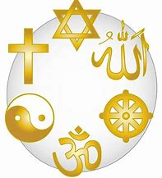  Religious Education | FAITH THROUGH ART  We will be looking at artwork associated with a range of religions to analyse and compare. We will then be producing similar pieces using our own techniques.

