Year 5 Spelling Spring 1 - Spelling will be tested on the following Monday
No new spellings set in Week 1 due to the term starting on Wednesday 5th January 2022 | Week 2  set on 10/01/22 | Week 3  set on 17/01/22 | Week 4  set on 24/01/22 | Week 5  set on 31/01/22 | Week 6  set on 07/02/22 | Week 7  set on 14/02/22
 | 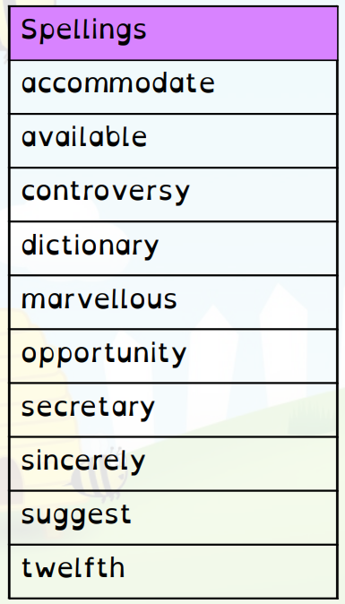 | 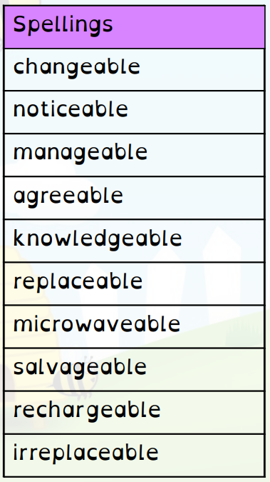 | 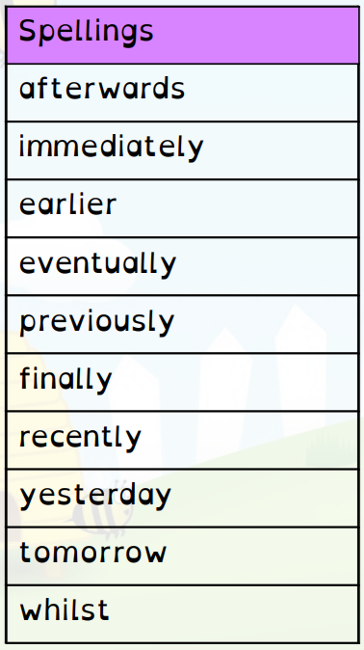 | 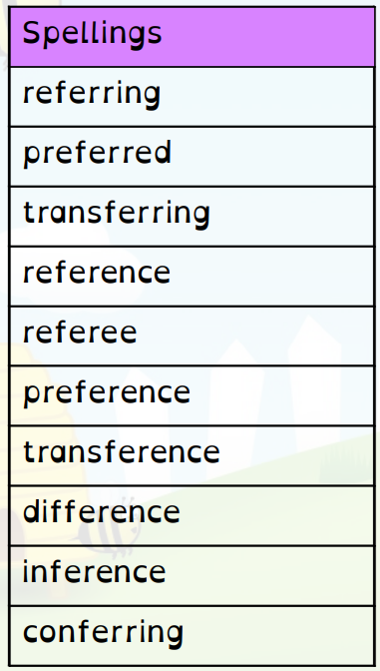 | 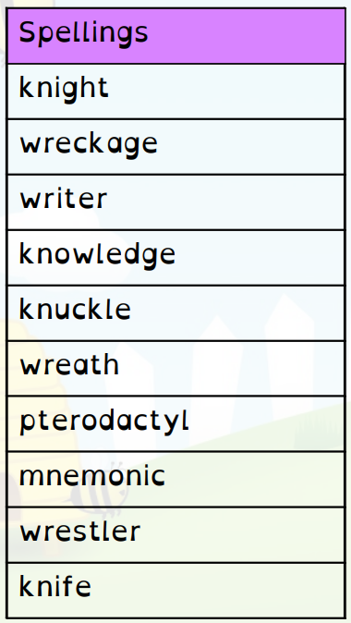 | 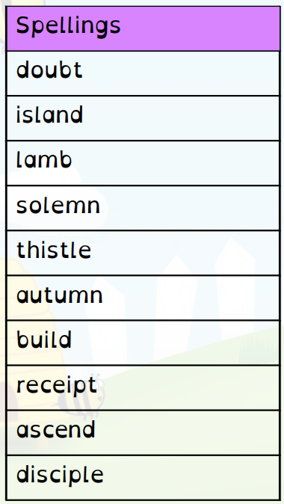

Year 6 Spelling Spring 1 - Spelling will be tested on the following Monday

No new spellings set in Week 1 due to the term starting on Wednesday 5th January 2022 | Week 2  set on 10/01/22 | Week 3  set on 17/01/22 | Week 4  set on 24/01/22 | Week 5  set on 31/01/22 | Week 6  set on 07/02/22 | Week 7  set on 14/02/22
 | 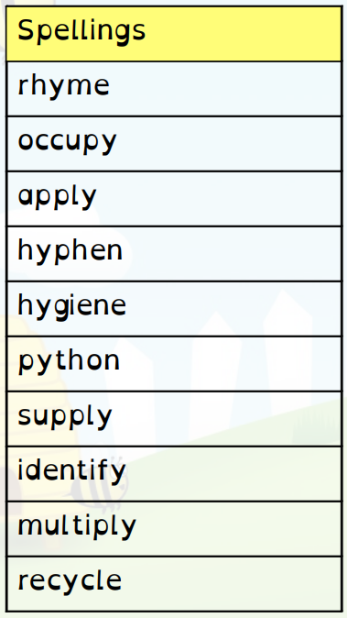 | 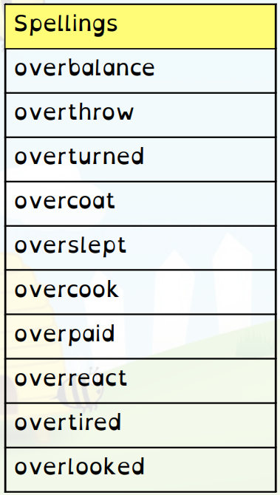 | 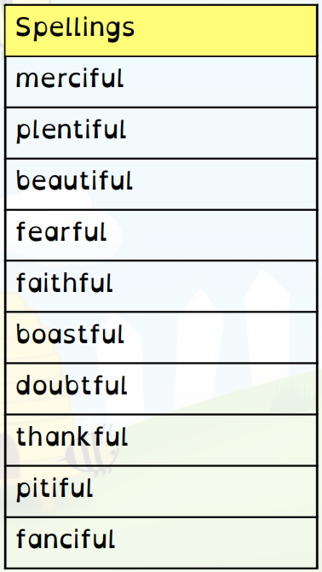 | 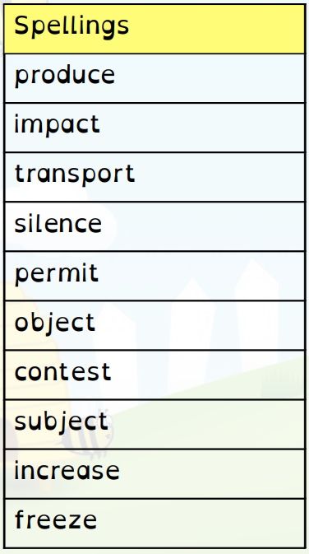 | 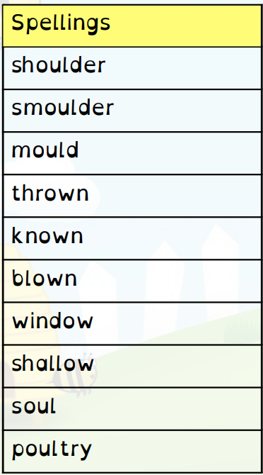 | 