Autumn Term 1 Curriculum - EYFS
Literacy  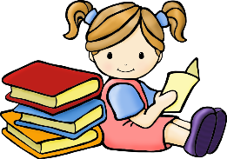 | Our topic for this first half term is ‘Marvellous Me’. During this time we will be learning all about each other, our likes, disalikes, our families and things that are important to us. The children will be practising writing their names and start to explore writing the sounds that they can hear in simple words.  - initial sounds  - sounds as they appear in words  - labels.  We will also be listening to some traditional tales including ‘Little Red Riding Hood’.
Maths  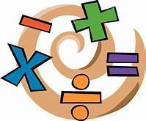 | Our Maths focus for the first half term of school will be linked to our ‘Marvellous Me’ theme. During the first few weeks we will be completing lots of ‘getting to know you’ activities. We will be applying our mathematical skills and knowledge to our classroom activities. We will then move on to ‘Just like me’ where we will be matching and sorting objects, comparing amounts and beginning to learn about size, mass and capacity. We will also spend some time exploring and making patterns.
Phonics  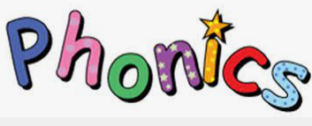 | During the first half term of school, we will begin our Monster Phonics journey. The children will meet the monsters and learn all about the sounds that they will teach them. We will then move on to learn about some single letter sounds with our Black Cat friends.  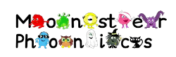
PSED  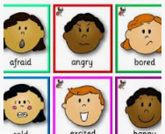 | We will spend a lot of time this half term getting to know each other. We will be completing activities involving:  - Settling into school and following routines.  - Building positive relationships with peers and adults.  - Talking about self in positive terms ‘I can…’ Developing a positive mindset and a ‘can do’ approach.  - playing cooperatively- playing alongside, with a peer, in a group, as part of a class, small group games, whole class games. Supported by adults who model the key skills needed when socialising.  - Turn taking.  - Sharing resources.  - Use of manners.  - Talking about feelings- self registration feeling board and reviewing this throughout the day.
UW | The Understanding the World element of EYFS involves learning all about aspects linked to R.E., History, Geography and Science. During this half term we will be learning about and using our senses, looking at the changes in the seasons that occur when Autumn arrives, learning all about our school and homes as well as exploring forest school.
EAD  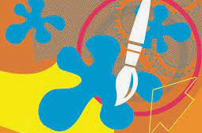 | Our Expressive Arts and Design this half term will include opportunities for our children to:  - create self portraits  - learn about famous artists linked to portraits  - create junk/box models when learning about school and sharing about home  - learn and sing songs all about me  - learn through experiences in our role play, forest school and small world/imagination play.
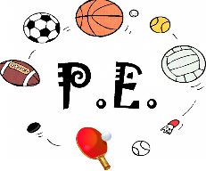 | During P.E we will be focussing on two areas: Health Related Exercise and football.  In our Health Related Exercise unit we will be looking at developing our understanding of how the body functions/ changes during exercise and developing our ability to exercise at different intensities.  In our football topic we will be developing our ball skills through practising dribbling, passing and shooting.

