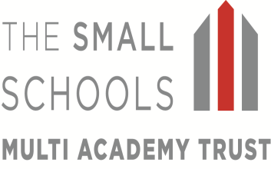

17th March 2020

Dear Parents/Carers,

Life changes on a daily basis at present, and as an organisation we have to adapt and manage change.

Following the Government’s recent announcement with regards to self-isolation and the impact of Coronavirus on vulnerable groups, as of today we have upgraded our response.

In order to try and delay the spread of the virus, I have implemented the following at all Trust schools:

- Inter school activities within the Trust and beyond will be suspended. Therefore, all joint activities such as the Performing Arts Group, staff meetings, staff training etc. will cease.
- MAT staff will be directed to work at one establishment and will not work across schools. I will be based at Richard Crosse for the time-being.
- Support from all external agencies such as Entrust Music Services, peripatetic music lessons and Progressive Sports will cease at the moment.
- Swimming and inter-school sports are cancelled.
- Extra-curricular clubs provided by external companies are cancelled.
- Local Governing Committee, Local Advisory Group and Director meetings are suspended in the short term.
- The forthcoming SIAM’s Inspection at St. Mary’s has been postponed.
- At St. Mary’s, the children will be taught in one of three classes rather than four, due to staff absence.
I must stress that all our schools’ continue to remain open and that in my opinion the measures I have implemented help to support the Government’s strategy to delay the spread of the infection.

Thank you for your continued support. I wish you and your families all the very best during this difficult time.

Yours sincerely,

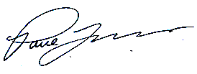

Mr P J Lovern
Chief Executive Officer

