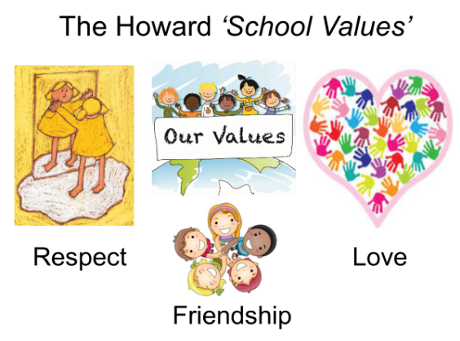

Our School Value this term is: Resilience

Autumn 1 Curriculum
English | We have lots of exciting writing opportunities planned this half term, starting with the well know children’s book, ‘Dear Zoo’. We will then move onto the story ‘Boa’s Bad Birthday’ where Year 1 will be focusing on sentence construction, using a capital letter and a full stop, whilst Year 2 will be focusing on using adjectives to describe and conjunctions. We will also be doing some non-fiction writing on Pirates.
Maths  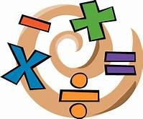 | Our focus points this term will be Big Maths. The children will undertake these tests every Friday. Other key topics include place value and addition and subtraction. Year 2 can also use Times Tables Rock Stars to practise their times tables at home.
Geography  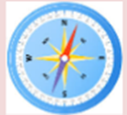 | Our Geography topic this half term will be called ‘Our School’. In this topic the children will use simple fieldwork and observational skills to study the geography of their school and its grounds and the key human and physical features of its surrounding environment.The children will also use simple compass directions (North, South, East and West) and locational and directional language [for example, near and far; left and right], to describe the location of features and routes on a map.
Art | Our focus will be on ‘Artist Study’ where the children will be exploring the life and work of Josiah Wedgwood. They will also be going on a trip to the Wedgewood Museum in Stoke on Trent where they can make their own pottery.
Science  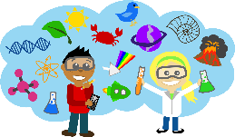 | Animals including humans. In this topic the children will be learning to identify and name a variety of common animals including fish, amphibians, reptiles, birds and mammals. They will also be Identifying whether these common are carnivores, herbivores or omnivores
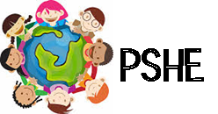 | In PSHE, we will explore ‘E-Safety’.
Computing  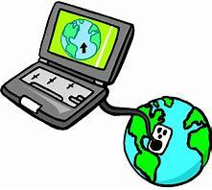 | For this session we will focus on word processing skills.
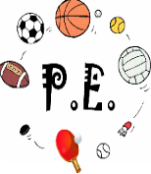 | Our PE topics will be looking at functional movement and the ways in which we move around. We will play lots of different games and learn how to take turns and work within a team.
Religious Education  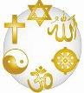 | Who made the world? We will be looking at how Christians believe that God created the universe and why the earth and everything in it is important to God. They will be exploring how God has a unique relationship with human beings as their creator and sustainer and how humans should care for the world because it belongs to God.

