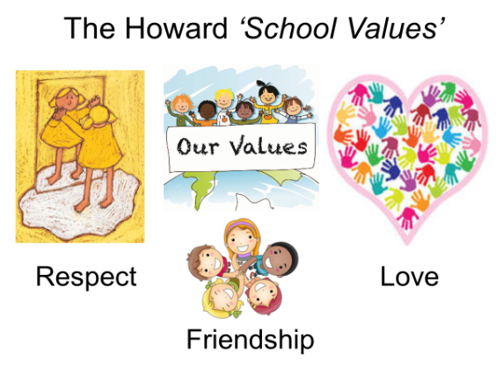

Our School Value this term is:

Spring 2 Curriculum
English  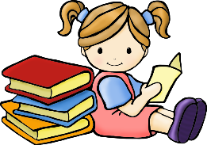 | We have lots of exciting writing opportunities planned this half term, starting with the story Nibbles by Emma Yarlett. We will be writing character descriptions, designing out traps and retelling the story. We will then be looking at the story The Day the Crayons Quit by Drew Daywalt.
Maths  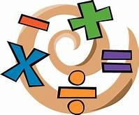 | Our focus points this term will be Big Maths. The children will undertake these tests every Friday. Other key topics include: Year 1 – measurement - length and height/weight and volume, Year 2 – geometry - properties of shapes and fractions. Year 2 can also use Times Tables Rock Stars to practise their times tables at home.
Geography | Our geography topic this half term is ‘Weather Patterns’. In this topic the children will be researching the weather in the United Kingdom and comparing it to other countries. They will also be learning about the different seasons.
DT  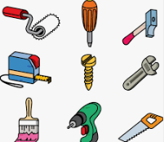 | Our DT topic this half term is ‘Complete Vehicles’. In this topic the children will investigate a variety of vehicles and their uses and features. They will be looking at ways of creating and decorating the body of a vehicle and then designing, making and evaluating their own.
Science | Animals including humans. In this topic the children will be exploring food chains in a  Habitat and looking at what is meant by a food chain. They will also be describing how some animals obtain their food from plants and other animals.
 | In PSHE, we will explore ‘Road Safety’ and ‘First Aid’
Computing | For this session we will be looking at ‘How to be computer scientists’.
PE  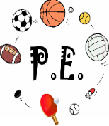 | Our PE topic this half term is gymnastics and orienteering.
Religious Education  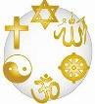 | Salvation - In this topic we will be learning the importance of Easter to Christians. We will be looking at the stories associated with Holy and Easter from the Bible recosgnising th link with the idea of Salvation (Jesus rescuing people). We will also be looking at ways in which Jesus gave instruction on how to behave.

