Autumn Term 1 Curriculum
English | This term our focus for English will link beautifully with our history topic - The Ancient Egyptians. Our narrative focus is based on the book “The Egyptian Cinderella”, our non-narrative focus is linked to the discovery of Tutankhamun. We will be writing our own stories and newspaper articles based on these books. Immersing ourselves in this topic will allow us to expand our vocabulary and ensure our writing meets the audience and purpose for the text type.  We will explore a range of grammar devices through our English and develop our vocabulary through our reading texts. It is integral that the children read high quality texts, please use our list of 100 books to read in Year 2,3 and 4 to help you choose something new.
Maths  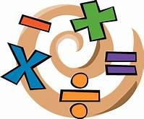 | Our Autumn term focuses for maths are as follows: place value and addition and subtraction.  We will begin working on our times tables and the use of Times Tables Rock stars to ensure we are fluent in all tables up to x 12. Year 4s are expected to take a multiplication tables check in June, so it is imperative that they can rapidly recall their multiplication facts to 12x12. Remember to use Times Tables Rock Stars at home.
History  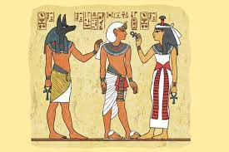 | This term our focus topic is: Ancient Egyptians  Our National Curriculum focus will be:  - the achievements of the earliest civilizations – an overview of where and when the first civilizations appeared and a depth study of one of the following: Ancient Sumer; The Indus Valley; Ancient Egypt; The Shang Dynasty of Ancient China
Art / DT | This term we will be focusing on DT and investigating electrical circuits to design and produce a product - in this case a light. We will be covering a variety of skills including: investigating materials, designing a product, working from a design, creating working circuits and evaluating a product.
Science | Our focus this term is: Light  We will be covering the below National Curriculum objectives:  Pupils should be taught to:  - recognise that they need light in order to see things and that dark is the absence of light  - notice that light is reflected from surfaces  - recognise that light from the sun can be dangerous and that there are ways to protect their eyes  - recognise that shadows are formed when the light from a light source is blocked by an opaque object  - find patterns in the way that the size of shadows change
Our PSHE this term is focussed on relationships with others, growth mindset and mindfulness.

We will also be using “Votes for schools” within our classrooms this year.

Computing | Our focus in computing will be computing systems and networks.
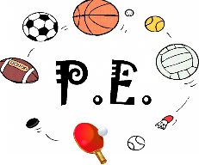 | Our PE this term includes the topics, “Health related Exercise” and football.  PE is normally Thursday and Friday. However, please make sure you have your full PE kit in school every day.
Religious Education  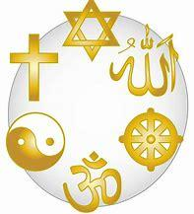 | In RE this term we will be exploring the Christian faith through the topic “People of God.”

