Spring Term Term 1 Curriculum Overview
English | This term we will be reading HOLES by LOUIS SACHER and also ARE HUMANS DAMAGING THE ATMOSPHERE by CATHERINE CHAMBERS. Our fiction writing focus will be diary entries, informal letters and narrative. Our non - fiction focus will be information texts.
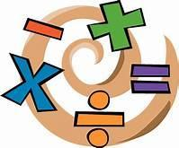  Maths | In maths this term:  Year 5 - MULTIPLICATION and DIVISION followed by FRACTIONS  Year 6 - RATIO, ALGEBRA and DECIMALS
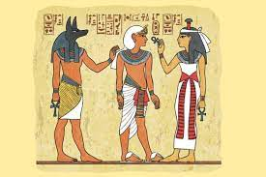  History/Geography | In geography this term we will be learning about NATURAL RESOURCES
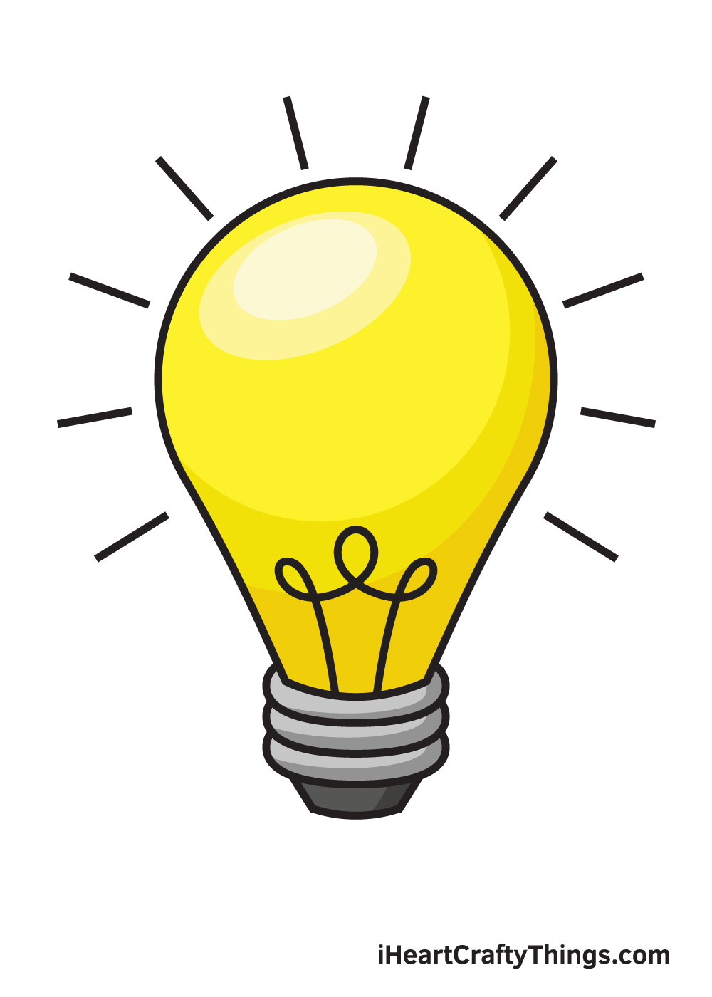  Art / DT | In art this term we will be developing our use of CHARCOAL. We will also be starting our GREENPOWER racing car project with Dr Allen.
Science | In science this term we will be studying THE CIRCULATORY SYSTEM. This will include the heart, lungs, blood, diet and drugs.
 | In PSHE we will be following VOTES FOR SCHOOLS programme while also looking at Autism Neurodivergence.
Computing | In ICT and computing this term we will be learning about 3D MODELLING
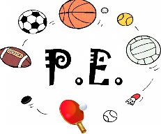 | In PE this term we will be developing our movement skills through GYMNASTICS and DANCE. Please come to school in PE kits on a MONDAY AND FRIDAY
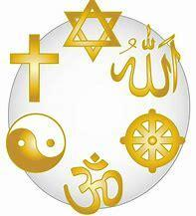  Religious Education | IN RE this term we will be learning about THE KINGDOM OF GOD while trying to understand WHAT KIND OF KING WAS JESUS?

