Autumn Term 1 Curriculum - Year 1
English  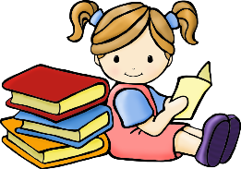 | During our first English topic we will be listening to and unpicking well known traditional tales. We will be focusing on capital letters, full stops and beginning to write simple sentences. We will then move on to instructional writing where we will apply instructions to real life situations.  Getting to know one another and learning about our friends will be a focus also.
Maths  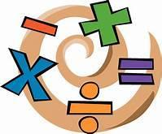 | Our autumn term focusses for maths are: Place value (within 10), Addition and Subtraction (within 10) and Shape.  To start off with, the children will be sorting and counting objects, representing and recognising numbers as words, counting forwards and backwards, and looking at one more and one less. They will then use these skills further when they move on to addition and subtraction.
Geography  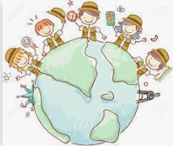 | Our topic this half term is Our world/ Around the world. During this exciting topic, the children will meet Buddy the bee. Together they will be locating the seven continents of the world and exploring some countries that are a part of each continent. The children will also be learning about the five oceans of the world. We will learn catchy songs to help us remember.
Art / DT | During our first art topic, we will be exploring printing. Together we will explore repeated patterns, recreate prints from the environment and experiment creating our own designs and prints. We will explore a range of tools and techniques to do this.
Science  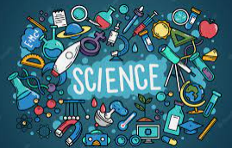 | Our science topic is called ‘Living things and their habitats’. During this fun topic we will be exploring and comparing the differences between things that are living, dead and never been alive. We will explore what a habitat is and how they provide basic needs for animals and plants. Finally we will be able to name a variety of plants and animals in their habitats, including micro-habitats.
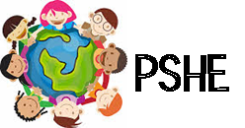 | During PSHE we will be completing a series of lessons based on being mindful and forming friendships. We will also be looking at first aid and CPR through lessons on helping the injured and how to help with CPR. Alongside this we will be completing votes for schools lessons.
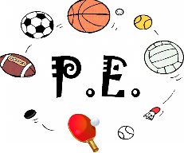 | During P.E we will be focussing on two areas: Health Related Exercise and football.  In our Health Related Exercise unit we will be looking at developing our understanding of how the body functions/ changes during exercise and developing our ability to exercise at different intensities.  In our football topic we will be developing our ball skills through practising dribbling, passing and shooting.
Religious Education  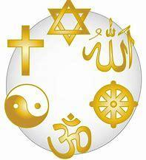 | In our first R.E topic we will be looking at ‘What do Christian’s believe God is like?’ We will learn what parables are and look at how Christians show their belief in God. We will learn these through thinking, talking and asking questions.

