Summer Term 2 Curriculum
English | This term, to link with our Stone Age topic, we will be reading the text “How to Wash a Woolly Mammoth.” We will be linking this to our non-fiction instructional writing.  We will also be exploring the text “A Stone for Sascha”. This is a fabulous picture book for older readers and will provide a great challenge for our fiction writing.  We will continue to explore a range of grammar devices through our English and develop our vocabulary through our reading texts. It is integral that the children read high quality texts, please use our list of 100 books to read in Year 3 and 4 to help you choose something new.
Maths | For Year 3, we will be studying time, shape, mass and capacity. Year 4’s focus in maths will be statistics, shape and position and direction. Also, we will continue work on enhancing our basic arithmetic skills and ensuring we embed key skills.  We will be continuing to push our work on times tables and the use of Times Tables Rock stars to ensure we are fluent in all tables up to x 12. Year 4s are expected to take a multiplication tables check in June, so it is imperative that they can rapidly recall their multiplication facts to 12x12. Remember to use Times Tables Rock Stars at home.
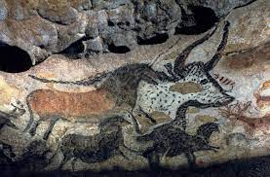  History | This term our focus topic is “ Ages of Man”  Our National Curriculum focus will be:  - Changes in Britain from the Stone Age to the Iron Age
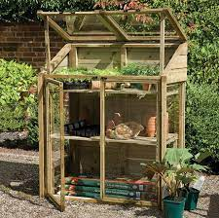  Art / DT | This term we will be focusing on DT and making mini greenhouses. We will be investigating stable structures, creating suitable designs, following a design criteria, creating products and evaluating these products.
Science | Our focus this term is: Working Scientifically.  We will be covering the below National Curriculum objectives:  Pupils should be taught to:  - asking relevant questions and using different types of scientific enquiries to answer them  - setting up simple practical enquiries, comparative and fair tests  - making systematic and careful observations and, where appropriate, taking accurate measurements using standard units, using a range of equipment, including thermometers and data loggers  - gathering, recording, classifying and presenting data in a variety of ways to help in answering questions  - recording findings using simple scientific language, drawings, labelled diagrams, keys, bar charts, and tables  - reporting on findings from enquiries, including oral and written explanations, displays or presentations of results and conclusions  - using results to draw simple conclusions, make predictions for new values, suggest improvements and raise further questions  - identifying differences, similarities or changes related to simple scientific ideas and processes  - using straightforward scientific evidence to answer questions or to support their findings.
Our PSHE this term is focussed on our SRE topic.
The children in Year 3 and 4 will be taught age appropriate content from the sex and relationships governance guidance for schools.

We will also be using “Votes for schools” within our classrooms this year.

Computing | Our focus in computing will be “Learning to be computer scientists.”
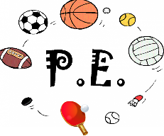 | Our PE this term is cricket and athletics.  PE is normally Wednesday and Friday. However, please make sure you have your full PE kit in school every day.
Religious Education | In RE this term we will be exploring Faith in the Community.

