Spring Term 1 - Curriculum - Year 1
English  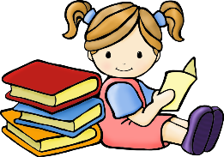 | Our first text this half term will be ‘The way back home’. This links to our first History topic all about Space and space travel.  The children will be building on their sentence skills by adding adjectives to their writing, conjunctions including ‘and’ and writing questions linked to our space topic. The children will also be using some of the skills that they have learned in phonics, including plurals.
Maths  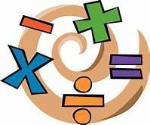 | Our first Spring term Maths focus will be place value within 20. The children will be:  - counting within 20  - develop a deeper understanding of the numbers 11-20  - Estimate, compare and order numbers 1-20  - use number lines to support their mathematical skills
Geography  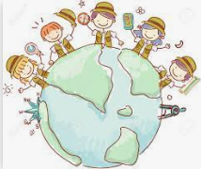 | Our Geography topic will involve looking at the weather patterns. The children will be learning all about the four seasons, how weather data is collected, the daily weather patterns of the UK and investigating how the weather is different in other countries.
Art / DT  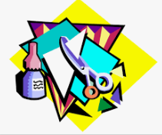 | Our Art topic this half term will focus on clay. The children will begin by exploring clay, observing what happens when water is added and how we can mould it into different shapes. They will look at a range of methods including pinching the pot, the coil method and the slab method. By the end of the topic the children will have created a tea light using one of these methods.
Science  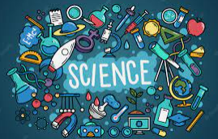 | Our science topic is called ‘Animals, including humans and their food chains’. During this topic the children will develop their understanding of how food chains work, learn about food chains in watery habitats and describe how some animals obtain their food from plants and other animals.
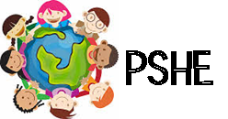 | During PSHE this half term the children will be learning all about the importance of road safety. This will include the stop, look, listen and think sequence, why it is important to be bright and be seen and how to be safe when you travel.
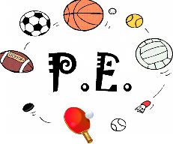 | In P.E. the children will be taking part in gymnastics and dance activities. They will develop knowledge and skills related to gymnastic balance, create routines with balance control and extensions.  In dance the children will explore travelling around spaces in different ways, play games involving dance related instructions and create new ways of moving to different pieces of music.
Religious Education  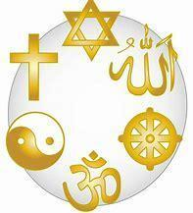 | Our R.E topic this first half term will be ‘What do Muslims believe?’. The children will learn about the Islam and that Muslims believe in one god, Allah. The children will learn about the Qu’ran and why ramadan is important to the Muslim faith.

