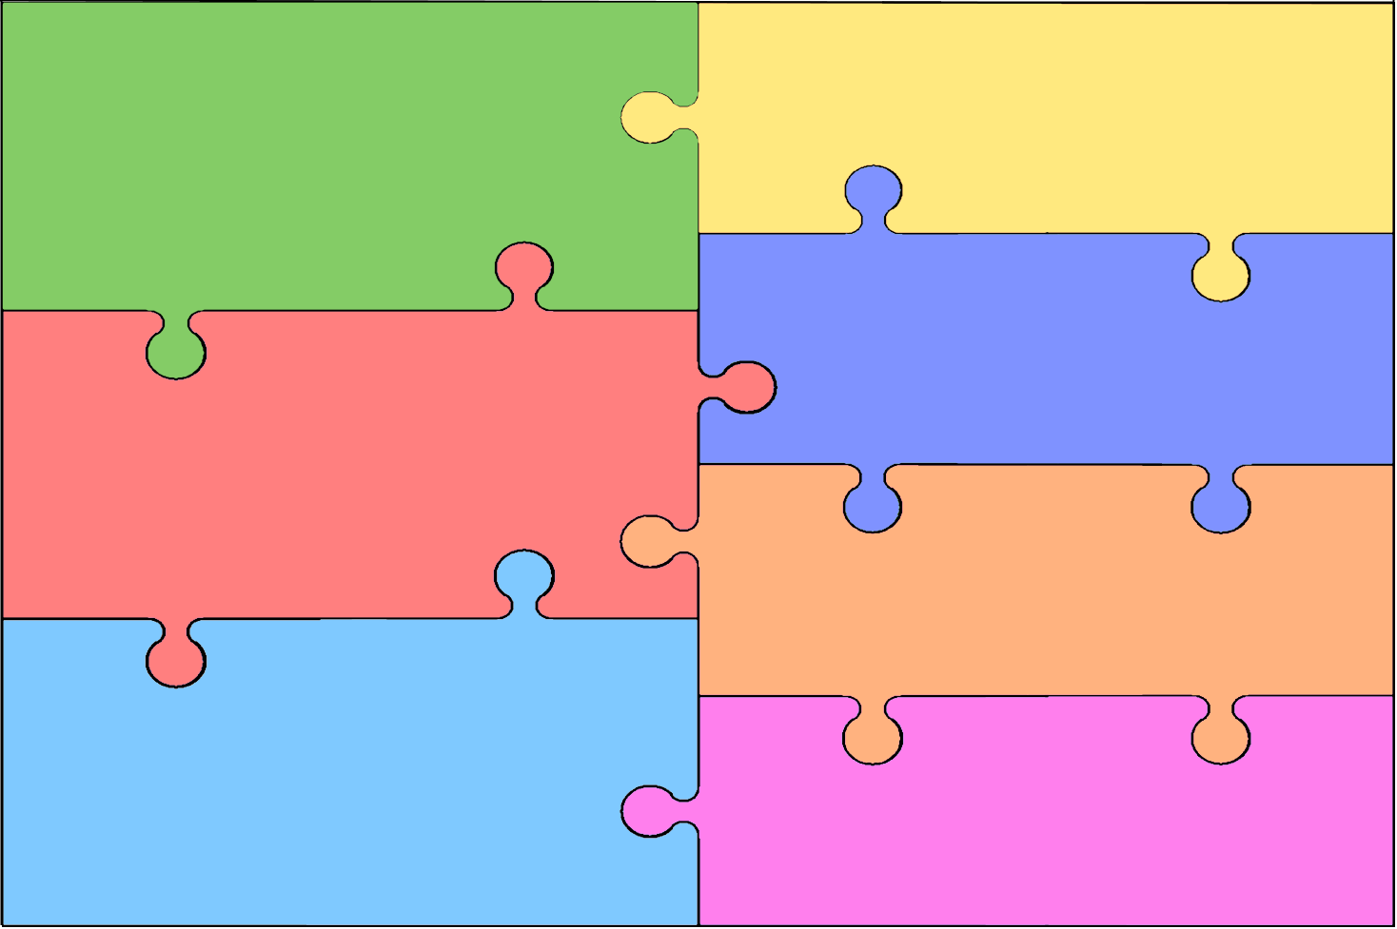
Activities Curriculum Plan for Early Years Foundation Stage
Personal, Social & Emotional Development  - Group play—extending play ideas, building up role play, initiating play/conversations, responding to others, making friends.  - Praise and responsibility – reward system/class jobs.  - Developing confidence with unfamiliar people and situations  - Communicating with others (home and community).  - Communicating wants and needs awareness of own feelings and actions – circle time activities.  - Sharing/turn taking  - Behaviour in school—boundaries, new routines/social situations.  - Children involved in class rules. | Literacy  - Recognise name and familiar words  - Rhyming  - Alliteration  - Books— title, front cover, author, illustrator, pages, blurb.  - Stories—structures, events, settings, characters, illustrations.  - Letter formation  - Name writing  - Initial sounds
Mathematics
- Match and sort
- Compare amounts
- Compare size, mass and capacity
- Exploring pattern

Communication & Language

- Group—listening/conversation
- Stories/rhymes —attention and recall, repeated refrains, key events and phrases.
- Following directions – circle time activities
- Simple instructions
- Follow a story – story map, role-play.
- Retelling past / familiar events in correct order.
- Introduction of new vocabulary in play/activities-including ‘pretend’ talk.
- Differences in sounds, word patterns and rhythms.
- Repetition-stories, rhymes, games.
Understand the World

- Similarities and Differences-How am I unique?
- Animals
- Our School
- RE - The World
- Operating equipment—IPads, technological toys, etc.
- Computers-games IWB.
Physical Development

- Running, jumping, climbing, balancing and spatial awareness-PE, games, ride-on, milk crates, tyres, climbing apparatus, slide.
- Increasing control catching, throwing, kicking, etc. – balls, hoops, bean bags.
- Manipulation activities – dough gym, threading, tweezers.
- Pencil control-thumb and two fingers.
- Copy/begin to form recognisable letters.
Expressive Arts & Design

- Dancing, games, singing, moving rhythmically.
- Repeated rhythms—clapping, instruments.
- Construction-junk modelling, blocks, Lego, etc.
- Imaginative play-roleplay-home corner, drama, singing, dancing, small world, puppets, etc.
- Colours-craft, painting, drawing, making, etc.

