TSSMAT Home learning – FRENCH
March 2020

This ‘activities menu’ reflects what each year group is working towards but you can choose from any year group.

Go straight to your year group page, or read the online tips.

Online: Online tools can help with pronunciation and translation. Google translate is ok. https://www.collinsdictionary.com/dictionary/english-french is better, and a really good dictionary that gives you language in context is https://www.linguee.com/english-french

Youtube: Pinpin et Lili, Tagadatsointsoin, Comptines et Chansons are good channels to try for stories and nursery rhymes. There are lots of popular cartoons available in French too (Peppa Cochon, Lucky Luke…)

Apps: DuoLingo is fun for older learners (Y5/6), though the sentences are very contrived! There are some apps for younger learners that at least have some free activities before you pay. Worth a try are:

Without the need for any resources, you can adapt memory/travel games. How about: naming the colours you see, seeing how many French words you can remember (maybe for a certain topic e.g. animals), or adapting counting games to use French numbers.

https://www.youtube.com/watch?v=KL9wwjPSuNU handwashing song for Early Years

https://www.youtube.com/watch?v=fQC_oU0NbFA handwashing for KS1 (join in the counting)

https://www.youtube.com/watch?v=QvTRTHWUVPc Minions sing Happy Birthday in French

https://www.youtube.com/watch?v=C7SUpUouL6g handwashing rap for UKS2

Year 1

Some words to practise:
- 1 - 15: un, deux, trois, quatre, cinq, six, sept, huit, neuf, dix: onze, douze, treize, quatorze, quinze
- blanc, bleu, gris, jaune, marron, noir, orange, rose,rouge, vert, violet, l’arc-en-ciel, multicolore

A classroom game: Countdown Count backwards from 5 in French and blast off like a rocket (blast off = “La fusée décolle!”); Colour hunt & colour splat Say a colour in French and the other ‘player/s’ search for an object of that colour. You can then sit in a circle and arrange the objects in the middle. Say a colour and the other player (or up to 2 players) has to ‘splat’ or grab an object of that colour as quickly as they can.

A finger rhyme to play: https://www.youtube.com/watch?v=4hLKKpz77u0 Mr Thumb is sleeping.
A song to sing: https://www.youtube.com/watch?v=KBVTs11huwQ 5 snails on a cabbage (like 10 Green Bottles)

Some facts to find out: Which countries border France? Do any of them speak French?*

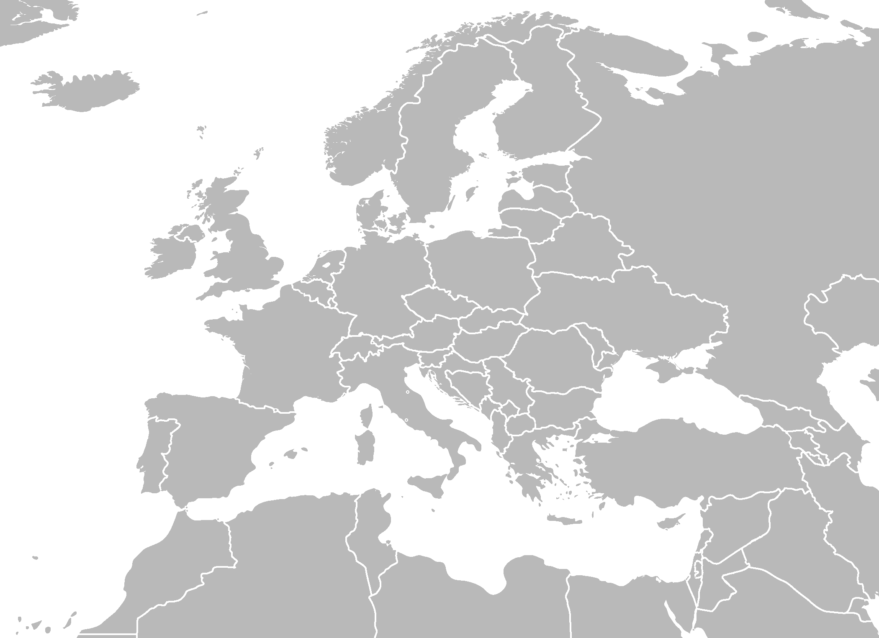

Year 2

Some words to practice:
- la banane, la carotte, la fraise (strawberry), le haricot vert (green bean), la pêche (peach), le petit pois (pea), la poire (pear), la pomme (apple), la pomme de terre (potato)
- Je voudrais... (I would like...)

A game to play: Cache-cache. (Hide and seek). Count to 10 in French and shout ‘j’arrive’ (sharreev) to say when you are looking for people.

A memory game: Au marche (I went to market) Take it in turns to say what you would like to buy at market. Two versions of the game: either try not to repeat the thing that has just been said. Or, you must repeat what has just been said and then add your own. The next turn must repeat both previous items and then add their own too etc etc.

Start each turn by saying, “Au marché je voudrais…” (o marshay, juh voodray) = At market, I would like...

A song to sing: Two versions of an éléphant counting song https://www.youtube.com/watch?v=Ns92r5TQH3k https://www.youtube.com/watch?v=ib3zBfCY3AE

Some facts to find out: Can you find the capital city, Paris, on a map of France? What do tourists like to do and see in Paris? See if you can find pictures of these things: le Centre Pompidou, le Louvre, la Tour Eiffel, les Catacombes, l’Arche de Triomphe.

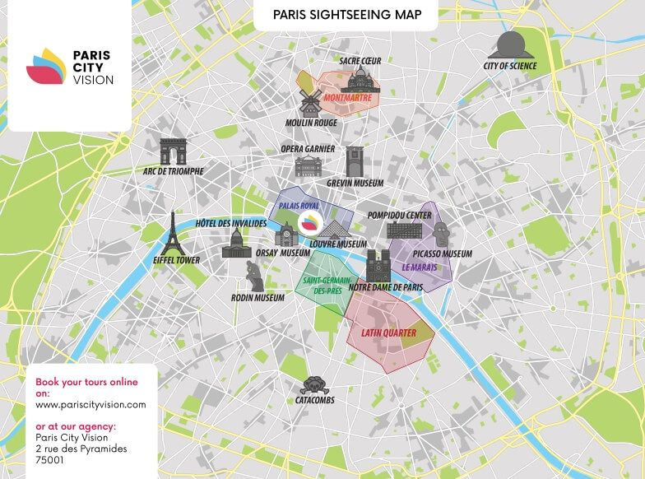

Year 3 Some words to practice saying:
- janvier, février, mars, avril, mai, juin, juillet, août, septembre, octobre, novembre, décembre
- Année (year), mois (month), saison (season), hiver (winter), printemps (spring), été (summer), automne (autumn)

A game to play: Jeux de chat ‘Cat games’. These are all like tag with variations popular in France. THe person who is on is the cat, le chat. The people being chased are the mice, les souris. Every time a new cat is tagged, they must shout ‘chat’ to announce a new chaser.

- Chat perché (Perching cat) You are on den if your feet do not touch the ground.
- Chat blessé (Injured cat) Whenever you are tagged, you must always move with a pretend injury to that part of the body for the duration of the whole game, regardless of whether you become a mouse again or are tagged to be the cat.

An activity to try: http://www.freewordsearches.net/wordsearch/french-months-and-seasons online wordsearch NB: there are no accents on the words even though accents ARE part of the spelling in French!

Some facts to find out: What can you find out about the composer of this fantastical piece about an Animal Carnival? https://www.youtube.com/watch?v=K_jqpDEP-lM
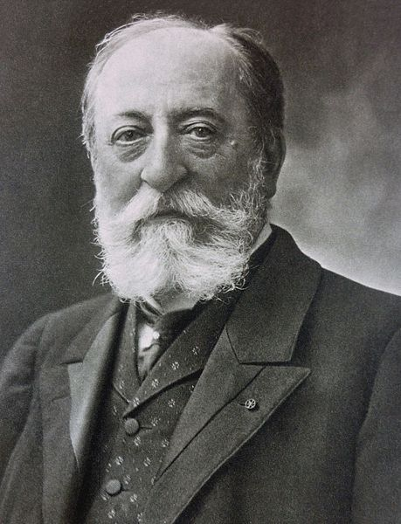

Name:
Nationality:

Famous works:

What did he think about his most famous work, Carnaval des Animaux?

How many animals can you name (in French!) that are featured in the Carnaval?

Which is your favourite ‘movement’ (i.e. which piece of animal music) do you like the most in the Carnaval?

Year 4

Some words to learn to say:
- Days of the week Monday - Sunday: lundi, mardi, mercredi, jeudi, vendredi, samedi, dimanche
- Months of the year
- https://www.youtube.com/watch?v=Lpwf5N0rfVE

An online activity to try: https://www.logicieleducatif.fr/eveil/geographie/jours-de-la-semaine.php Put the French days of the week in order.

Some facts to find out: Do we write days and months with capital letters in French?
What does ‘Mardi Gras’ in French? What do we call it in English and do France and England celebrate this special day in the same way? This link to a recipe might help! https://cuisine.journaldesfemmes.fr/recette/333415-recette-de-crepes-la-meilleure-recette-rapide

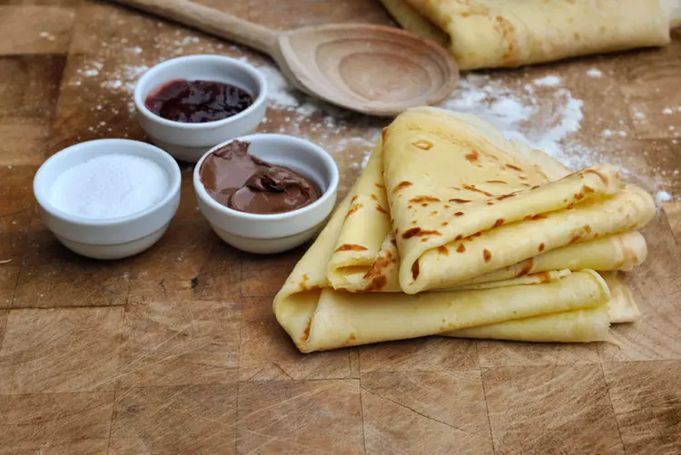

Years 5&6

Learn New Vocabulary  Complete the short High Five French videos to learn vocabulary from some new topics. https://radiolingua.com/learnathome /#primaryfrench |  | Famous French People  Create a powerpoint presentation about famous French people. They could be artists, authors, sports people, musicians or historical figures. | Appreciate Art  Take a virtual tour of the Musée d’Orsay in Paris https://artsandculture.google.com/partner/musee-dorsay-paris?hl=en Choose a piece of artwork that you particularly like and write a summary of what you learnt about it. | Bon Appetit!  Make crèpes for your family using the recipe enclosed.
Rhyme time  Copy out and illustrate this French comptine. Make up actions can use when you repeat it. Which French words rhyme? |  | Quiz Time  Complete the France Quest sheet. Can you set 5 questions for someone else to answer about France? | Visual Dictionary  Create a visual dictionary by taking photos of different rooms in the house or items of furniture and finding the French word using  https://www.collinsdictionary.com/dictionary/english-french | La Francophonie  Make a line of paper dolls from a concertina of paper, and decorate each one in the flag colours of a different French-speaking country.
Petit escargot  Porte sur son dos  Sa maisonette.  Aussitôt qu’il pleut  Il est tout heureux.  Il sort sa tête! | Little snail  Carries on his back  His little house.  As soon as it rains  He is all happy.  He pokes his head out!
You’ve Got Mail  Write a postcard in French. Say hello, what your name is, how old you  are, something that you like, and goodbye. Maybe you can send it to a friend!  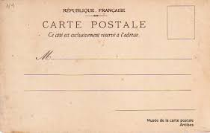 |  | A Game for the Garden  Play Jeu de chat (Cat game) It’s like tag and the person who is on is le chat. The people being chased are les souris. Every time a new cat is tagged, they must shout ‘chat.’ | Listen To This!  Watch this video of a well-known children’s song. https://www.youtube.com/ watch?v=Ns92r5TQH3k Can you look up the meaning of some words? | Language Log  Keep a language log of all new words learnt whilst you are away from school. You can organise this either by topic or in alphabetical order.  