Maths | English | Topic
Maths Year 5  Day 1  Complete 1 Fluent in Five arithmetic set daily.  Week 1 – test 1  (Mark with your parents and talk through ones where you have made mistakes)  Complete one rapid reasoning  Week 1 – Test 1  (Answers are available)  Day 2  Decimals / Fractions  http://www.snappymaths.com/counting/fractions/interactive/addfracc2d/addfracc2d.htm  Adding fractions with different denominators  http://www.snappymaths.com/counting/fractions/interactive/subfracc2d/subfracc2d.htm  Subtracting fractions with different denominators  Maths Year 6  Day 1  Complete 1 Fluent in Five arithmetic set daily.  Week 1 – test 1  (Mark with your parents and talk through ones where you have made mistakes)  Complete one rapid reasoning  Week 1 – test 1  (Answers are available)  Day 2  Algebra Focus  Classroom Secrets Pack  (D = Developing  E = Expected  GD = Greater Depth)  Find Pairs of Values 2  Choose your level of challenge and complete in your books.  (Home learning packs – guidance and answers are also available) | English whole class  Viking Narratives – Day 1  https://www.bbc.co.uk/teach/class-clips-video/english-ks2-viking-sagas-ep1/zm23d6f  Watch – Odin Creates the World  What have you discovered about the Viking creation story?  Write a short descriptive piece about Asgard. What is there? What does it look like? Where is it?  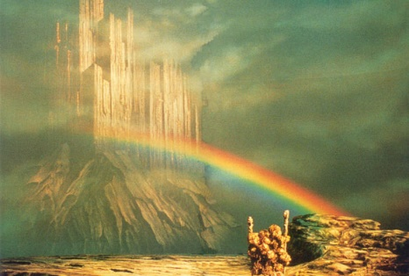  Viking Narratives – Day 2  Jotunheim is the home of the giants.  Use the clip, what do you imagine it might look like there? Can you write a description of this alternative setting?  Guided Reading Year 5  Independently read a chapter of your own book and write a summary for the chapter.  Complete a reading revision mat –  Focus Fiction  (Mark together and correct any mistakes)  Guided Reading Year 6  Independently read a chapter of your own book and write a summary for the chapter.  Complete a reading revision mat –  Focus Fiction  (Mark together and correct any mistakes) | History – Vikings  https://www.bbc.co.uk/teach/class-clips-video/history-ks2-the-vikings-animation/zhrygwx  Watch the above clip about the Viking invasion.  Why did the Vikings invade Britain?  http://www.primaryhomeworkhelp.co.uk/vikings.html  Read the information  Who were they?  When did they come?  Where did they come from?  Why did they come?  Write a diary as either a Viking invader or an Anglo Saxon settler – how did their life change?
Alongside these activities you could also complete the following:
● Daily reading (30 mins)
● Time Tables Rock Stars and Maths Frame (30 mins)
● Spelling Shed (30 mins)
https://mathsframe.co.uk/en/resources/resource/477/Multiplication-Tables-Check

