Maths | English | Topic
Maths Year 5  Day 1  Complete 1 Fluent in Five arithmetic set daily.  Week 2 – test 1  (Mark with your parents and talk through ones where you have made mistakes)  Complete one rapid reasoning  Week 2 – Test 1  (Answers are available)  Follow the below link for today’s maths lesson:  https://whiterosemaths.com/homelearning/year-5/  Lesson 1 - Decimals up to 2 dp  1 – Watch the PowerPoint  2 – Work through the task  3 - The answers are available for you to check your work  Day 2  Complete 1 Fluent in Five arithmetic set daily.  Week 2 – test 2  (Mark with your parents and talk through ones where you have made mistakes)  Complete one rapid reasoning  Week 2 – Test 2  (Answers are available)  Follow the below link for today’s maths lesson:  https://whiterosemaths.com/homelearning/year-5/  Lesson 2 - Decimals as fractions (1)  1 – Watch the PowerPoint  2 – Work through the task  3 - The answers are available for you to check your work  Maths Year 6  Day 1  Complete 1 Fluent in Five arithmetic set daily.  Week 2 – test 1  (Mark with your parents and talk through ones where you have made mistakes)  Complete one rapid reasoning  Week 2 – Test 1  (Answers are available)  Follow the below link for today’s maths lesson:  https://whiterosemaths.com/homelearning/year-6/  Lesson 1 - Using ratio language  1 – Watch the PowerPoint  2 – Work through the task  3 - The answers are available for you to check your work  Day 2  Complete 1 Fluent in Five arithmetic set daily.  Week 2 – test 2  (Mark with your parents and talk through ones where you have made mistakes)  Complete one rapid reasoning  Week 2 – Test 2  (Answers are available)  Follow the below link for today’s maths lesson:  https://whiterosemaths.com/homelearning/year-6/  Lesson 2 - Ratio and fractions  1 – Watch the PowerPoint  2 – Work through the task  3 - The answers are available for you to check your work | English whole class  Viking Gods - Information Text – Day 1  Use the PowerPoint to research Viking Gods and Goddesses.  Plan an information text – you will be writing this tomorrow.  Who might our audience be?  What is the purpose of our writing?  What is in our toolkit?  What might our audience want to know?  What should I research?  Viking Gods - Information Text – Day 2  Use your planning from yesterday to begin to write your Viking Information text.  Toolkit:  Paragraphs  Headings  Subheadings  Semi Colons  Brackets  Fronted Adverbials  Range of clause structures  Precise Noun Phrases  Technical Vocabulary  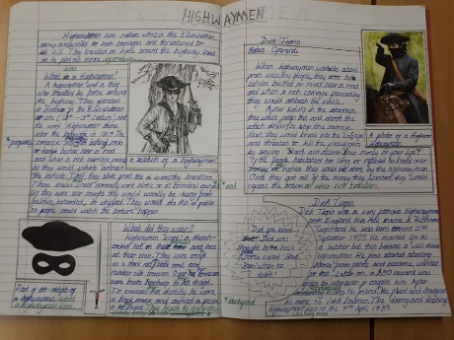  How could you present your work in a creative way? Add some pictures and get creative  Guided Reading Year 5 and 6  Independently read a chapter of your own book and write a summary for the chapter.  Complete a reading revision mat –  Danegeld by Rudyard Kipling  (Mark together and correct any mistakes)  Spellings – To be tested Friday  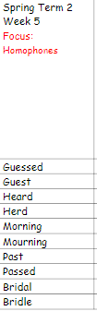 | History – Vikings  Focus – Viking Religions  Use the below websites to research what Vikings believe.  https://www.bbc.co.uk/bitesize/clips/zyy9wxs  https://vikings.mrdonn.org/gods.html  https://kidskonnect.com/history/norse-gods-goddesses/  Read through the PowerPoint:  Task 1 – Can you match the God’s to their descriptions  Task 2 – Complete the Viking Worksheet  Task 3 – Create your own Viking Gods Top Trump Cars
Additional Learning Opportunities:
- Daily reading (30 mins)
- Time Tables Rock Stars and Maths Frame (30 mins)
- Spelling Shed (30 mins)
- https://mathsframe.co.uk/en/resources/resource/477/Multiplication-Tables-Check
- PE with Joe Wicks https://www.youtube.com/watch?v=qGKGNzNbWjU
- Cosmic Yoga https://www.youtube.com/user/CosmicKidsYoga
- Education City

