Maths | English | Topic
Maths Year 5  Wednesday  Complete 1 Fluent in Five arithmetic set daily.  Week 2 – test 3  (Mark with your parents and talk through ones where you have made mistakes)  Complete one rapid reasoning  Week 2 – Test 3  (Answers are available)  Follow the below link for today’s maths lesson:  https://whiterosemaths.com/homelearning/year-5/  Lesson 3 - Step 8 - Understand percentages  1 – Watch the PowerPoint  2 – Work through the task  3 - The answers are available for you to check your work  Thursday  Complete 1 Fluent in Five arithmetic set daily.  Week 2 – test 4  (Mark with your parents and talk through ones where you have made mistakes)  Complete one rapid reasoning  Week 2 – Test 4  (Answers are available)  Follow the below link for today’s maths lesson:  https://whiterosemaths.com/homelearning/year-5/  Lesson 4 - Step 9 - Percentages as fractions and decimals  1 – Watch the PowerPoint  2 – Work through the task  3 - The answers are available for you to check your work  Maths Year 6  Wednesday  Complete 1 Fluent in Five arithmetic set daily.  Week 2 – test 3  (Mark with your parents and talk through ones where you have made mistakes)  Complete one rapid reasoning  Week 2 – Test 3  (Answers are available)  Follow the below link for today’s maths lesson:  https://whiterosemaths.com/homelearning/year-6/  Lesson 3 - Step 1 - Measure with a protractor  1 – Watch the PowerPoint  2 – Work through the task  3 - The answers are available for you to check your work  Thursday  Complete 1 Fluent in Five arithmetic set daily.  Week 2 – test 3  (Mark with your parents and talk through ones where you have made mistakes)  Complete one rapid reasoning  Week 2 – Test 4  (Answers are available)  Follow the below link for today’s maths lesson:  https://whiterosemaths.com/homelearning/year-6/  Lesson 4 - Step 2 - Introduce angles  1 – Watch the PowerPoint  2 – Work through the task  3 - The answers are available for you to check your work | English whole class  Viking Gods - Information Text – Day 3  Continue to write your Viking Gods Information Text  Can you include:  A title  Images  Introduction  At least 3 Gods  Toolkit:  Paragraphs  Headings  Subheadings  Semi Colons  Brackets  Fronted Adverbials  Range of clause structures  Precise Noun Phrases  Technical Vocabulary  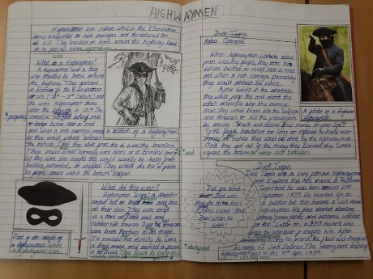  Viking Gods - Information Text – Day 4  Proof read and edit your work  Post for me to see  Guided Reading Year 5 and 6  Independently read a chapter of your own book and write a summary for the chapter.  Complete Comprehension  Victorious Vikings  (Mark together and correct any mistakes)  Spellings – To be tested Friday  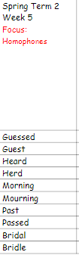 | Science  Complete the Electricity  Unit Check  DT/ ICT  Dr Allen has also set us some work this week. The link below will lead you to a video tutorial as well as a pdf guide for CAD software.  The activity uses a free online CAD package to guide you through designing a steering wheel for your Formula Goblin car. When it is finished email it to me and I can then e-mail the design over to WMG where they use augmented reality to superimpose it onto a 3D CAD image of the Greenpower car.  Year 6, this is similar to what you did on the trip to Warwick last year so you will be familiar with the software.  https://warwick.ac.uk/fac/sci/wmg/about/outreach/resources/tinkercad/goblin  Diane, from the university, has also given her email d.s.burton@warwick.ac.uk  Incase you need any help or have any questions about the software.  I can’t wait to see your designs!
Additional Learning Opportunities:
- Daily reading (30 mins)
- Time Tables Rock Stars and Maths Frame (30 mins)
- Spelling Shed (30 mins)
- https://mathsframe.co.uk/en/resources/resource/477/Multiplication-Tables-Check
- PE with Joe Wicks https://www.youtube.com/watch?v=qGKGNzNbWjU
- Cosmic Yoga https://www.youtube.com/user/CosmicKidsYoga
- Education City

