Maths | English | Topic
Maths Year 5  Monday  Complete 1 Fluent in Five arithmetic set daily.  Week 4 – test 1  (Mark with your parents and talk through ones where you have made mistakes)  Complete one rapid reasoning  Week 4 – Test 1  (Answers are available)  Follow the below link for today’s maths lesson:  https://whiterosemaths.com/homelearning/year-5/  Summer Term – Week 2  Lesson 1 - Adding decimals with the same number of decimal places  – Watch the PowerPoint  2 – Work through the task  3 - The answers are available for you to check your work  Tuesday  Complete 1 Fluent in Five arithmetic set daily.  Week 4 – test 2  (Mark with your parents and talk through ones where you have made mistakes)  Complete one rapid reasoning  Week 4 – Test 2  (Answers are available)  Follow the below link for today’s maths lesson:  https://whiterosemaths.com/homelearning/year-5/  Summer Term – Week 2 - Lesson 2 - Subtracting decimals with the same number of decimal places  1 – Watch the PowerPoint  2 – Work through the task  3 - The answers are available for you to check your work  Maths Year 6  Monday  Complete 1 Fluent in Five arithmetic set daily.  Week 4 – test 1  (Mark with your parents and talk through ones where you have made mistakes)  Complete one rapid reasoning  Week 4 – Test 1  (Answers are available)  Follow the below link for today’s maths lesson:  https://whiterosemaths.com/homelearning/year-6/  Summer Term – Week 2 - Lesson 1 - Angles in special quadrilaterals  1 – Watch the PowerPoint  2 – Work through the task  3 - The answers are available for you to check your work  Tuesday  Complete 1 Fluent in Five arithmetic set daily.  Week 4 – test 2  (Mark with your parents and talk through ones where you have made mistakes)  Complete one rapid reasoning  Week 4 – Test 2  (Answers are available)  Follow the below link for today’s maths lesson:  https://whiterosemaths.com/homelearning/year-6/  Summer Term – Week 2 – Lesson 2 - Angles in regular polygons  1 – Watch the PowerPoint  2 – Work through the task  3 - The answers are available for you to check your work | English – Year 5  Warm Up –  Complete one of the vocabulary ninja sheets.  Talk for Writing Book (PDF)  Year 5 = The Game  Follow the instructions from page 15 onwards.  Tasks include:  - Sentence imitation  - Adjective game  - Planning your story (guidelines / worksheets available)  - First draft of your story.  - Proof read and edit  - Option to publish as a mini book.  English – Year 6  Warm Up –  Complete one of the vocabulary ninja sheets.  Talk for Writing Book (PDF)  Year 6 = Doors  Complete activity 5 and 6.  Guided Reading Year 5 and 6  Independently read a chapter of your own book and write a summary for the chapter.  Complete a reading revision mat –  Stormzy  (Mark together and correct any mistakes)  Spellings for Friday:  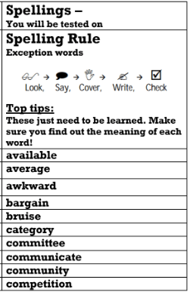 | Geography  Our new topic for this term is Trade.  Lesson 3 –  Read through the PowerPoint.  Complete the below activity:  Cut out the statements from people involved in different stages of the global supply chain of cotton jumpers.  • Read the statements and think about whether they are primary, secondary or tertiary stages of production.  • Put them in order of the supply chain stages and give them a number.  • Colour the primary red, the secondary orange, and the tertiary green  • Stick them in the correct column: primary, secondary or tertiary.  PE -  Mr Challinor has set us a Stoke City challenge.  Have a go for the chance of winning a signed shirt.  Computing:  (All about keeping safe online)  Follow this link  https://www.thinkuknow.co.uk/parents/Support-tools/home-activity-worksheets/8-10s/  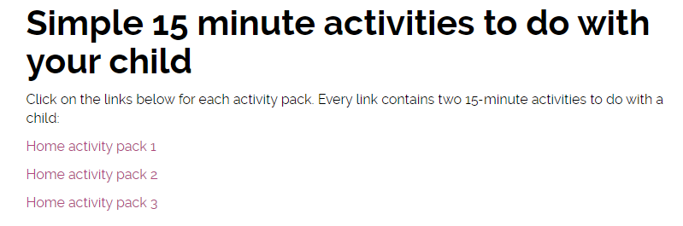  The above should show:  There are 3 work packs to support your learning at home.  Art:  Zentangle Art  A teacher has shared this art idea online – it looks fantastic. Have a go and upload any of your challenges.  (DO NOT TWEET THE TEACHER MENTIONED IN THE INTRODUCTION)
Additional Learning Opportunities:
- Daily reading (30 mins)
- Time Tables Rock Stars and Maths Frame (30 mins)
- Spelling Shed (30 mins)
- https://mathsframe.co.uk/en/resources/resource/477/Multiplication-Tables-Check
- PE with Joe Wicks https://www.youtube.com/watch?v=qGKGNzNbWjU
- Cosmic Yoga https://www.youtube.com/user/CosmicKidsYoga
- Education City

